PUTNAM VALLEY
TOWN BOARD MEETING
7:00 P.M.
WEDNESDAY, SEPTEMBER 18, 2013

1. Pledge of Allegiance
2. Supervisor’s Opening Comments
3. Approval of Town Board Minutes
4. School District Report
5. Re-appoint Town Assessor-S. Luongo
6. Award Transfer Station Bid
7. Award District Garbage Pick Up Bid
8. Authorize Change Work Order-Town Hall Emergency Roof
Repair-Brian Shook Construction
9. Request to Waive Wetland Permit Fees-Spur/Moon Beach
10. Discuss Incentive Zoning Project Applications-Beverly Hills
Cemetery Corp. & Glenview Park Inc.
11. Town Board Review of Bids Received for Proposed Town
Hall Addition

12. Parks & Recreation
a. Refunds
b. Personnel

13. Building Department
a. Report for August 2013

14. DISTRICTS
a. Lake Peekskill
1. District Report
2. Authorize Lake Lowering

15. Public Comment
16. Budget Transfers & Amendments
17. Audit of Monthly Bills
18. Adjournment

PUTNAM VALLEY TOWN BOARD
REGULAR TOWN BOARD MEETING
WEDNESDAY, SEPTEMBER 18, 2013

7:00 P.M.

Present: Supervisor Tendy
Councilwoman Whetsel
Councilwoman Annabi
Councilman Mackay
Councilman Luongo

Also Present: Town Counsel Zutt
Town Clerk Eileen Royael

AMENDMENTS TO THE AGENDA

Presented by Supervisor Tendy

RESOLUTION #R13-282

RESOLVED, that the Town Board add the following amendments to the agenda:

Amend agenda to add Executive Session to discuss contractual matters in regard to East of Hudson Contract and a possible contractual matter in Roaring Brook and personnel matter.
Add #4a- County Legislators Report
Remove Item# 11- Town Board Review of Bids Received for Proposed Town Hall Addition
Add#12c: Authorize to Bid Phase 2 Electrical- Town Park Maintenance Building

Seconded by Councilman Mackay, unanimously carried.

SUPERVISOR’S OPENING COMMENTS

Supervisor Tendy reminded the residents that Town Day is Saturday, September 21, 2013 with the Boy Scouts doing a Pie Booth at 3 p.m. He encouraged all to attend.

Councilwoman Annabi added that there will be 61 vendors; they will have everything from Amway to zeppoles. Parade begins at 1:00 p.m. at the high school and ends on Morrissey Drive.

Councilman Luongo added that 2014 is the 175th anniversary of the Town of Putnam Valley. The Anniversary Committee will be selling t-shirts for $10 to commemorate the anniversary.

APPROVAL OF TOWN BOARD MINUTES

Presented by Supervisor Tendy

RESOLUTION # R 13-283

RESOLVED, that the Town Board approve the Town Board Minutes of August 14 and August 21, 2013.

Seconded by Councilman Luongo, unanimously carried.

SCHOOL DISTRICT REPORT

County Legislator Oliverio told the residents that tonight is “Back to School Night” at the middle school and at the high school will be on September 25th. The Elementary School had a “Back School Night” on Tuesday and the next one is on Thursday, September 20th. There are two big events coming up, on October 3, 2013 at 7:00 p.m. at the High School there will be the bon fire to kick off the fall sports season. On October 5, 2013 the Home Coming Game will take place. He asked that all parents stay with their children the night of the bon fire.

COUNTY LEGISLATORS REPORT

County Legislator Oliverio told the residents that the County Legislators will be passing a resolution banning tractor trailers from using Peekskill Hollow Road except for local delivery, there will be signage going up within the next 30 days. Putnam County will be holding a 2014 budget meeting at Putnam National Golf Course on Wednesday, October 2nd at 5:30 p.m. He added that in regard to the Putnam Valley properties that the county own, there are discussions and interest on the Oregon Corners property and the Oscawana Lake/Church Road property.

County Legislator Scuccimara announced that this Saturday, September 21st, “Medication Take Back Day” will take place at American Legion on Cedar Street in Cold Spring. She added that the flu season is here and Putnam County is offering flu shots on October 9th at the Garrison Fire Department and again on October 21st at the Carmel Fire Department, over the age of 60 the shot is free, otherwise $25.00

County Legislator Oliverio added that the Putnam Valley School District will be offering free flu shots to the students, parents will need to sign up.

RE-APPOINT TOWN ASSESSOR-S. LUONGO

Presented by Councilwoman Annabi

RESOLUTION # R13-284

RESOLVED that the Town Board re-appoint Sheryl Luongo as Sole Assessor for the Town of Putnam Valley, term of office to be October 1, 2013-September 30, 2019. Salary of Assessor is set annually by the Town Board at the annual Organization Meeting of the Town Board in January of every year.

Seconded by Supervisor Tendy, motion passed with four ayes as Councilman Luongo recused himself.

AWARD TRANSFER STATION BID

Presented by Councilman Luongo

RESOLUTION # R13-285

RESOLVED, that the Town Board award the transport and disposal of garbage bid at the Transfer Station to AAA Carting and Rubbish Removal, 480 Furnace Dock Road, Cortlandt Manor, NY at the rate of $78.66 per ton for the year 2014, as they were the lowest bidder and;

BE IT FURTHER RESOLVED that the Town Board authorize the Town Supervisor to sign the contract for the transport and disposal of garbage at the Transfer Station with AAA Carting and Rubbish Removal for the year 2014.

Seconded by Councilwoman Annabi, unanimously carried.

AWARD DISTRICT GARBAGE PICK UP BID

Presented by Councilman Mackay

RESOLUTION # R13-286

RESOLVED, that the Town Board award AAA Carting & Rubbish Removal, 480 Furnace Dock Road, Cortlandt Manor, NY the bid for the collection and disposal of residential garbage and recyclables from the Districts within the Town of Putnam Valley for the years 2014, 2015 and 2016, cost $109,929.16 per year, as they were the lowest bidder and;

BE IT FURTHER RESOLVED that the Town Board authorize the Supervisor to sign a three-year contract with AAA Carting & Rubbish Removal for the collection and disposal of residential garbage and recyclables from the Districts within the Town of Putnam Valley for the years 2014, 2015 and 2016.

Seconded by Councilwoman Annabi, unanimously carried.

AUTHORIZE CHANGE WORK ORDER-TOWN HALL EMERGENCY ROOF REPAIR-
BRIAN SHOOK CONSTRUCTION

Presented by Councilwoman Whetsel

RESOLUTION #R 13-287

RESOLVED, that the Town Board authorize the change work order for emergency roof repairs above the Town Hall Court Room at the cost of $1,500.00 as an additional three square feet of shingles need to be installed to connect the gable roof and;

BE IT FURTHER RESOLVED that the Town Board authorize the Supervisor to sign the contract with Brian Shook Construction for this change work order.

Seconded by Councilman Luongo, unanimously carried.

REQUEST TO WAIVE WETLAND PERMIT FEES-SPUR/MOON BEACH

Presented by Councilwoman Annabi

RESOLUTION #R 13-288

RESOLVED, that the Town Board waive the wetland permit fees for the Spur Beach restoration project and the removal of boulders from Moon Beach.

Seconded by Councilman Mackay, unanimously carried.

DISCUSS INCENTIVE ZONING PROJECT APPLICATIONS-BEVERLY HILLS CEMETERY CORP. & GLENVIEW PARK INC.

David Steinmetz from the Law Firm of Zarin & Steinmetz told the Town Board members that he is representing the Shippers and Beverly Hills Cemetery. The applicants are submitting an Incentive Zoning Application in regard to Tax Map# 84.-2-33, 34, 35 and 36. The applicants are seeking to expand the cemetery by 55.45 acres which they would acquire from the Shippers. This expansion would insure that the cemetery waill continue to provide a much needed public benefit. Cemeteries are not listed as a permitted used in any Zoning District in the Town, in exchange for allowing Beverly Hill Cemetery to expand, the applicants are proposing to donate to the town, 90 acres of land for conservation and a public nature trail in perpetuity and also offer a $50,000 financial contribution paid over ten years. The applicants are also seeking to rezone certain portions of Lots 33 & 34 to permit commercial usage. These lots front Peekskill Hollow Road and Mill Street, which would offset the removal from the tax rolls of the property being added to the cemetery. He added that if the application is not accepted by the Town Board the applicants will withdraw their rezoning petition. If the Town Board accepts their application, the four lots would be reconfigured to create a cemetery lot, a commercial lot and an open space/conservation lot so they would intend to see a lot line change from the Planning Board. The applicants would like a determination from the Town Board under Town Zoning Code Section 165-110(C) that the “proposal is worthy of further consideration.”

Supervisor Tendy appreciates the amount of time and work that went into this presentation; it makes the Town Board’s job easier. He likes the general idea and is optimistic that this application can be tweaked.

County Legislator Oliverio questioned what commercial building is envisioned there as he does not want the Adams Corner Store to lose business.

David Steinmetz responded that he cannot say at this point what commercial business would be there, but would like to work together with the Town Board. He added that he would like the Town Board to pass a resolution indicating a desire for this application.

Town Counsel Zutt noted that this is the first time the Town would be accepting an Incentive Zoning Application and he would like to wait on doing anything tonight.

PARKS AND RECREATION REFUNDS

Presented by Councilman Mackay

RESOLUTION #R13-289

RESOLVED, that the Town Board approve the following refunds:

Michael DeGrazia $50.00
20 Peekskill Hollow Road PVCC
Putnam Valley, NY 10579 Unable to attend

Stephanie Bale $50.00
44 Hudson View Drive PVCC
Putnam Valley, NY 10579 Unable to attend

Pat Sherwood $170.00
PO Box 113 Day Camp
Putnam Valley, NY 10579 Unable to attend

Seconded by Councilwoman Annabi, unanimously carried.

PARKS & RECREATION- PERSONNEL APPOINTMENTS/ ADJUSTMENTS

Presented by Councilman Mackay

RESOLUTION #R 13-290

RESOLVED, that the Town Board approve the following additions/changes to personnel:

Andre Hohlock, PVCC Asst. @ $9.00 per hour

Seconded by Councilwoman Annabi, unanimously carried.

AUTHORIZATION TO BID PHASE 2 ELECTRICAL-TOWN PARK MAINTENANCE BUILDING

Presented by Councilman Mackay

RESOLUTION #R 13-291

RESOLVED, that the Town Board authorize Parks & Recreation to bid out Phase 2 of the electric for the Town Park Maintenance Building which would include the wiring and lighting of both the office and bathroom.

Seconded by Councilwoman Annabi, unanimously carried.

BUILDING DEPARTMENT REPORT

Presented by Councilwoman Whetsel

RESOLUTION # R13 -292

RESOLVED that the Town Board accept the Building Department report for the month of August 2013, for filing with the Town Clerk.

Seconded by Councilman Mackay, unanimously carried.

LAKE PEEKSKILL REPORT

Councilwoman Annabi announced that this past week was bulk pick up for Route 1 and next Monday, September 23rd is bulk pick up for Route 2. They had a district wide tag sale and it was very successful.

AUTHORIZE LAKE LOWERING OF LAKE PEEKSKILL

Presented by Councilwoman Annabi

RESOLUTION # R13 -293

RESOLVED that the Town Board authorize the Lake Peekskill District Employees to commence lowering Lake Peekskill by six feet beginning October 1, 2013.

Seconded by Councilman Luongo, unanimously carried.

PUBLIC COMMENT

Kurt Altenberger a resident of Lee Avenue would like permission from the town to park in the Lookout Manor parking area as the road is narrow and during the winter it makes it difficult to park. This past spring he got a red sticker on his windshield stating his car was parked illegally.

Town Board discussed this, Town Counsel Zutt added that the code would have to be changed by amending a local law. It was brought to the Town Board’s attention that the Lee Avenue residents except for Mr. Altenberger are not Lookout Manor District residents.

Councilwoman Annabi announced that Town Day is Saturday, September 21, 2013, parade at 1:00 p.m., Town Day starts at 2:00 p.m..

BUDGET TRANSFERS & AMENDMENTS

Presented by Supervisor Tendy

RESOLUTION #R 13 -294

RESOLVED, that the Town Board approve the following budget transfers and amendments as submitted by bookkeeper Marianne DeSantis:
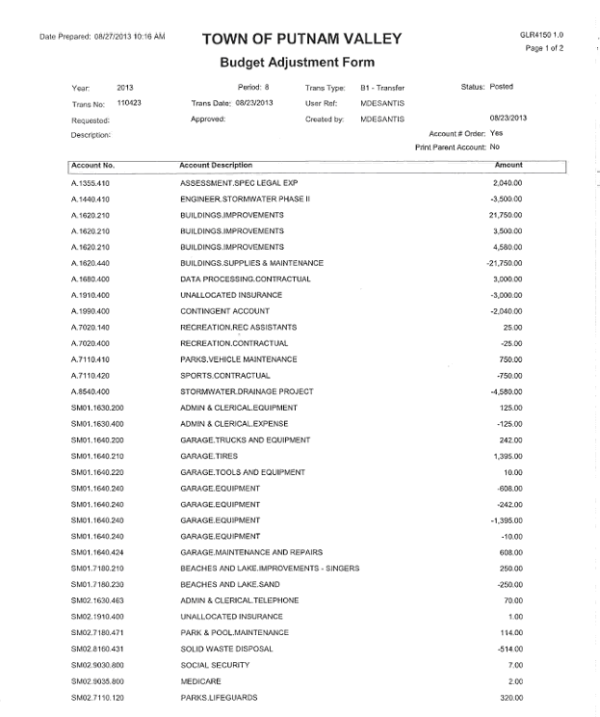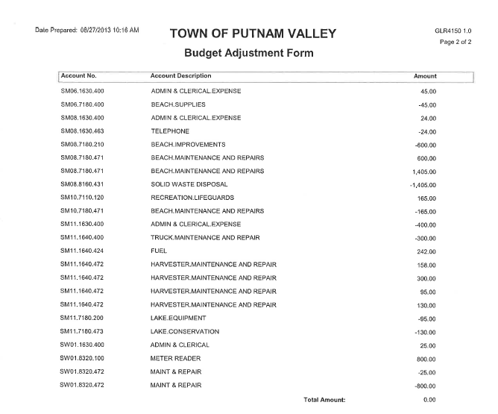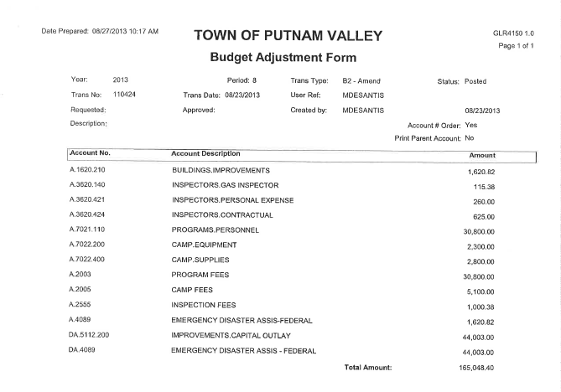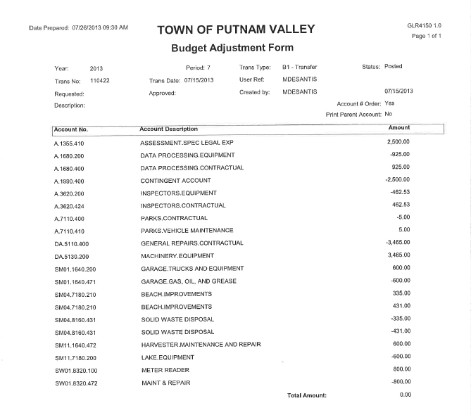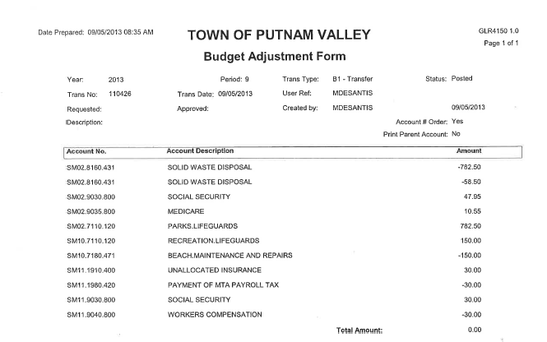
Seconded by Councilman Luongo, unanimously carried.

AUDIT OF MONTHLY BILLS

Presented by Supervisor Tendy

RESOLUTION # R 13-295

RESOLVED, that the Town Board approve the following bills, after audit, being paid:

VOUCHER NUMBERS AMOUNTS

4674-4677, 4696-4706,
4717-4725, 4744-4758,
4778-4790, 4792,
4796-4799, 4803-4808,
4824-4828, 4846-4857,
4859, 4861-4870 $263,111.39
4871, 4872, 4882-4891
4923, 4930, 4932, 4933
4935-4937, 4949, 4951
4960-4975, 4983-4991 $54,038.33
4672-4673, 4694-4695
4707-4716, 4759-4775
4777, 4845, 4858, 4860
4873-4881, 4892, 4893
4900, 4942-4968, 4950,
4958 $88,826.57
4801-4802, 4809-4823,
4895-4902, 4921-4922,
4925-4927, 4929, 4931,
4934, 1938-4941,
4952-4957, 4976-4982,
4992, 4993 $46,131.07

Seconded by Councilwoman Annabi, unanimously carried.

Supervisor Tendy motioned to go into Executive Session at 8:10 p.m to discuss contractual matters in regard to East of Hudson Contract and a possible contractual matter in Roaring Brook and a personnel matter with no further business taking place.

Seconded by Councilman Luongo, unanimously carried.

Respectfully submitted,

Eileen Royael 9-20-13
Town Clerk
`

