PUTNAM VALLEY TOWN BOARD

REGULAR MEETING

7:00 P.M.

WEDNESDAY, SEPTEMBER 17, 2014

- Pledge of Allegiance
- Supervisor’s Opening Comments
- County Legislator’s Report
- Approval of Town Board Minutes
- Discussion on Proposed Local Law Amending Chapter 165 Zoning Code Section 165-44 Habitable Space –Option A and Option B
- Appoint Marriage Officer- Dan Ricci
- Standard Workday Resolution

DEPARTMENTS
- Parks & Recreation
  - Refunds
  - Personnel
- Building Department Report
  - Report for August
- Districts
  - Lake Peekskill
      - Lake Peekskill Water Quality Discussion
      - Authorize Lake Lowering
      - Appoint Temporary Seasonal Laborer-J. Cobb
- Public Comments
12. Budget Transfers & Amendments
13. Audit of Monthly Bills

PUTNAM VALLEY TOWN BOARD
REGULAR TOWN BOARD MEETING
WEDNESDAY, SEPTEMBER 17, 2014

7:00 P.M.

Present: Supervisor Tendy
Councilwoman Whetsel
Councilman Mackay
Councilman Luongo

Also Present: Town Clerk Eileen Royael

Absent: Councilwoman Annabi
Town Counsel Zutt

AMENDMENTS TO THE AGENDA

Presented by Supervisor Tendy

RESOLUTION #R14-256

RESOLVED, that the Town Board add the following amendments to the agenda:
#7a- Authorize Eagle Scout Project-Noah Kelvas
#10B1- Authorize Roaring Brook Lake Dam Custodian to lower lake

Remove
#5 - Discussion on Proposed Local Law Amending Chapter 165 Zoning Code Section 165-44 Habitable Space –Option A and Option B
#8A.- Refunds ( Parks & Recreation)

Seconded by Councilman Luongo, unanimously carried.

SUPERVISOR’S OPENING COMMENTS

Supervisor Tendy noted that last weekend was the Oktoberfest at the German American Club. It was well attended, great food and great music. He congratulated all who put together this great event.

Supervisor Tendy reminded the residents that Town Day is Saturday, September 20, 2014; parade begins at Town Hall at 1:00 and goes to the Town Park. Weather looks great, lots of vendors, food, rides, llamas, live bands, DJ, arts and crafts for the kids and a pie-throwing booth. Fireworks begin between 9:15-9:30 p.m., bring a lawn chair, best fireworks in the area.

Councilman Luongo announced that wristbands are available for purchase of $10 all day for the rides.

Councilman Mackay added that Niese Maple Farm is open from 9:00 a.m. to 1:00 p.m. for breakfast, as well as the store.

COUNTY LEGISLATOR’S REPORT

County Legislators Oliverio and Scuccimarra noted that they will receive the County Budget from County Executive O’Dell on September 29, 2014 at the Putnam National Golf Course.
Once received, that is when the legislators will get down to the hard work.

County Legislator Scuccimarra announced that “Medication Take Back Day” will be at the American Legion Club in Cold Spring this Saturday from 9-12. Putnam County Health Department will be giving out flu shots on September 22nd at the Carmel Fire House, October 8th at the Garrison Fire House and October 20th at the Carmel Fire House. Shots are free for residents 60 years of age and older, everyone else is $25.00.

Councilman Mackay asked if the Putnam County Health Department can distribute the flu shots to our seniors at the Senior Center.

County Legislator Scuccimarra replied that can be arranged. She also noted that Putnam County Hazardous Waste Day will take place on September27th. Call the health department to register.

APPROVAL OF TOWN BOARD MINUTES

Presented by Supervisor Tendy

RESOLUTION # R 14-257

RESOLVED, that the Town Board approve the Town Board Minutes of August 13 and August 20, 2014.

Seconded by Councilman Luongo, unanimously carried.

DISCUSSION ON PROPOSED LOCAL LAW AMENDING CHAPTER 165 ZONING CODE SECTION 165-44 HABITABLE SPACE-OPTION A AND OPTION B-REMOVED

APPOINT MARRIAGE OFFICER- DAN RICCI

Presented by Councilman Luongo

RESOLUTION # R 14-258

RESOLVED that the Town Board appoint Daniel Ricci as a New York State Marriage Officer for the Town of Putnam Valley for the term 9-17-14 through 9-17-16.

Seconded by Councilman Mackay , unanimously carried.

AMEND STANDARD WORKDAY RESOLUTION # R14-164

Presented by Councilman Mackay

RESOLUTION # R 14-259

RESOLVED that the Town Board amend Resolution #R14-164 due to correcting the Records of Activities Result columns on the Standard Workday Reporting Resolution and;

BE IT FURTHER RESOLVED that the Town Board hereby established the following standard work days for elected and appointed officials and will report the following days worked to the New York State and Local Employees Retirement System based on the Record of Activities maintained and submitted by these officials to the Clerk of this body:

Seconded by Councilman Luongo, unanimously carried.

AUTHORIZE EAGLE SCOUT PROJECT-NOAH KELVAS

Presented by Supervisor Tendy

RESOLUTION # R 14-260

RESOLVED that the Town Board authorize Noah Kelvas to do his Eagle Scout Project at Hilltop Beach consisting of constructing a gate and a table for the benefit of the Hilltop District residents.

Seconded by Councilman Luongo, unanimously carried.

PARKS & RECREATION- PERSONNEL APPOINTMENTS/ ADJUSTMENTS

Presented by Councilwoman Whetsel

RESOLUTION #R 14-261

RESOLVED, that the Town Board approve the following additions/changes to personnel:

- Andrew Pinon, Crossfit Training Course, $240.00 for season.
- Maria Pagani, PVCC Ass’t. @ $10.00 per hour.
- Toni Ann Cortina, PVCC Ass’t Supervisor, @ $13.00 per hour.
- Samantha DiMarco, PVCC Ass’t. raise to $9.00 hour, as she is now 18 years old and can be alone with children.
- Sal Catalafamo, Chess Instructor, @ $30.00 per hour. (Supplies provided by instructor).
- Dawn Vaccaro, Art Instructor, @ $30.00 per student. (Supplies provided by instructor.)
- Patti Squallante, Art Instructor, @ $65.00 per student. (Supplies provided by instructor).
- Lawrence Kunze, Baseball Camp Asst. Director, @ $704.00 for season.

Seconded by Councilman Mackay, unanimously carried.

BUILDING DEPARTMENT REPORT

Presented by Councilman Mackay

RESOLUTION # R14-262

RESOLVED that the Town Board accept the Building Department report for the month of August 2014, for filing with the Town Clerk.

Seconded by Councilman Luongo, unanimously carried.

LAKE PEEKSKILL REPORT-NONE

LAKE PEEKSKILL WATER QUALITY DISCUSSION

Supervisor Tendy spoke about the beach closures in Lake Peekskill due to the algae. We have been in contact with the NYS DEC, our Wetlands Inspector, Bruce Barber and Princeton Hydro.
Princeton Hydro has been asked to put together a schedule of costs to do a study of the lake and what their recommendations are. There is lack of oxygen at the bottom of the lake and the snails are out of control. This will be a budgetary item for Lake Peekskill next year.

AUTHORIZE LAKE LOWERING-LAKE PEEKSKILL

Presented by Supervisor Tendy

RESOLUTION # R14-263

RESOLVED that the Town Board authorize the Lake Peekskill District Employees to commence lowering of Lake Peekskill by six feet beginning October 1, 2014.

Seconded by Councilman Luongo, unanimously carried.

APPOINT TEMPORARY SEASONAL LABORER-J COBB

Presented by Supervisor Tendy

RESOLUTION # R14-264

RESOLVED that the Town Board appoint Jason Cobb as a temporary seasonal laborer for the Lake Peekskill Improvement District at the rate of $11.44 per hour with no benefits effective September 15, 2014. Jason will assist with the Bulk Pick Up in Lake Peekskill for four days as the crew is shorthanded due to the absence of John D’Alessio.

Seconded by Councilman Luongo, unanimously carried.

AUTHORIZE ROARING BROOK LAKE DAM CUSTODIAN TO BEGIN LOWERING ROARING BROOK LAKE

Presented by Supervisor Tendy

RESOLUTION # R14-265

RESOLVED that the Town Board authorize the Roaring Brook Lake Dam Custodian to begin lowering the lake by 42 inches beginning October 1, 2014.

Seconded by Councilman Mackay , unanimously carried.

PUBLIC COMMENT

Roseanne Walsh a resident of Lake Peekskill told the Town Board that she belongs to the Lake Peekskill Civic Association and they have decided to hold off on hiring Princeton Hydro to do a study of Lake Peekskill. They want to fix the hypolimentic system that already exists in the lake. We feel that it will help increase the oxygen levels.

Supervisor Tendy believes that if the hypolimentic system can get functioning again it will help the lake. The Town Board has decided to do a study on Lake Peekskill as this year the lake was so bad and feels that it is imperative for the health of the lake.

Ted Muniak, a resident of Lake Peekskill also would like to get the hypolimentic system back up and running. They want to see if this will solve the lake issue problems before we spend the money for a study. Need to locate the pipes.

Supervisor Tendy told the residents of Lake Peekskill that they will contact Princeton Hydro and discuss the hypolimentic system with them. We can hold off on the study to see if the hypolimentic system will work. He also noted that it was good to see the membership of the Lake Peekskill Civic Association growing. Their meetings have been poorly attended in the past and if anyone is looking to help Lake Peekskill, they can call him at 845-526-2121 and he will direct them to Ted Muniak.

Ted Muniak added that the Lake Peekskill crew did a great job removing the bulk items in Lake Peekskill. He also commended Rich Quaglietta, Interim Building/Zoning Inspector on doing a great job. He also told the Town Board members that he had contacted the County Legislators to help get changes in the law when it comes to foreclosed properties. Many of these properties have junk left on them.

County Legislator Oliverio added that this is a gray area and until the court signs off on a foreclosure nothing can be done. Our legal department is contacting the New York State Attorney General’s office to see if the rules can be changed.

Susan Midlarsky would like “Lake Savers” to help with the water quality in Lake Peekskill. They have helped a lot of lakes recover.

Councilman Luongo reminded the residents of Lake Peekskill to put out their recycling properly.

Michael Bennett, Putnam Valley Grange, noted that their past “Mushroom Workshop” was a success. On September 28, 2014, they are having another workshop “Bluebirds”, this workshop will teach you how to attract the blue birds and care for them. He also told the residents that he has set up a new website, www.PV10579.com, and this site will notify residents of events and activities in our area. If you send me your email address you will get weekly newsletters.
He is hoping to get information from the town in regard to road work happening, inclement weather reports etc.

Supervisor Tendy told Mr. Bennett that he has received a lot of questions about this website.
He wants the residents to know that the information on this website is not coming from the town; this is not a town website. If any residents want to know anything they should go to the town’s website at www.putnamvalley.com or call his office at 845-526-2121. He also noted that he does not think it is in the best interest of a private individual to put emergency information on a private website, if you make a mistake you are liable. He suggested that Mr. Bennett contact an attorney.

Councilman Luongo told the residents that the fire department will be selling hot dogs, hamburgers and sausage and peppers again this year at Town Day. On November 1, 2014 at 7:00 p.m., the Putnam Valley Fire Department will be hosting a Halloween Costume Party, spaghetti dinner, all you can eat for $35.00. Reservations are needed, call Melissa at 845-821-4069 or call him at 914-760-6339.

BUDGET TRANSFERS & AMENDMENTS

Presented by Supervisor Tendy

RESOLUTION #R 14-266

RESOLVED, that the Town Board approve the following budget transfers and amendments as submitted by bookkeeper Marianne DeSantis:

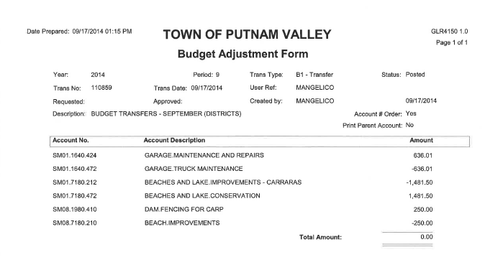

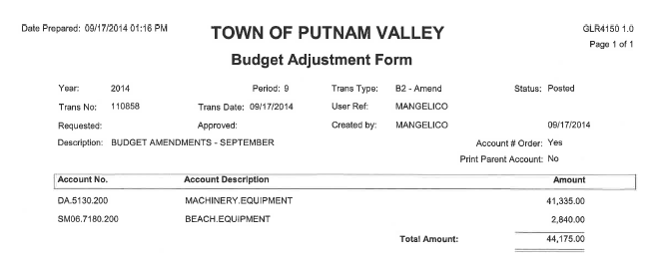

Seconded by Councilman Luongo, unanimously carried.

AUDIT OF MONTHLY BILLS

Presented by Supervisor Tendy

RESOLUTION # R 14-267

RESOLVED, that the Town Board approve the following bills, after audit, being paid:

VOUCHER NUMBERS AMOUNTS
8812-8823, 8825-8827,
8848-8866, 8868-8880,
8891-8904, 8912-8914,
8916, 8918-8919, 8921,
8923, 8925-8929,
8946-8948, 8979-8980,
8986-8990 $187,276.89
8997-9007, 9019-9026,
9051-9077 $23,914.74
8792-8811, 8824,
8811-8890, 8951-8956,
8968-8969, 8971-8972,
8977, 8994-8996,
9014-9018, 9045-9046 $108,679.20
8905-8911, 8915, 8917,
8920, 8922, 8924, 8928,
8949-8950, 8957-8967,
8970, 8973-8976,
9008-9013, 9047-9050,
9080-9085 $42,210.96

Seconded by Councilman Mackay, unanimously carried.

Supervisor Tendy moved to close the meeting at 7:38 p.m.
Seconded by Councilman Luongo, unanimously carried.

Respectfully submitted,

Eileen Royael
Town Clerk 9-18-14

