PUTNAM VALLEY TOWN BOARD

REGULAR MEETING

7:00 P.M.

WEDNESDAY, SEPTEMBER 16, 2015

- Pledge of Allegiance
- Supervisor’s Opening Comments
- Authorize Supervisor to Sign Contract with Protection One-Fire Alarm- TABLED ON 9-9-15
- County Legislator’s Report
- Approval of Town Board Minutes
- Acknowledgement Of 2014 Justice Court Audit

DEPARTMENTS
- Parks & Recreation
  - Refunds
  - Personnel
- Building Department Report
  - Report for August
- Districts
  - Lake Peekskill
      - Authorize Lake Lowering

- Public Comments
11. Budget Transfers & Amendments
12. Audit of Monthly Bills

PUTNAM VALLEY TOWN BOARD
REGULAR TOWN BOARD MEETING
WEDNESDAY, SEPTEMBER 16, 2015

7:00 P.M.

Present: Supervisor Tendy
Councilwoman Annabi
Councilwoman Whetsel
Councilman Mackay
Councilman Luongo

Also Present: Town Clerk Eileen Royael
Town Counsel Florence

AMENDMENTS TO THE AGENDA

Presented by Supervisor Tendy

RESOLUTION #R15-239

RESOLVED, that the Town Board add the following amendments to the agenda:

#6b Authorize Town Supervisor to Sign Contract with Cronin Engineering and for the Expenditure for Carp Barrier Plans on Dunderberg Road-Cronin Engineering

#9b1- Authorize Roaring Brook Lake Dam Custodian to lower lake

Add Executive Session to discuss possible litigation and contractual matter

Seconded by Councilman Luongo, unanimously carried.

SUPERVISOR’S OPENING COMMENTS

Supervisor Tendy recognized the children in the audience. He noted that the children added a life to the “Pledge of Allegiance”. The children are the life of our country. He also noted that this is a political year and some on the Town Board have decided to do things that we think are important to our community. None of us are running a negative campaign; some residents may have received a negative cartoon flyer in the mail with his name on it. Supervisor Tendy wanted the residents to know that he had nothing to do with it, he doesn’t know where it came from and he wanted the residents to know that he does not campaign like that.

AUTHORIZE SUPERVISOR TO SIGN CONTRACT WITH PROTECTION ONE

Presented by Councilwoman Annabi

RESOLUTION #R15-240

RESOLVED, that the Town Board authorize the Town Supervisor to sign a contract with Protection One for a fire alarm system to be installed at the Parks and Recreation building located at 273 Oscawana Lake Road. Amount of contract is $4,692. This expense has been funded through the Building Maintenance budget.

Seconded by Councilman Luongo, unanimously carried.

COUNTY LEGISLATOR REPORT

County Legislator Scuccimarra told the residents that October is a busy month for the legislators. They are working on the $145 million budget, it is tough to figure out what programs can be cut. Putnam County received a $3.5 million grant for infrastructure equipment and technology for vital communication towers. The legislators are also looking into the future on recycling electronics. She also noted that our lake communities have a huge problem with septic systems, Putnam County does not have the money to help homeowners and we are looking into state or federal help. On September 29th at the Putnam County Golf Course at 11:00 a.m. there will be an informational meeting on the “Yellow Dot Program.” Any senior who is concerned about paying their heating bill can get assistance from the “HEAP Program”, call 845-808-1700. On September 21st, from 2-6:30 flu shots will be given at the Carmel Fire Department. Councilwoman Annabi asked County Legislator Scuccimarra to look into help for those residents who can’t afford to pump out their septic systems; maybe a tax exemption can be given.

Ilene Gouldman, County Legislator Gouldman’s wife presented “Certificates of Appreciation” to the girl scouts who participated in the town wide clean up. September 24th-27th, the Vietnam Traveling Memorial will be at the Putnam County Veteran’s Park. September 26th, the County Clerk will be sponsoring “National Passport Awareness”, residents will be able to get information and applications on passports. Putnam County Sheriff’s Department along with County Legislator Gouldman will be at the Putnam Valley Library with information on Credit Card Fraud on September 30th from 7-8 p.m. September 27th-October 11th is “Restaurant Week” in Putnam County. October 3rd is “Hazardous Waste Day” at the Putnam County Health Department, 1 Geneva Road, Brewster, NY. On October 10th, Legislator Gouldman will be sponsoring “Child Safety ID Program” at the Putnam Valley Library from 10-12 p.m.

APPROVAL OF TOWN BOARD MINUTES

Presented by Councilwoman Whetsel

RESOLUTION # R 15-241

RESOLVED, that the Town Board approve the Town Board Minutes of August 12 and August 19, 2015.

Seconded by Councilwoman Annabi, unanimously carried.

ACKNOWLEDGEMENT OF TOWN OF PUTNAM VALLEY JUSTICE COURT AUDIT

Presented by Councilman Luongo

RESOLUTION # R15-242

RESOLVED that the Town Board acknowledges than an audit was conducted on the Town of Putnam Valley Justice Court records by O’Connor & Davies for the year ending December 31, 2014.

Seconded by Councilwoman Annabi, unanimously carried.

AUTHORIZE TOWN SUPERVISOR TO SIGN CONTRACT WITH CRONIN ENGINEERING AND FOR THE EXPENDITURE FOR CARP BARRIER PLANS ON DUNDERBERG ROAD-CRONIN ENGINEERING

Presented by Supervisor Tendy

RESOLUTION # R15-243

RESOLVED that the Town Board authorize the Town Supervisor to sign a contract with Cronin Engineering for the carp barrier plans on Dunderberg Road not to exceed $3,500.

Seconded by Councilman Mackay, unanimously carried

PARKS & RECREATION- REFUNDS

Presented by Councilman Mackay

RESOLUTION #R 15-244

RESOLVED, that the Town Board approve the following refunds:

Michelle Sherwood $500.00
70 Paulding Lane Cheerleading Camp
Crompond, NY 10517 Withdrawn

Swavette Hagans $31.00
1171 Oregon Road Day Camp
Cortlandt Manor, NY 10567 Withdrawn

Kim McKeown $400.00
27 Cedar Ledges Day Camp
Putnam Valley, NY 10579 Withdrawn

Seconded by Councilman Luongo, unanimously carried.

PARKS & RECREATION- PERSONNEL APPOINTMENTS/ ADJUSTMENTS

Presented by Councilman Mackay

RESOLUTION #R 15-245

RESOLVED, that the Town Board approve the following additions/changes to personnel:

Zachary Hamilton, PVCC Ass’t, @ $9.00 per hour
Michael Seiler, PVCC Ass’t @ $9.00 per hour

Seconded by Councilwoman Whetsel, unanimously carried.

BUILDING DEPARTMENT REPORT

Presented by Councilwoman Whetsel

RESOLUTION # R15-246

RESOLVED that the Town Board accept the Building Department report for the month of August 2015, for filing with the Town Clerk.

Seconded by Supervisor Tendy, unanimously carried.

AUTHORIZE LAKE LOWERING-LAKE PEEKSKILL

Presented by Councilwoman Annabi

RESOLUTION # R15-247

RESOLVED that the Town Board authorize the Lake Peekskill District Employees to commence lowering of Lake Peekskill by six feet beginning October 1, 2015.

Seconded by Councilman Mackay, unanimously carried.

LAKE PEEKSKILL REPORT

Councilwoman Annabi reported that the “Lake Peekskill Tag Sale” was a great success, great turnout. There will be an Art Show in Lake Peekskill in October, date to be announced. There is discussion in regard to forming a garden club in Lake Peekskill. Looking into state and federal funding for help in septic pump-outs.

Ted Muniak, president of the LPCA noted that the 2016 Budget meetings went well and that the detention pond will be getting cleaned out. On September 21st, there is a LPCA meeting, all are invited, dues are $15, members get a discount on septic pump outs. On October 19th, “Meet the Candidates” at the Lake Peekskill Community Center.

AUTHORIZE LAKE CUSTODIAN TO BEGIN LOWERING ROARING BROOK LAKE

Presented by Councilwoman Annabi

RESOLUTION # R15-248

RESOLVED that the Town Board authorize the Roaring Brook Lake Dam Custodian to begin lowering of Roaring Brook Lake by 42 inches beginning October 1, 2015.

Seconded by Councilman Mackay, unanimously carried.

PUBLIC COMMENTS

Councilwoman Annabi announced the Town Day is this Saturday, September 19th, parade beginning at 2:00 p.m. from the Putnam Valley High School to Morrissey Drive. She thanked Entergy, Cablevision and Tompkins Mahopac Bank for their generous donations. She noted it is a great day for our community to come together.

Councilman Luongo thanked Councilwoman Annabi for putting this great event together. It is a lot of work and is not a small undertaking. He also thanked all of the volunteers who are helping to make “Town Day” happen.

Sam Oliverio thanked the Putnam Valley Highway Department for the great paving job on Bryant Pond Road. He also asked the Town Board to consider opening up the bridge on Lovers Lane so that it can be a two way street again.

Councilman Luongo asked Sam Oliverio if the county has concerns about the bridge.

Sam Oliverio told Councilman Luongo that the county has had discussions on repairing it.

Dan Vera, resident told the Town Board that he has some recommendations in regard to reducing next years’ budget. He will give those recommendations to the Town Board at the Budget Meeting on October 7th.

Ted Muniak thanked the Lake Peekskill employees for doing a great job cleaning up after the Bulk Pick- Up in Lake Peekskill.

A resident from Mill Ponds asked when the repairs will be done on the water system.

Supervisor Tendy responded that because it is a district water system there are certain requirements that need to be addressed as per our Bond Counsel. He noted that we are looking into the steps now. We will have a district meeting as soon as we know all the facts. Another concern is the water costs being charged to Mill Ponds from Yorktown.

Town Counsel Florence noted that he is reviewing their contract with Yorktown, which is a 20 year contract with the option of renewing for another 20 years. Yorktown has to meet the NYC Aqueduct guidelines on selling water out of district.

Councilwoman Annabi also reminded the residents that the town has an oil co-op, contact Beverly Kelly at 845-526-2121.

BUDGET TRANSFERS & AMENDMENTS

Presented by Supervisor Tendy

RESOLUTION #R 15-249

RESOLVED, that the Town Board approve the following budget transfers and amendments as submitted by Finance Director Maria Angelico:

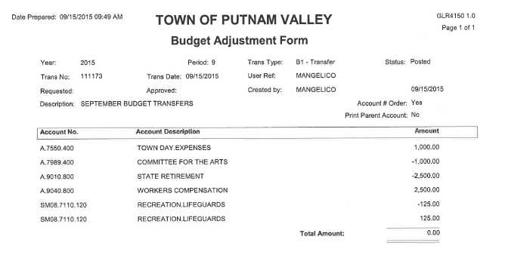
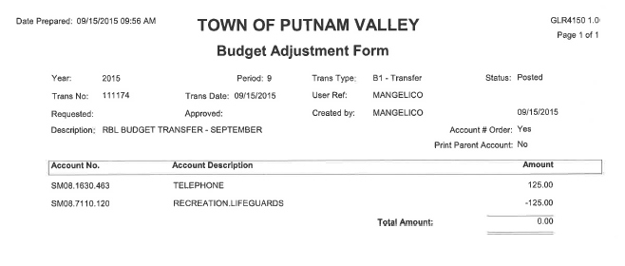

Seconded by Councilman Mackay, unanimously carried.

AUDIT OF MONTHLY BILLS

Presented by Supervisor Tendy

RESOLUTION # R 15-250

RESOLVED, that the Town Board approve the following bills, after audit, being paid:

VOUCHER NUMBERS AMOUNTS
12889, 12893-12896, 12939,
12944, 12947, 12969,
12970-13011, 13017, 13042 $725,348.57
12772-12803, 12821-12842,
12878-12887 $77,098.04
12888, 12890-12892,
1289-12909, 12936-12940,
12943, 12946, 12948-12951,
13012-13016, 13018-13022,
13024-13045, 13043-13044,
13046 $375,94.02
12843-12862, 12910-12924,
12926-12935, 12941-12942,
12945, 13041, 13045,
13047-13048 $62,763.68

Seconded by Councilman Mackay, unanimously carried.

Supervisor Tendy moved to go into Executive Session at 7:50 p.m. to discuss possible litigation and a contractual matter with no further business taking place.

Seconded by Councilman Mackay, unanimously carried.

Respectfully submitted,

Eileen Royael
Town Clerk 9-18-15

