PUTNAM VALLEY TOWN BOARD

PUBLIC HEARINGS

6:30 P.M.

REGULAR MEETING

7:00 P.M.

WEDNESDAY, AUGUST 20, 2014

PUBLIC HEARINGS
To hear comments on a proposed local law to amend the Putnam Valley Zoning Code, Chapter 165, so as to allow livable space in structures located on non-conforming lots, to be increased by more than 20% of the existing livable space provided no external changes are made to the structure.(Option A)

Immediately following:
To hear comments on a proposed local law to amend the Putnam Valley Zoning Code, Chapter 165, so as to allow livable space in structures located on non-conforming lots, to be increased by more than 20% of the existing livable space provided no external changes are made to the structure and said structure has existed in its current size and configuration for at least five (5) years prior to the application for permission to create said added livable space. (Option B)

Immediately following:
3. To hear comments on a proposed local law to amend Chapter 165 of the Town Code of Putnam Valley (Zoning) so as to exclude underwater land in calculating lot area, minimum open area, and front, rear, side yard and lakefront setbacks
Immediately following:
4. To hear comments on a proposed local law to amend Chapter 120 of the Town Code of the Town of Putnam Valley in respect to parking on West Shore Drive, a town highway.

AGENDA
- Pledge of Allegiance
- Supervisor’s Opening Comments
- County Legislator’s Report
- Approval of Town Board Minutes

DEPARTMENTS
5. Zoning
A. Request Waiver of Civil Penalty-Gannon/Romero
B. Request Waiver of Civil Penalty-Cerqueira
C. Request Wavier of Civil Penalty-Disanza/Cassidy
6. Parks & Recreation
  - Refunds
  - Personnel

7. Building Department Report
A. Report for July
8. Districts
A. Lake Peekskill
      - Lake Peekskill Report
2. Discussion of Speed Bumps on Beach Roads-Lake
Peekskill
3. Discussion re Lake Peekskill Lake Water Quality
And Discussion on possible aeration and other
measures

9. Public Comments
10. Budget Transfers & Amendments
11. Audit of Monthly Bills

PUTNAM VALLEY TOWN BOARD

PUBLIC HEARINGS

6:30 P.M.

REGULAR MEETING

7:00 P.M.

WEDNESDAY, AUGUST 20, 2014

PRESENT: Deputy Supervisor Annabi
Councilwoman Whetsel
Councilman Mackay
Councilman Luongo

ALSO PRESENT: Town Clerk Royael
Town Counsel Zutt

ABSENT: Supervisor Tendy

PUBLIC HEARINGS

Deputy Supervisor Annabi opened the public hearing at 6:30 p.m.

1. To hear comments on a proposed local law to amend the Putnam Valley Zoning Code, Chapter 165, so as to allow livable space in structures located on non-conforming lots, to be increased by more than 20% of the existing livable space provided no external changes are made to the structure.(Option A)

Town Counsel Zutt explained that this proposed law allows livable space in structures on non-conforming lots to be increase by more than 20% of existing livable space provided no external changes are made to the structure except what would be required by the Uniform Code. There are lots of variance applications before the Zoning Board to finish basements or attics with no visible changes to the structure. It may require some external changes such as doors or windows to comply with the Uniform Code.

Interim Building/Zoning Inspector Quaglietta added that residents will finish their basements or attics even if we don’t grant them a variance, this proposed law will help.

Councilman Luongo added that this will alleviate the variances but not the building permit process.

Deputy Supervisor Annabi closed the public hearing at 6:36 p.m.

Seconded by Councilman Luongo, unanimously carried.

Deputy Supervisor Annabi opened the public hearing at 6:36p.m.

2. To hear comments on a proposed local law to amend the Putnam Valley Zoning Code, Chapter 165, so as to allow livable space in structures located on non-conforming lots, to be increased by more than 20% of the existing livable space provided no external changes are made to the structure and said structure has existed in its current size and configuration for at least five (5) years prior to the application for permission to create said added livable space. (Option B)

Town Counsel Zutt explained that the difference between Option A and Option B is that the structure would need to exist for five years prior to an application to create additional living space such as finishing a basement or attic.

Deputy Supervisor Annabi closed the public hearing at 6:40 p.m.

Councilman Luongo seconded, unanimously carried.

Deputy Supervisor Annabi opened the public hearing at 6:40 p.m.

3. To hear comments on a proposed local law to amend Chapter 165 of the Town Code of Putnam Valley (Zoning) so as to exclude underwater land in calculating lot area, minimum open area, and front, rear, side yard and lakefront setbacks

Town Counsel Zutt explained that this proposed law excludes underwater land in the calculating of a lot area, and setbacks. The underwater land beyond a shoreline will not be included in the calculation of a lot area, minimum open area or for any setback purposes.

Deputy Supervisor Annabi closed the public hearing at 6:43 p.m.

Councilman Mackay seconded, unanimously carried.

Deputy Supervisor Annabi opened the public hearing at 6:44 p.m.

4. To hear comments on a proposed local law to amend Chapter 120 of the Town Code of the Town of Putnam Valley in respect to parking on West Shore Drive, a town highway.

Town Counsel Zutt explained that this law would prevent parking on the frontage of the Hilltop Improvement District property. There have been numerous complaints of cars parking on the road that are not part of the district.

Joyce Leone, representing the Hilltop Homeowners told the Town Board that they requested that this law be drafted. Once this law is passed “No Parking” signs can be put up and the Sheriff’s Department can enforce this law. She also noted that there have been no negative comments from the community.
Deputy Supervisor Annabi closed the public hearing at 6:46 p.m.

Councilman Luongo seconded, unanimously carried.

REGULAR TOWN BOARD MEETING

PRESENT: Deputy Supervisor Annabi
Councilwoman Whetsel
Councilman Mackay
Councilman Luongo

ALSO PRESENT: Town Clerk Royael
Town Counsel Zutt

ABSENT: Supervisor Tendy

Deputy Supervisor Annabi opened the meeting at 7:10 p.m.

AMENDMENTS TO THE AGENDA

Presented by Deputy Supervisor Annabi

RESOLUTION #R 14- 233

RESOLVED, that the Town Board amend the agenda to include:

#4a Authorize Ban Renewal for Highway Equipment
#4b Review and Discuss Princeton Hydro 2014 Lake Peekskill Water Quality Monitoring Report
#4c Resolution on Proposed Local Law to amend Chapter 120 of the Town Code-West Shore Drive
#4d Resolution on Proposed Local Law to amend Chapter 165 of the Town Code (Zoning) so as
to exclude underwater land in calculating lot area, minimum open area or for any Setback purposes
Add Executive Session to discuss WJ Holdings litigation and to seek legal advice from Town Counsel

Seconded by Councilman Mackay, unanimously carried.

SUPERVISOR’S COMMENTS

Deputy Supervisor Annabi reminded the residents that school will be opening soon. Please drive carefully and watch for stopped buses and children.

COUNTY LEGISLATOR REPORT
Councilwoman Whetsel read County Legislator Oliverio’s report:

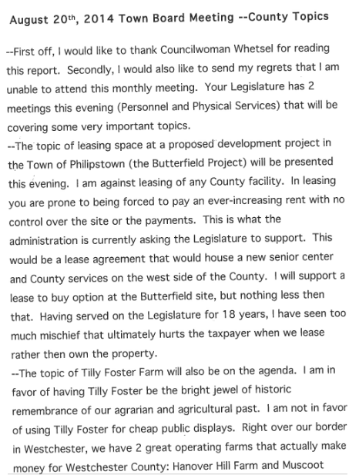
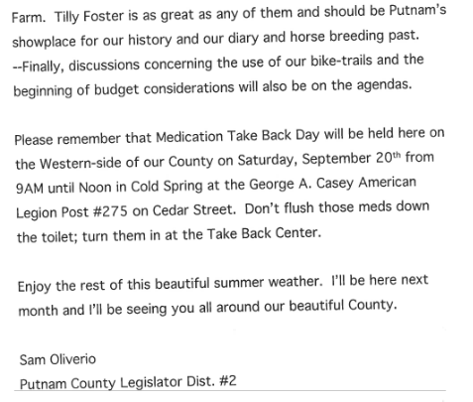

Approval of Town Board Minutes

Presented by Deputy Supervisor Annabi

RESOLUTION #R 14- 234

RESOLVED, that the Town Board approve the Town Board minutes of July 9 and July 16, 2014.

Seconded by Councilman Mackay, unanimously carried.

AUTHORIZE BAN RENEWAL FOR HIGHWAY EQUIPMENT

Presented by Councilman Mackay

RESOLUTION #R 14- 235

RESOLVED, that the Town Board authorize the BAN renewal to replace a loader and one ton dump truck which the Highway Department will go out to bid for. This equipment can be purchased for under $200,000.

Seconded by Councilwoman Whetsel, unanimously carried.

REVIEW AND DISCUSS PRINCETON HYDRO 2014 LAKE PEEKSKILL WATER QUALITY MONITORING REPORT

Discussion:
Andrea O’Brien, a resident of Lake Peekskill is upset that there are no signs on the bridge to warn the people fishing that they should not eat the fish they catch. Signage needs to be placed there. She also wanted the Town Board to know that she sat on the Park & Recreation Committee for 22 years in the Town of Cortlandt prior to moving to Putnam Valley. The condition of Lake Peekskill is an emergency; we need to get NYS, Putnam County and/or the federal government involved. Our drinking water is unsafe; we need to get a committee together to investigate the lake situation.

RESOLUTION ON PROPOSED LOCAL LAW TO AMEND CHAPTER 120 OF THE TOWN CODE-WEST SHORE DRIVE

Presented by Deputy Supervisor Annabi

RESOLUTION #R 14- 236
LOCAL LAW # 1-2014

A LOCAL LAW to amend Chapter 120 (“Vehicles and Traffic”) of the Town Code of the Town of Putnam Valley (“Town Code”) in respect to parking on West Shore Drive, a Town highway.

BE IT ENACTED by the Town Board of the Town of Putnam Valley as follows:

(1) Section 120-03 of the Town Code be and is hereby amended so as to add the following street and location to the list of streets on which parking is prohibited throughout the entire year:

Street Location

West Shore Drive East side along frontage of Hilltop Beach District property (Tax Map 62.14-2-2). Exception – Parking is permitted for one passenger vehicle operated by the lifeguard- on-duty. An identification tag shall be displayed by the lifeguard on the vehicle dashboard when the vehicle is so parked.

(2) This Local Law shall take effect upon its filing with the New York State Secretary of State.

Dated: Putnam Valley, New York
August 20, 2014

Seconded by Councilman Luongo

ROLL CALL VOTE
Councilman Luongo- Aye
Councilman Mackay- Aye
Councilwoman Whetsel- Aye
Deputy Supervisor Annabi- Aye

Motion carried with four ayes- Supervisor Tendy absent

RESOLUTION ON PROPOSED LOCAL LAW TO AMEND CHAPTER 165 OF THE TOWN CODE (ZONING) SO AS TO EXCLUDE UNDERWATER LAND IN CALCULATING LOT AREA, MINIMUM OPEN AREA OR FOR ANY SETBACK PURPOSES

Presented by Deputy Supervisor Annabi

RESOLUTION #R 14- 237

LOCAL LAW # 2- 2014

A LOCAL LAW to amend Chapter 165 of the Town Code of the Town of Putnam Valley (“Zoning”) so as to exclude underwater land in calculating Lot Area, Minimum Open Area, and Front, Rear, Side Yard, and Lakefront setbacks.

BE IT ENACTED by the Town Board of the Town of Putnam Valley as follows:
(1) A new subsection “D” shall be added to Section 165-10 of the Town Code, reading as follows:
“D. Where a deed describes a Lot as bounded by a lake, pond, river, stream
or brook, underwater land beyond said shoreline shall not be included in the
calculation of Lot area, Minimum Open Area, or for any Setback purposes.”

(2) This Local Law shall take effect upon its filing with the New York State Secretary of State.

Date: Putnam Valley, New York
August 20, 2014

Seconded by Councilman Luongo

ROLL CALL VOTE
Councilman Luongo- Aye
Councilman Mackay- Aye
Councilwoman Whetsel- Aye
Deputy Supervisor Annabi- Aye

Motion carried with four ayes- Supervisor Tendy absent

REQUEST WAIVER OF CIVIL PENALTY- GANNON/ROMERO

Presented by Deputy Supervisor Annabi

RESOLUTION #R 14- 238

RESOLVED, that the Town Board waive the Civil Penalty imposed on William Gannon and Diana Romero TM#83.8-1-8 in regard to legalizing a finished basement that existed when they purchased their home.

Seconded by Councilman Mackay, unanimously carried.

REQUEST WAIVER OF CIVIL PENALTY- CERQUEIRA

Presented by Deputy Supervisor Annabi

RESOLUTION #R 14- 239

RESOLVED, that the Town Board waive the Civil Penalty imposed on Jose Cerqueira TM#42.-3-12, in regard one car garage with covered deck and finished basement.

Seconded by Councilman Mackay, unanimously carried.

REQUEST WAIVER OF CIVIL PENALTY- DISANZA-CASSIDY

Presented by Deputy Supervisor Annabi

RESOLUTION #R 14- 240

RESOLVED, that the Town Board waive the Civil Penalty imposed on Ronald DiSanza and Betty Cassidy TM# 83.66-2-29, for replacing an existing deck without the necessary permits.

Seconded by Councilman Mackay, unanimously carried.

PARKS & RECREATION REFUNDS

Presented by Councilman Luongo

RESOLUTION #R14- 241

RESOLVED, that the Town Board approve the following refunds:

Thomas Cobelli $110.00
41 Avon Road LaCrosse Camp
Lake Peekskill, NY 10537 Cancelled

Ronald Freyer $110.00
7 Shawnee Road LaCrosse Camp
Putnam Valley, NY 10512 Cancelled

Lihua Song $110.00
52 School St. LaCrosse Camp
Cortlandt Manor, New York 10567 Cancelled

Jane DeTorres $110.00
468 Peekskill Hollow Road LaCrosse Camp
Putnam Valley, NY 10579 Cancelled

Maria Russo $135.00
9 Heather Lane Cheerleading Camp
Putnam Valley, NY 10579 Unable to attend

Shari Heyen $70.00
26 B Pecoho Road Swim Lessons
Lake Peekskill, NY 10537 Unable to attend

Seconded by Councilman Mackay, unanimously carried.

PARKS & RECREATION- PERSONNEL APPOINTMENTS

Presented by Councilman Luongo

RESOLUTION #R14- 242

RESOLVED, that the Town Board approve the following additions/changes to personnel:

- Samantha Cunningham, Cheerleading Ass’t. @ $310.00 for week #1. (Amended from last month’s personal)
- Amana Hess, Cheerleading Ass’t., @ $300.00 for week #2.
- Kaitlyn Johnson, Cheerleading Ass’t. @ $300.00 for week #2.
- Jenna Leonard, Cheerleading Ass’t. @ $300.00 for week #2
- Ariana Maucieri, Cheerleading Ass’t. @ 1843.36 for week #2.
- Regina Albano, Cheerleading Ass’t., @ 548.00 for week #2.
- Joseph Natalie, Baseball Camp Supervisor, @ $1300.00 for camp.
- Edward Lent, Baseball Camp Ass’t. @ $230.00 for camp.
- Elviz Belen, Baseball Camp Ass’t. @ $135.00 for camp.
- Zachary Girvalo, Baseball Camp Ass’t. @ $100.00 for camp.
- Jim Magrone, Men’s Softball League coordinator, @ $400.00 for season.
- Young Tran, Summer Volleyball Coordinator, @ $375.00 for season.
- Travis McCarty, Basketball Camp Coordinator, @ an additional $5548.54 for season, based on amount of money brought in.
- Craig Glenn, Intramural Camp, @ $4,533.49 for camp.
- Mick Coleman, Intramural Camp, @ $4,533.49 for camp.
- Shawn Tarkenton, Intramural Camp, @ $4,533.49 for camp.
- Michael LaScala, Strength Training Camp, @ $1,000.00 for camp.
- Chris Moljo, Strength Training Camp, @ $1,000.00 for camp.
- Demetria Andritsopoulos, Strength Training Camp, @ $300.00 for camp.
- Matt Mello, Strength Training Camp, @ $500.00 for camp.
- John Moljo, Strength Training Camp, @ $5640.00 for camp.
- Nick Lenhard, Girl’s Basketball Camp, @ $1318.00 for camp.

Seconded by Councilman Mackay, unanimously carried.

Building Department Report

Presented by Councilman Mackay

RESOLUTION #R 14-243

RESOLVED, that the Town Board accept the July Building Department Report.

Seconded by Councilman Luongo, unanimously carried.

LAKE PEEKSKILL REPORT

NO REPORT

DISCUSSION ON SPEED BUMPS ON BEACH ROADS-LAKE PEEKSKILL

Deputy Supervisor Annabi noted that Tim Barnes, a resident had given a lot of information on speed bumps to the Town Board in July.

Larry Cobb, Highway Superintendent suggested that a cement island be put in the middle of North Beach parking lot as a deterrent for the cars to do donuts. He is not in favor of speed bumps. He reached out to other Highway Superintendents and they are also not in favor of them, there are a lot of issues with them, one being lawsuits. He also added that if a resident sees someone speeding they should get their license plate and call the sheriff.

Tim Barnes feels that lake communities need separate attention in regard to signage. Our roads are narrow and children are walking along side of the roads. We have asked for the sheriff to come and issue radar, instead they sit down at the Indian Church to ticket drivers on Oscawana Lake Road. We are asking the Town Board to put pressure on the Sheriff to go into Lake Peekskill and ticket the speeders.

Deputy Supervisor Annabi noted that the Sheriff’s Dept. only has one car on this side of the County. She also noted that we can’t do speed bumps on Lake Drive or Northway, need to find other options.

Councilman Luongo replied that maybe the Sheriff’s Department can help us get a handle on this situation.

Highway Superintendent Cobb also asks resident to trim their hedges that are overgrown.

Andrea O’Brien, Lake Peekskill resident noted that other police agencies have radar that takes pictures of license plates.

A resident noted that there is no reason for anyone to follow the law if there is no enforcement. We would like the Sheriff’s Department to give us three days in Lake Peekskill, their presence will help.

Tim Barnes also would like the lights at the North Beach basketball courts turned off, they are an annoyance. He also suggested moving the gate at North Beach up to the Community Center.

Deputy Supervisor Annabi told the residents that the Town Board will have to do a lot of research into finding solutions to the speeding, the lights at North Beach and moving the fence. There are no trespassing signs down at North Beach, we will have to look into why the Sheriff is not ticketing those who are trespassing.

Dawn Powell wants better communication between the town and the residents. When there was a health emergency situation only the lake front owners received mail. There are other residents who use the lake who do not live lakefront.

Deputy Supervisor Annabi noted that on all the gates at the beaches signs were posted about the beach being closed. It has also been in the newspapers and yes a mailing was sent to all of the lakefront residents. We will have to look into other ways to get out the message.

Andrea O’Brien, resident suggested doing a town wide email.

DISCUSSION ON LAKE PEEKSKILL LAKE WATER QUALITY AND DISCUSSION ON POSSIBLE AERATION AND OTHER MEASURES

Deputy Supervisor Annabi told the residents that the Town Board is looking into a lot of different ideas to help the lake, still getting a lot of information.

PUBLIC COMMENTS

Deputy Supervisor Annabi announced that Town Day is on September 20th. There will be a parade from Town Hall to the Town Park with floats. There will be Llamas, rides on the fire truck, carnival rides, vendors, food and fireworks at 9:15 p.m. If anyone would like to be a vendor they can contact Deputy Supervisor Annabi at Annabi@pvtb.com or call 845-721-4182.

Tim Barnes a resident of Lake Peekskill would like the vendors not to sell weapons of destruction to the children.

Deputy Supervisor Annabi replied that she is not sure she can tell the vendors what they can sell but will ask them.

Councilman Mackay recommended a visit to Niese Farm on Saturdays and Sundays. They serve breakfast from 9:00 a.m. to 1:00 p.m. and the store is open until October.

Budget Transfer and Amendments

Presented by Deputy Supervisor Annabi

RESOLUTION #R 14- 244

RESOLVED, that the Town Board approve the following budget transfers and amendments as submitted by bookkeeper Marianne DeSantis:

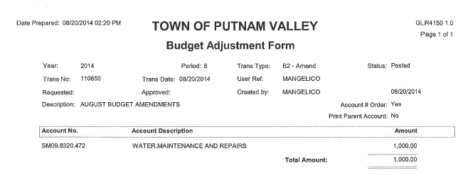
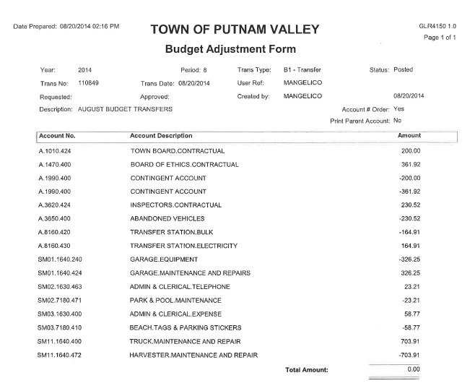

Seconded Councilman Mackay, unanimously carried.

Audit of Monthly Bills

Presented by Deputy Supervisor Annabi

RESOLUTION #R 14- 245

RESOLVED, that the Town Board approve the following bills, after audit, being paid:

VOUCHER NUMBERS AMOUNTS
8405-8408, 8416-8437,
8473-8497, 8507-8522,
8524, 8586-8598
8613-8619, 8622-8625,
8627, 8629-8642,
8658-8662 $292,341.90
8506, 8674-8693, 8695,
8698, 8700, 8702-8704,
8706-8707, 8721, 8736,
8755-8771 $51,535.69
8345-8361, 8364-8365,
8456-8472, 8526-8527,
8545, 8599-8607, 8621,
8663-8673, 8708 $90,038.04
8546-8560, 8562,
8569-8585, 8688, 8694,
8696-8697, 8699, 8701
8705, 8709-8720, 8766 $44,887.23

Seconded by Councilman Luongo, unanimously carried.

Deputy Supervisor Annabi motioned to go into Executive Session at 8:10 p.m. to discuss W.J. Holdings litigation and to see legal advice from Town Counsel with no further business taking place.

Seconded by Councilman Luongo, unanimously carried.

Respectfully submitted,

Eileen Royael
Town Clerk 8-21-14

