PUTNAM VALLEY TOWN BOARD

REGULAR MEETING

7:00 P.M.

WEDNESDAY, AUGUST 19, 2015

- Pledge of Allegiance
- Supervisor’s Opening Comments
- Discuss Amnesty/Penalty Fees- TABLED FROM 7-15-15
- County Legislator’s Report
- Certificates Of Appreciation- Thad & Mary Gifford-Smith-Camp Combe And Eagle Scout –James Gummerson
- Approval of Town Board Minutes

DEPARTMENTS
- Parks & Recreation
  - Refunds
  - Personnel
- Building Department Report
  - Report for July
- Districts
  - Lake Peekskill
      - Lake Peekskill Report
      - Resolution to Set Aside Areas at Lake Peekskill-Carraras Beach for Boat Storage
- Public Comments
- Budget Transfers & Amendments
- Audit of Monthly Bills
PUTNAM VALLEY TOWN BOARD
REGULAR MEETING
7:00 P.M.
WEDNESDAY, AUGUST 19, 2015

PRESENT: Supervisor Tendy
Councilwoman Annabi
Councilwoman Whetsel
Councilman Mackay

ALSO PRESENT: Deputy Town Clerk Rau
Town Counsel Florence

ABSENT: Councilman Luongo

Supervisor Tendy opened the meeting at 7:01 p.m.

AMENDMENTS TO THE AGENDA

Presented by Supervisor Tendy

RESOLUTION #R 15 -225

RESOLVED, that the Town Board amend the agenda to reflect the following:
#5- Thad and Mary Gifford-Smith were unable to attend
Add- Executive Session at the end of the meeting to discuss contractual matters.

Seconded by Councilwoman Annabi, unanimously carried.

Supervisor’s Opening Comments

Supervisor Tendy read from a 1904 Putnam Valley newspaper.

Councilman Mackay asked if he could make a few comments. He read the following statement:

“We need to have a much broader discussion of our budget. Every year I ask that we tell each department to start with last year budget number and minus 5% and that will be the starting point for this year. Document your department needs to exceed that number. I want to be very clear that I have the up most respect for our managers and the job they are doing. I don’t think for one minute they are wasting money, but, I don’t know that we can do more with less. We can and must work smarter.

Our cap is at .73%, will we be able to make it? I honestly don’t think so. This tax cap is totally unrealistic but we must try to get as close as we can so as to limit the tax increase and how much we take from fund balance.

We have had this discussion in the past when we have non-union new hires for departments. I believe we all agreed that no one comes in at what the previous manager left at. So, in that line I am proposing we reduce the supervisor line to say $55,000 and the Town Clerk line to $45,000. Last year we hired two new employees and we didn’t bring them in at the higher level. I don’t think I am hard and fast with those numbers we can talk about this but I believe this must be done.

The Town Board is a part time position. We have other part time positions but the town board is the only one that is entitled to benefits, ie. Health and NY State Pension.

I am proposing we eliminate the benefits for all town board members. Folks it’s part time and this is not why we ran for office. We need to show the taxpayers we are serious about spending. I don’t know who passed this and I don’t care. I do know that this is wasted taxpayer money and as a taxpayer this perk makes me very mad. Quite frankly you all don’t deserve this and to answer anyone’s question, no, I don’t receive any benefits from the town. One pension I feel is enough and I deplore those who keep taking advantage of the system.

I think we need to have a very serious discussion on these points and when we are done; I believe you will see that these actions must be done now. We cannot continue to do business as usual.”

Discuss Amnesty/Penalty Fees

Supervisor Tendy explained that Building Inspector Quaglietta would like to bring in an amnesty program for building violations. Currently the 2015 fee schedule states “The fee for permits for work undertaken and/or completed prior to the obtainment of a building permit shall be double the otherwise applicable fee, but not less than $500” Building Inspector Quaglietta thinks that creating an amnesty program for existing violations will encourage people to come forward and clear up their violations which will help them when they sell their homes.

Councilman Mackay asked if this is different from what the Town Board has been doing.

Supervisor Tendy replied that those are only used in certain cases like when a person buys a home, then sells it and the new owner discovers violations from the original owner. This is about fixing violations on properties unrelated to sales.

Councilwoman Annabi wanted to know what time period this amnesty would be for.

Supervisor Tendy replied that the fee is set every January so this would be for 2016. He believes it’s a good idea and that it can’t hurt to try. He thinks the board should discuss it more with Rich.

County Legislator’s Report

County Legislator Gouldman spoke about the unclaimed funds event held at the Putnam Valley Library in July. He said it was very successful and because of this success, there will be a second event next spring. In the meantime, if anyone wants help determining if they have unclaimed funds, they can contact him at William.goudlman@putnamcountyny.gov. In September, the traveling Vietnam Wall will be coming to Putnam County Veteran’s memorial park.

County Legislator Gouldman also spoke about two more events he will be holding at the Putnam Valley Library. On September 30 from 7-8 pm there will be a credit card fraud workshop and on October 10 from 10-12 there will be a free child safety program.

Patty Villanova, a town resident, asked County Legislator Gouldman if there was an update on a proposal she made to the Rules committee. The proposal was to waive the licensing fees for plumbers and contractors in Putnam County over the age of 65.

County Legislator Gouldman replied that the law department and Ways and Means are looking into it. Currently, the application does not have a space for age so there is no way to know if applicants are over 65.

County Legislator Gouldman replied that he would rather base it on income and told Ms. Villanova to come to the next Rules committee meeting.

County Legislator Scuccimarra said this month protective services reviewed the sheriff sub station in town, which is in dire need of repair. As of now, the sheriff and highway department is surveying the property and will give a list of priorities to the county to work on the property.

County Legislator Scuccimarra stated that a concerned constituent approached her about the accidents at Church Road and Oscawana Lake Road. She said that she is thinking about adding a flashing yellow traffic light.

Supervisor Tendy said the Town had asked the state to reduce the speed on part of Oscawana Lake Road and they didn’t. We’ll need to contact the state for this, but he has no problem with it.

Councilwoman Annabi said that the four-way stop sign at Wood Street and Bryant Pond Road took years and a lot of letters to get. Hopefully we can get something.

County Legislator Scuccimarra said that tomorrow, Thursday August 20, Senator Chuck Schumer will be in Cold Spring advocating for increased access to the river. Right now, there aren’t a lot of ways to get on to the river. There will also be a new Cold Spring Shuttle route from Cold Spring to Beacon, stopping at hiking locations between the two Main Streets.

County Legislator Scuccimarra is also excited about a bill before the state senate, proposed by Senator Serino called the Care Act. This act is for when you have someone in the hospital. The hospital would have a designated caregiver for the patient and the hospital would educate that person on how to care for them when they return home.

Lastly, she spoke about the latest environmental concern: microbeads. They are found in care products like toothpaste. They used to be natural but are now made of plastic and are staying in the waterways. Eric Schneiderman, New York State Attorney General is calling for a ban of microbeads and Councilwoman Scuccimarra thinks we should take that on.

Certificates Of Appreciation

Councilwoman Annabi presented a Certificate of Appreciation to Eagle Scout James Gummerson of troop 3165 out of Yorktown. He cleaned up Lawson Cemetery, planting flowers, laying granite grave markers, and paving the walkways. It can be viewed on the Putnam County website under Putnam County gravesites or on Facebook under James Eagle Scout.

Mr. Gummerson thanked the town for his certificate and said he would be going away to college soon and was looking for volunteers to help maintain the cemetery in his absence.

Approval of Town Board Minutes

Presented by Supervisor Tendy

RESOLUTION #R 15 -226

RESOLVED, that the Town Board approve the minutes of July 8 and July 15, 2015.

Seconded by Councilman Mackay, unanimously carried.

Parks & Recreation Refunds

Presented by Councilman Mackay

RESOLUTION #R 15 -227

RESOLVED, that the Town Board approve the following refunds:

Gabrielle Sandomir $135.00
38 Pembrooke Ct Intramural Camp
Putnam Valley, NY 10579 Family Emergency

Adam Nolan $135.00
2 Putnam Road Girls B’Ball Camp
Cortlandt Manor, NY 10567 Camp did not run

Charlene Pateman $100.00
68 Oak Ridge Drive Intramurals
Putnam Valley, NY 10579 Withdrawn from camp

Kelly Kerr $135.00
401 Lake Shore Road Cheerleading Camp
Putnam Valley, NY 10579 Medical Withdrawal

Carmel Sigmund $135.00
6 Stonefield Court Cheerleading Camp
Cortlandt Manor, NY 10567 Withdrawn

Madison Sherwood $135.00
70 Paulding Lane Cheerleading Camp
Crompond, NY 10517 Withdrawn

Danielle Busa $135.00
102 Bell Hollow Road Cheerleading Camp
Putnam Valley, NY 10579 Withdrawn

Mayra Bermeo $135.00
149 South Street Cheerleading Camp
Peekskill, NY 10566 Withdrawn

Tina Kurtenbach $85.00
21 White Hill Road Cheerleading Camp
Putnam Valley, NY 10579 Withdrawn

Eileen Fritz $135.00
45 Lincoln Road Girls Basketball
Putnam Valley, NY 10579 Camp Cancelled

Seconded by Councilwoman Annabi, unanimously carried.

Parks & Recreation Personnel

Presented by Councilman Mackay

RESOLUTION #R 15 -228

RESOLVED, that the Town Board approve the following additions/changes to personnel:

- Georgine Bagnato, PVCC Ass’t., @ $10.00 per hour.
- Elizabeth Stasiak, Rec. Ass’t. @ $10.00 per hour.
- Caitlyn Sigmund, Cheerleading Ass’t. @ $280.00 for 2 week camp.
- Jessica Wagner, Cheerleading Ass’t. @ $280.00 for 2 week camp.
- Antonia Hoyos, Cheerleading Ass’t., @ 280.00 for 2 week camp.
- Amanda Hess, Cheerleading Ass’t., @ $650.00 for 2 week camp.
- Samantha Bruno, Cheerleading Ass’t. @ $280.00 for 2 week camp.
- Jenna Leonard, Cheerleading Ass’t. @ $407.63 for 2 week camp.
- Ariana Maucieri, Cheerleading Instructor. @ $4556.06 for 2 week camp.
- Regina Albano, Cheerleading Instructor., @ $4524.43 for 2 week camp.
- Karen Brothers, Cheerleading Ass’t. @ $800.00 for 2 week camp.
- Amanda Yanarelli, Day Camp Sub. @ $7.68 per hour.
- Brian Fitzmaurice, Day Camp Sub. @ $7.68 per hour.

Seconded by Councilwoman Annabi, unanimously carried

Building Department Report

Presented by Councilwoman Whetsel

RESOLUTION #R 15 -229

RESOLVED, that the Town Board accept the July 2015 Building Department Report.

Seconded by Councilman Mackay, unanimously carried

Lake Peekskill Report

Councilwoman Annabi stated that all of the beaches are open. After there is Blue-green algae, we need to wait until the water is clear before the Health Department can test it. Residents can go online to the Town Website to see if their beach is open. There is also a link for community events- right now an upcoming event it the Lake Peekskill Tag Sale, which is open to everyone.

Set Aside Areas at Lake Peekskill-CARRARAS Beach for Boat Storage

Discussion

Councilwoman Annabi asked Town Counsel Florence to explain the proposed resolution.

Town Counsel Florence explained that the residents would like to officially use the sides of the beach for the boats and the central area for swimming.

Supervisor Tendy asked if this would need a public hearing.

Town Counsel Florence responded that he didn’t think so because it’s not a local law but it does create legal entitlements. He recommended having the hearing in October.

Presented by Supervisor Tendy

RESOLUTION #R 15 -230

RESOLVED, that the Town Board set a Public Hearing to hear public comments on the proposed resolution for the separation of swimming and boating at Carrera’s Beach in Lake Peekskill for Wednesday, October 14th at 6pm.

Seconded by Councilwoman Annabi, unanimously carried.

Public Comments

Dan Vera, a town resident made the following public comments:
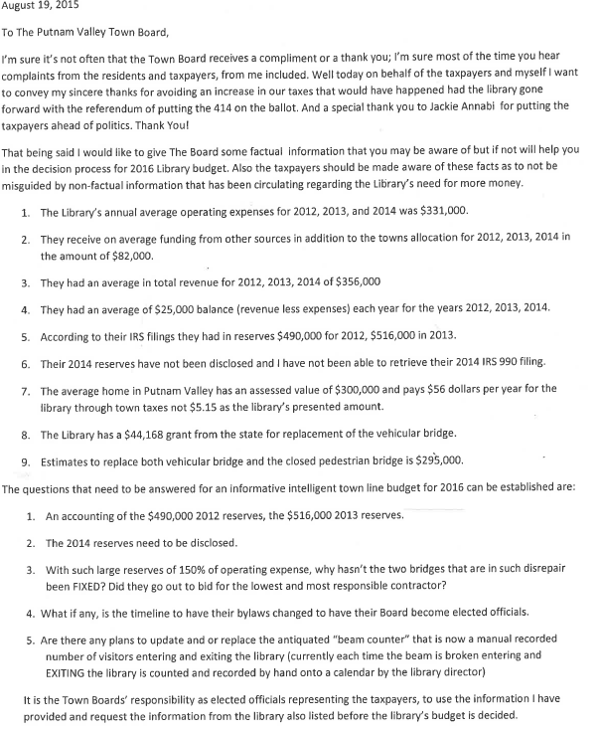

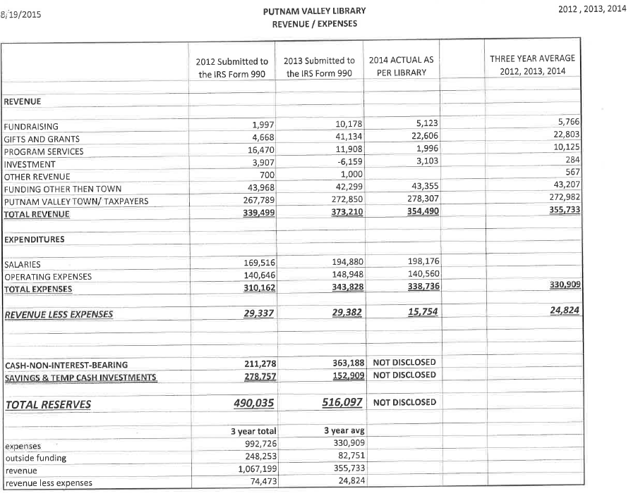
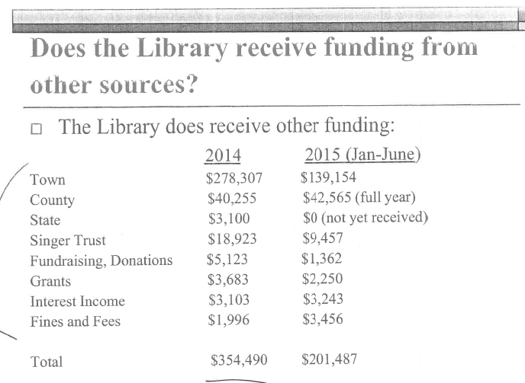
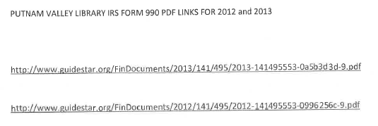

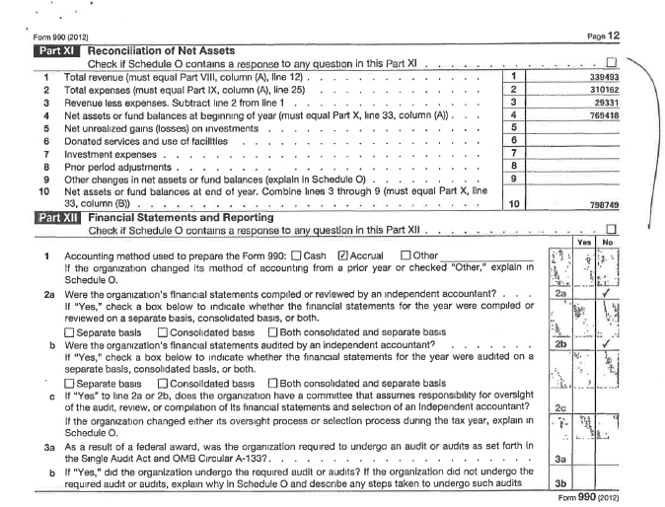

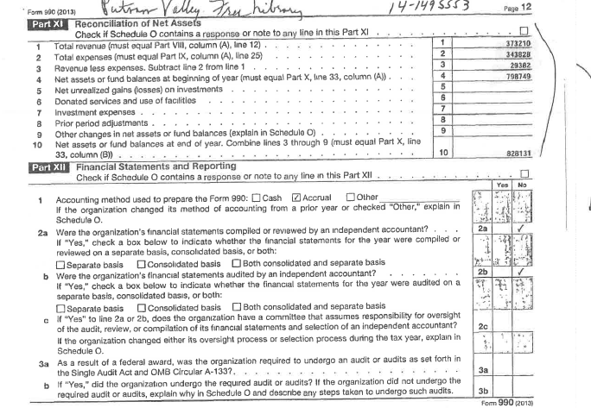
Sam Oliverio prefaced his comment with the fact that he is a friend of the family. He wanted to know who gave the authority to go to trial.

Supervisor Tendy replied the Town Board years ago.

Mr. Oliverio asked if the decision is in favor of the Cornu’s, would the Town continue litigation?

Supervisor Tendy replied that he cannot discuss ongoing litigation.

Mr. Oliverio asked the total cost of the litigation over the years and Supervisor Tendy replied that he could FOIL that.

Mr. Oliverio asked the Town Board to please let it go if it is decided in favor of the Cornu’s. We’re at a crossroads awaiting the ruling. When does it stop? When does the Town stop incurring such huge expenses?

Supervisor Tendy stated that we have to wait for the decision. The Town isn’t doing this because they want to incur expenses. These expenses were incurred as a direct result of the violations. The Town has made many good, fair and reasonable suggestions. We cannot discuss this any further.

Mr. Oliverio asked if the Lovers Lane Bridge could ever be open again.

Supervisor Tendy replied that the residents of Lovers Lane don’t want the bridge to reopen because it became a thoroughfare. The bridge will have to be dismantled or replaced. The Town hasn’t decided whether or not to replace the bridge.

Councilman Oliverio asked if the Town could call another meeting of the residents.

Supervisor Tendy agreed and said it can be brought up with the County Highway Department.

Patty Villanova stated that she recently found the minutes from the meeting Bob was talking about and said she remembers reading comments in favor of the bridge opening. The bridge closed before Bob was in office and he pursued opening it.

She added that she attended the Cornu trial and wanted to know when the litigation was authorized and if any of the Town Board members read the transcripts.

Ms. Villanova also congratulated Steve for what he said about the budget. She has another suggestion of doing more with what we have like greater efficiency with purchasing.

Lastly, she expressed her dissatisfaction with Bob as Supervisor and was happy that this would be his last term in office.

Councilwoman Annabi stated the Town Day would be on Saturday, September 19. There will be a lot of new vendors and great sponsors. If you would like to be a vendor, please email her at annabipvtb@gmail.com or call 845-526-2121.

Budget Transfers & Amendments

Presented by Supervisor Tendy

RESOLUTION #R 15 -231

RESOLVED, that the Town Board approve the following budget transfers and amendments as submitted by Finance Director Angelico:

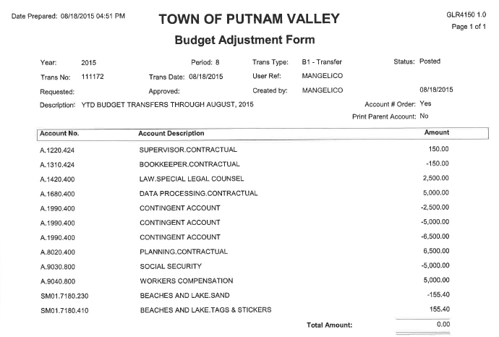

Seconded by Councilwoman Annabi, unanimously carried.

Audit of Monthly Bills

Presented by Supervisor Tendy

RESOLUTION #R 15 -232

RESOLVED, that the Town Board approve the following bills, after audit, being paid:

VOUCHER NUMBERS AMOUNTS
12395-12408; 12423-12430;
12461-12482; 12500-12517;
12597-12606; 12622-12647;
12655, 12659 $275,858.15
12448-12458; 12518, 12519;
12524, 12526, 12527, 12538;
12540-12570; 12665, 12666 $21,474.80
12667-12676; 12695-12733 $79,073.57
12520-12523; 12525, 12528;
12529-12531; 12533-12537;
12571-12596; 12648-12658;
12660-12664 $91, 008.09

Seconded by Councilman Mackay, unanimously carried.

Supervisor Tendy moved to go into executive session at 8:05 PM to discuss contractual matters with no further business taking place.

Seconded by Councilwoman Annabi, unanimously carried.

Respectfully submitted,

Patricia Rau
Deputy Town Clerk 8-24-2015

