PUTNAM VALLEY TOWN BOARD

REGULAR MEETING

7:00 P.M.

WEDNESDAY, JUNE 19, 2013

- Pledge of Allegiance
- Supervisor’s Opening Comments
- Discuss Permit Fee Waiver-Cantamessa –
Tabled 5-15-13
4. Hudson River Estuary Flooding Project Update-Diane
Olsen
5. Present Certificate of Appreciation-Eagle Scout M.
Monaghan
6. County Legislator’s Report
7. Approval of Town Board Minutes
8. School Report
9. Reject Bid Proposal-Town Hall Addition
10. Request Permission to Go Out to Re-Bid Town Hall
11. Request Waive Civil Penalty-A. Pagano

DEPARTMENTS
12. Parks & Recreation
a. Refunds
b. Award Town Park Maintenance Building Architectural
Contract and Authorize Supervisor to Sign Contract-
Brian Shook Construction

13 . Building Department
a. Report for May

DISTRICTS
14 a. Lake Peekskill
1. Lake Peekskill Report
2. Appoint Beach Monitors

15. Public Comments
16. Budget Transfers & Amendments
17. Audit of Monthly Bills

PUTNAM VALLEY TOWN BOARD

REGULAR MEETING

7:00 P.M.

WEDNESDAY, JUNE 19, 2013

PRESENT: Supervisor Tendy
Councilwoman Whetsel
Councilwoman Annabi
Councilman Mackay
Councilman Luongo

ALSO PRESENT: Town Clerk Eileen Royael
Town Counsel Zutt

Supervisor Tendy opened the meeting at 7:00 p.m.

AMENDMENTS TO THE AGENDA

Presented by Supervisor Tendy

RESOLUTION #R 13- 217

RESOLVED, that the Town Board add the following amendments to the agenda:

Add two Executive Session one in beginning of meeting to discuss contractual matter with NYSP and Teamsters Retroactive pay. Second Executive Session will be at end of meeting to discuss personnel matter and pending litigation PV vs. Adorno and PV vs. Kasper.

#4a Drug Use in Putnam Valley- Putnam County Chief Criminal Investigator Schramek
#5a Present Certificate of Appreciation- J. Burruano-20 years of Service PVES
#12c Discussion on the Putnam Valley Free Library Bridge Inspection
#13b Appoint Gas Inspector-John Landi

Seconded by Councilwoman Annabi, unanimously carried.

SUPERVISOR’S OPENING COMMENTS

Supervisor Tendy told the residents that he was sorry to learn that Lillian Feeney, former Town Clerk and Tax Collector from 1972-1980 passed away. Mrs. Feeney served the Town of Putnam Valley for 30 years as Town Clerk, Tax Collector, and Part-time Secretary to the Supervisor, Clerk to the Zoning Board, Court, Highway Superintendent, Police Department and Building Inspector. The “Reporter Dispatcher” named her “Putnam Valley’s Mrs. Town Hall” in 1977. Supervisor Tendy sends the family his and the Town Board’s condolences on the loss of Mrs. Feeney.

Supervisor Tendy motioned to go into Executive Session at 7:12 p.m. to discuss contractual matters in regard to NYSP and the Teamsters Retroactive pay.

Seconded by Councilwoman Annabi, unanimously carried.

Meeting resumed at 7:31 p.m.

DISCUSS PERMIT FEE WAIVER-CANTAMESSA

Building/Zoning Inspector Landi noted that this structure was erected without a permit, the former Building Inspector received complaints in 2008 and the owner promised to submit a survey, there was no follow up and no survey was received. The homeowner did not do what was requested by the Building Dept.

Councilwoman Annabi would like to Town Board to review what the Building Dept. has on this parcel.

Town Counsel Zutt replied that we need a survey, as the survey given was inadequate, it just shows the house and we require a survey with the structure. Need to request a survey now.

Supervisor Tendy suggested to take this item off the agenda in order to get more information for the Town Board to review, put on July’s agenda.

HUDSON RIVER ESTUARY FLOODING PROJECT UPDATE-DIANE OLSEN

Diane Olsen from Cornell Cooperative Extension spoke about the Hudson River Estuary Flooding Project. She noted that back in December the NYS DEC tried to develop information on how towns in the Hudson Valley deal with storms and flooding. There is a seminar on the 2012 changes to the National Flood Insurance Program, an overview of the benefits of the Community Rating System. This seminar will be held at the East Fishkill Town Hall in Hopewell Junction on July 17, 2013, 6:30-8:30 p.m. Over the past decade there have been instances of heavy rain fall and it is getting more frequent. Our streams cannot handle these storms and we are trying to get education and information gathered as this will be a long term project.

DRUG PROBLEM

Putnam County Chief Investigator Schramek told the residents that he was here representing Sheriff Smith, who sends his best wishes. He is here to talk about a major drug problem in Putnam County. There has been an increase in drug abuse and drug trafficking. The County is utilizing all of their resources to fight this problem. The county has seized drug money and vehicles involved in drug trafficking. They work very closely with multiple agencies and cannot at this time go into the specifics as we are still investigating. The County has concentrated the efforts in the Roaring Brook Lake and Lake Peekskill areas, but we need the public’s help in order to build cases against the drug peddlers. Residents can call 845-225-DRUG to report drugs; no one’s name will be used. The good news is that we are surrounded by compacted counties, Dutchess, Orange, Rockland and Westchester, and Putnam County has the lowest crime rate for the 3rd year in a row.

Supervisor Tendy noted that he has received many calls about drug peddling and the Sheriff’s Dept. has always followed up on those calls.

PRESENT CERTIFICATE OF APPRECIATION-EAGLE SCOUT M. MONAGHAN

Supervisor Tendy presented Michael Monaghan Jr. with a Certificate of Appreciation for reaching the rank of Eagle Scout. Michael’s Eagle Scout Project was done at the Senior Center; he fenced around the unsightly air conditioner units and beautified the gardens. The feedback from the seniors has been positive. On behalf of the Town Board, congratulations!

PRESENT CERTIFICATE OF APPRECIATION-JEANNE BURRANO

Supervisor Tendy presented Jeanne Burrano, who is now retiring from the Putnam Valley Central School District after twenty years of teaching, with a Certificate of Appreciation. Supervisor Tendy told Mrs. Burrano, the most important thing a teacher can do is make the child love to go to school and Mrs. Burrano did that. On behalf of the Town Board, congratulations!

Mrs. Burrano replied that she was blessed and honored to have children who loved learning.

COUNTY LEGISLATOR’S REPORT

County Legislator Oliverio told the residents that budget season has begun. The department heads has presented their budgets to the County Executive. We are confident that the budget will come in at 2% or lower. As far as the signage on the bike trails there will be a vote if the people want the signs or not. There is controversy between the County Executive and the Legislative Branch going on right now. The Putnam County Charter that was put together by County Legislator Oliverio’s father and Sheriff Smith’s father gave a balance of power, the County Executive cannot make decisions without the Legislative Branch. He also noted that the foreclosed properties are now with realtors and the prices are very reasonable. If anyone is interested in purchasing any of these properties, they can call the County and they can connect them with the realtors.

Councilman Mackay asked if the County could do the yard maintenance on those foreclosed properties.

County Legislator Oliverio responded that it is on the list to be done.

APPROVAL OF TOWN BOARD MINUTES

Presented by Councilman Luongo

RESOLUTION # R 13 - 218

RESOLVED, that the Town Board approve the Town Board Minutes of May 8 and May 15, 2013.

Seconded by Councilwoman Annabi, unanimously carried.

SCHOOL REPORT

Supervisor Tendy noted at the Board of Education meeting on June 20th, Dr. Frances Wills will be appointed Interim Superintendent of Schools, effective August 1st. Dr. Wills comes to us with twenty-two years of Superintendent experience, having spent sixteen of these years in the Briarcliff Manor Union Free School District. Dr. Wills has also served as a teacher, assistant principal, and principal, director of curriculum and university professor. Most recently Dr. Wills was charged with creating a Professional Development Center at Pace University School of Education. We believe that Dr. Wills will be an instructional asset to our wonderful school district. Please join us in welcoming Dr. Frances Wills to Putnam Valley! He added that school is out on Friday, congratulations to the graduates and please have a safe prom night.

Councilman Mackay added that a congratulation go out to the Girls’ Varsity Lacrosse Team- as they make it to the NYS Final 4.

REJECT BID PROPOSAL-TOWN HALL ADDITION

Presented by Councilwoman Annabi

RESOLUTION # R 13 - 219

RESOLVED, that the Town Board reject the bid proposal from Aphrodite Construction in the amount of $825,000 for the proposed Town Hall Addition. The town only received one bid and it is in the best interest of the town to rebid this project to allow for comparisons.

Seconded by Councilman Luongo, unanimously carried.

REQUEST PERMISSION TO GO OUT TO RE-BID TOWN HALL ADDITION

Presented by Councilwoman Whetsel

RESOLUTION # R 13 - 220

RESOLVED, that the Town Board authorize the Facilities Department to re-bid the proposed Town Hall addition project.

Seconded by Councilman Mackay, unanimously carried.

REQUEST WAIVE CIVIL PENALTY-A. PAGANO

Discussion

Mr. Pagano explained that he recently purchased a home in Putnam Valley at 18 Apple Lane. He purchased this property that was poorly renovated without a building permit. When he purchased this property he was aware that there were neither permits nor a Certificate of Occupancy. He hired an architect and met with the Building Inspector prior to closing to assure that he could bring this property up to code and receive a C of O. When he appeared before the Zoning Board to obtain a variance he was charged a Civil Penalty. He also was charged $5900 for a building permit due to the previous owner renovating without a permit. He asked the Town Board to waive the Civil Penalty and to consider reducing the building permit fee, which he was charged double due to the previous owner. He would like his money refunded.

Town Counsel Zutt explained to the Town Board that the approval of the variance is contingent on the Town Board waiving the Civil Penalty Fee.

John Landi, Building/Zoning Inspector added that Mr. Pagano knew prior to purchasing this property that the work was done with no permits, so the fee is doubled. Our fee schedule clearly states $500 minimum penalty or double the building permit fee.

Town Supervisor feels that Mr. Pagano is trying to make everything right.

Mr. Pagano told the Town Board that he has done everything that the Building Department has asked him to do and he was told that the minimum penalty would be $500 not $3900, he would like the Town Board to waive this penalty imposed by the Building Dept.

Town Counsel Zutt noted that the Town Board has never waived this type of penalty except for a tax exempt agency or a town hall related project.

Councilwoman Annabi added that he got double charged because of a violation the prior owner had.

Councilman Mackay asked why Mr. Pagano is being charged double when he was not the one who built it?

Town Counsel Zutt replied that unfortunately, the fee structure is in place and if you waive this penalty you would have to look at all of the others. The Town Board may want to consider a mid-year correction of the fee schedule and add a line that this would not apply to people who do not do the construction without a permit.

John Landi, Building/Zoning Inspector does not agree that there should be a correction; it will open a can of worms. Mr. Pagano already paid the penalty for the building permit.

The Town Board agreed to waive the Civil Penalty and decided that they will have to review the paperwork in regard to the Building Dept. fee and discuss again in July.

WAIVE CIVIL PENALTY- A.PAGANO

Presented by Supervisor Tendy

RESOLUTION # R13-221

RESOLVED that the Town Board waive the Civil Penalty imposed by the Zoning Board on Anthony Pagano at 18 Apple Lane, Putnam Valley, New York as the work done on this property was performed prior to Mr. Pagano purchasing the property.

Seconded by Councilwoman Annabi, unanimously carried.

PARKS & RECREATION REFUNDS

Presented by Councilman Mackay

RESOLUTION #R13- 222

RESOLVED, that the Town Board approve the following refunds:

Sheri Horan $1,000.00
174 Church Road Day Camp
Putnam Valley, NY 10579 Unable to attend

Barbara Salese $100.00
7 Valerie Lane Day Camp
Mahopac, NY 10541 Overpaid

Maria York $60.00
45 Twilight Lane Lifeguard
Putnam Valley, NY 10579 Overpaid

Gary Bertram $525.00
914 Hudson Avenue Men’s Softball
Peekskill, NY 10566 Got a sponsor

Seconded by Councilwoman Annabi, unanimously carried.

AWARD TOWN PARK MAINTENANCE BUILDING ARCHITECTURAL CONTRACT AND AUTHORIZE SUPERVISOR TO SIGN CONTRACT-BRIAN SHOOK CONSTRUCTION

Presented by Councilman Mackay

RESOLUTION #R13- 223

RESOLVED, that the Town Board award the Town Park Maintenance Building Architectural Contract to Brian Shook Construction at the cost of $28,300 which was the lowest of the two bids, and;

BE IT FURTHER RESOLVED that the Town Board authorize the Town Supervisor to sign the contract with Brian Shook Construction.

Seconded by Councilwoman Annabi, unanimously carried.

DISCUSSION ON THE PUTNAM VALLEY FREE LIBRARY BRIDGE INSPECTION

Supervisor Tendy told the residents that upon inspection of the bridge at the library it has been found that there is damage to the bridge. The bridge will be closed until repairs are completed for the safety of the residents. He asked the library to put the dumpsters in front of the entrance to the bridge.

John Landi, Building/Zoning Inspector has requested that the highway department place cement blocks in front of the bridge.

Kathleen McLaughlin, Director of the library added that the bridge will be open for walking only.

BUILDING DEPARTMENT REPORT

Presented Councilman Mackay

RESOLUTION # R 13-224

RESOLVED that the Town Board accept the Building Department report for the month of May 2013, for filing with the Town Clerk.

Seconded by Councilman Luongo, unanimously carried.

APPOINT GAS INSPECTOR

Presented Supervisor Tendy

RESOLUTION # R 13-225

RESOLVED that the Town Board appoint John Landi, Building/Zoning Inspector for the Town of Putnam Valley as the designated Gas Inspector for the town, effective June 1, 2013. Mr. Landi will have all of the powers that the former Putnam County Gas Inspector had.

Seconded by Councilman Mackay, unanimously carried.

LAKE PEEKSKILL REPORT

Councilwoman Annabi reminded everyone that Family Day for Lake Peekskill residents will take place on August 3, 2013. The bridge will be painted by the boy scouts and the paint was donated by Wallauer ‘s.

APPOINT BEACH MONITOR

Presented by Supervisor Tendy

RESOLUTION # R13- 226

RESOLVED that the Town Board appoint Barbara Casabianca as Beach Monitor for the Lake Peekskill District for the 2013 Season at the rate of $8.25 per hour:

Seconded by Councilwoman Annabi, unanimously carried.

PUBLIC COMMENT

Members of the Putnam Valley Rotary are asking residents to join this organization. Their senior members have retired and they are looking for younger members to join. The Putnam Valley Rotary Club does a lot of great things in the community for over 40 years, they have provided scholarships to Camp Combe and college bound students. If anyone is interested in joining please call Diane at 845-528-1123.

Ted Muniak, President of the LPCA thanked Larry Cobb and the highway department for fixing the light so quickly. Lake Peekskill will have volunteers testing the lake this summer and he reminded Lake Peekskill residents that membership to the LPCA is $15.00, mail dues to P.O. Box 91, Lake Peekskill, NY and if anyone is interested in joining, call him at 845-528-5979.

Councilwoman Annabi added that the new flags will soon be flying.

BUDGET TRANSFERS & AMENDMENTS

Presented by Supervisor Tendy

RESOLUTION #R 13- 227

RESOLVED, that the Town Board approve the following budget transfers and amendments as submitted by bookkeeper Marianne DeSantis:
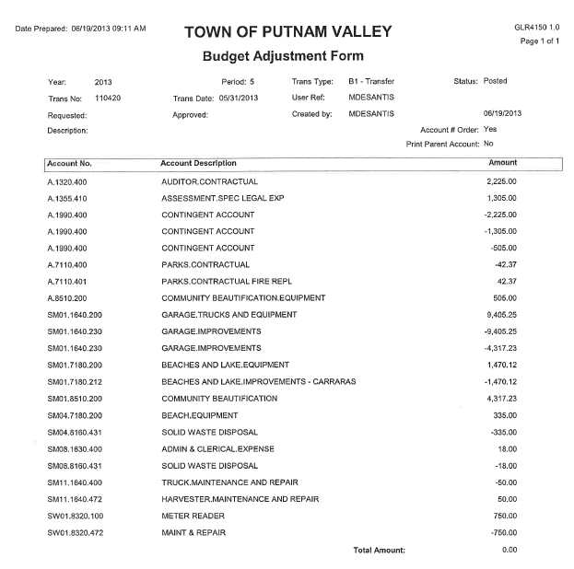
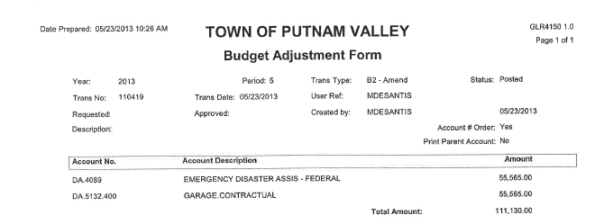
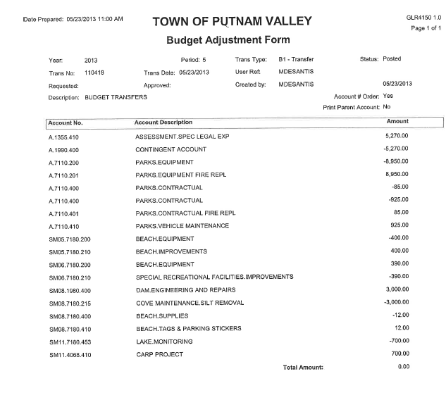
Seconded by Councilwoman Annabi

AUDIT OF MONTHLY BILLS

Presented by Supervisor Tendy

RESOLUTION # R 13- 228

RESOLVED, that the Town Board approve the following bills, after audit, being paid:

VOUCHER NUMBERS AMOUNTS

3518-3532, 3541-3555
3575-3580, 3585-3591
3593-3605,3614-3616
3618-3620, 3629-3636
3668-3671, 3673-3674,
3670-3702, 3710
3717-3723, 3725-3727
3729-3730, 3749-3750 $159,590.97
3257, 3592, 3759-3764
3836, 3838-3839, 3842
3844, 3849-3853, 3855
3857-3866, 3868, 3870
3873, 3878-3889, 3891
3894-3919, 3921-3946
3948 $121,066.54
3452-3455, 3492, 3493
3510, 3511, 3533-3540
3606-3613, 3617
3623-3628, 3653-3661
3666-3667, 3672, 3699
3703-3709, 3712-3715
3719, 3724, 3751-3756
3805-3806, 3835-3898 $84,667.00
3678-3697, 3765-3782
3799-3804, 3807-3817
3816-3817, 3867, 3869
3871, 3872, 3874-3877
3920, 3949-3951 $110,199.67

Seconded by Councilwoman Annabi, unanimously carried.

Supervisor Tendy motioned to go into Executive Session at 8:52 to discuss personnel matter and pending litigation PV vs. Adorno and PV vs. Kasper with no further business taking place.

Seconded by Councilwoman Annabi, unanimously carried.

Respectfully submitted,

Eileen Royael
Town Clerk 6-27-13

