PUTNAM VALLEY TOWN BOARD
WORK SESSION
6:00 P.M.
WEDNESDAY, MAY 8, 2013

WORK SESSION

1. Award Bid-Roaring Brook Lake Gate Valve Replacement
2. Amend Resolution # R12-351-Authorizing Expenditure for
Holiday Decoration
3. Discuss Permit Fee Waiver-Cantamessa
4. Amend Resolution #R13-178- Appointing Seasonal Laborer
5. Accept MIKAB Report-Cell Tower Piano Mountain
6. Review of 5-15-13 Agenda

PUTNAM VALLEY TOWN BOARD
WORK SESSION
WEDNESDAY, MAY 8,2013
6:00 P.M.

Present: Supervisor Tendy

Councilwoman Whetsel

Councilwoman Annabi

Councilman Mackay

Councilman Luongo

Also Present: Eileen Royael, Town Clerk

William Zutt, Town Counsel

Supervisor Tendy opened the Work Session at 6:01 p.m.

AMENDMENTS TO THE AGENDA

Presented by Supervisor Tendy

RESOLUTION #R 13- 184

RESOLVED, that the Town Board add the following amendments to the agenda:

Add Executive Session to discuss contractual matters
Add #5a Appoint Part Time Building Inspector
Add #5b Appoint Temporary Laborer to Highway Dept.
Add #5c Waive Building Permit Fees for new roof at the Putnam Valley Grange

Seconded by Councilwoman Annabi, unanimously carried.

AWARD BID-ROARING BROOK LAKE GATE VALVE REPLACEMENT

Presented by Supervisor Tendy

RESOLUTION #R 13- 185

RESOLVED, that the Town Board award the gate valve replacement at the Roaring Brook Lake Dam to Legacy Valve, LLC, 14 Railroad Ave., Valhalla, NY in the amount of $97,673.50.

Seconded by Councilman Mackay, unanimously carried.

AMEND RESOLUTION # R12-351-AUTHORIZING EXPENDITURE FOR HOLIDAY DECORATION

Presented by Supervisor Tendy

RESOLUTION #R 13- 186

RESOLVED, that the Town Board amend Resolution # R12-351 authorizing the expenditure of $554.00 with Display Sales, Inc., the holiday decoration was subsequently purchased from Rileigh’s Outdoor Décor at a lower sale price of $505.00.

Seconded by Councilwoman Mackay, unanimously carried.

DISCUSS PERMIT FEE WAIVER REQUEST-CANTAMESSA

Supervisor Tendy read Mr. Cantamessa’s letter to the Town Board members.

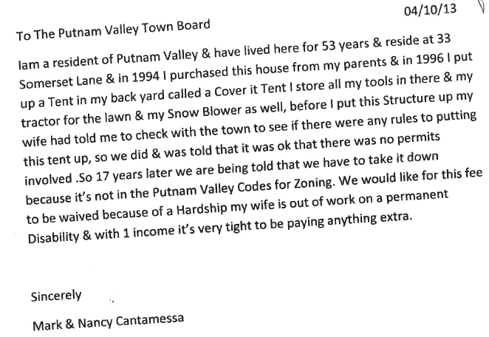

Mr. Cantamessa who resides at 33 Somerset is asking that the town waive the permit fee in regard to his permanent tent (Cover It Tent) that he put up in 1996, and is now not in compliance with the present Zoning Code.

Building/Zoning Inspector Landi informed the Town Board that in 2008 they were asked to come in and get a permit and a survey for this tent and they never did. The Building Dept. has received complaints from their neighbor in regard to Mr. Cantamessa doing body work on cars in this tent, Mr. Landi has pictures to document this. He added that before 1996 permits were required for this type of structure and he is not sure who told Mr. Cantamessa that no permit was required.

Town Counsel Zutt added that this is a pretty substantial building, and besides needing a permit they may need to seek a variance from the Zoning Board.

Councilwoman Whetsel asked how much the permit fee would be.

Building/Zoning Inspector Landi responded that he was not sure as of now.

Supervisor Tendy asked Mr. Landi to get a ball park figure on the permit fee cost by next week.

Town Counsel Zutt requested that the Town Board asked Mr. Cantamessa to submit a survey prior to the Town Board considering a waiver on the building department fee.

AMEND RESOLUTION #R13-178 APPOINTING SEASONAL LABORER-LAKE PEEKSKILL

Presented by Supervisor Tendy

RESOLUTION #R 13- 187

RESOLVED that the Town Board amend Resolution #R13-178 removing Devin Gallagher as a temporary laborer and appoint William Orsino as a temporary laborer for Lake Peekskill Improvement District at the rate of $11.44 per hour with no benefits, beginning April 22, 2013 and ending September 27, 2013.

Seconded by Councilwoman Annabi, unanimously carried.

ACCEPT MIKAB REPORT-CELL TOWER PIANO MOUNTAIN

Presented by Supervisor Tendy

RESOLUTION # R13-188

RESOLVED that the Town Board accept the December 11, 2012 MIKAB Report on the Cablevision Cell Tower located on Piano Mountain as all items have been corrected and documented.

Seconded by Councilwoman Annabi, unanimously carried.

APPOINT PART TIME BUILDING INSPECTOR

Presented by Supervisor Tendy

RESOLUTION # R13-189

RESOLVED, that the Town Board appoint William Bujarski as permanent part-time Building Inspector effective 4/3/13 at the rate of $28.00 per hour, with no benefits, not to exceed 17 ½ hours per week, and as permanent part-time Fire and Zoning Inspector at no additional salary.

Seconded by Councilwoman Annabi, unanimously carried.

APPOINT TEMPORARY LABORER TO HIGHWAY DEPT.

Presented by Supervisor Tendy

RESOLUTION # R13-190

RESOLVED, that the Town Board appoint Jeremy Whalen as a temporary highway laborer at the rate of $11.44 per hour with no benefits effective May 9, 2013. This appointment is to cover a full time employee who is out on worker’s compensation.

Seconded by Councilman Luongo, unanimously carried.

WAIVE BUILDING PERMIT FEE- PUTNAM VALLEY GRANGE REPLACEMENT ROOF

Presented by Supervisor Tendy

RESOLUTION # R13-191

RESOLVED, that the Town Board waive the building permit fee for the replacement roof at the Putnam Valley Grange located on the corner of Mill Street and Peekskill Hollow Road.

Seconded by Councilwoman Annabi, motion carried with four ayes, Councilwoman Whetsel recused herself.

REVIEW OF 5-15-13 AGENDA

Supervisor Tendy reviewed the 5-15-13 agenda with the Town Board members, no comments were made.

Supervisor Tendy motioned to go into Executive Session at 6:14 pm to discuss contractual matters in regard to the current Intermunicipal contract with the Town of Patterson and the Board of Assessment Review and the Teamsters Contract with no further business taking place.

Respectfully submitted,

Eileen Royael
5-9-13

