PUTNAM VALLEY TOWN BOARD

REGULAR TOWN BOARD MEETING

WEDNESDAY, MARCH 18, 2015

7:00 P.M.

REGULAR TOWN BOARD MEETING

AGENDA
      - Pledge of Allegiance
      - Supervisor’s Opening Comments
      - Certificate of Appreciation- S. Velichko & M. Bradfield
      - County Legislator Report
      - Recognition By Putnam Valley Chamber of Commerce
      - Future Plans of Parks & Recreation-F. DiMarco
7. Approval of Town Board Minutes
8. School District Report
9. Authorization to Go Out to Bid-Grass Cutting District
Properties
10. Discussion of Lifeguards
11. Discussion on Decommissioning & Demolition of
Building Lake Peekskill-NYC Aqueduct Connection

DEPARTMENTS
12. Highway
a. Award Truck Bid-Ford F350
13. Parks & Recreation
- Personnel Appointments
b. Refunds
14. Building Department
a. Report for February

15. DISTRICTS
A. Lake Peekskill
1. Lake Peekskill Report
2. Authorize Advertisement for Two Seasonal
Laborers
3. Authorize Advertisement for Beach Monitors
B. Lookout Manor
1. Authorize to Advertise for Seasonal District
Laborer
C. Oscawana Lake
1. Authorize to Advertise for Harvester Operators
D. Roaring Brook Lake
1. Authorize Advertisement for Lake Supt.
E. Wildwood Knolls
1. Adopt Wildwood Knolls Facilities Warrant
F. Barger Pond
1. Authorize to Advertise for Seasonal District
Laborer
16. Public Comment
17. Budget Transfers and Amendments
18. Audit of Monthly Bills

PUTNAM VALLEY TOWN BOARD
7:00 P.M.
REGULAR TOWN BOARD MEETING
WEDNESDAY, March 18, 2015

Present: Supervisor Tendy
Councilwoman Whetsel
Councilwoman Annabi
Councilman Mackay
Councilman Luongo

Also Present: Town Clerk Eileen Royael
Town Counsel Florence

Supervisor Tendy opened the Town Board Meeting at 7:00 p.m.

AMENDMENTS TO THE AGENDA

Presented by Supervisor Tendy

RESOLUTION #R 15-114

RESOLVED that the Town Board amend the agenda to add or remove the following:

Add Item#9a- Authorize Supervisor to sign Agreement with Richard Comi d/b/a The Center for Municipal Solutions
Remove Item 11- Discussion on Decommissioning & Demolition of Building Lake Peekskill- NYC Aqueduct Connection
Remove Item 12b- Parks & Recreation Refunds
Add Executive Session to discuss contractual issue in regard to Teamsters, NYC Aqueduct and potential litigation

Seconded by Councilman Luongo, unanimously carried.

SUPERVISOR’S OPENING COMMENTS

Supervisor Tendy sent his condolences as well as the Town Board’s to the family of “Tony Rush” who passed away. Mr. Rush was a lifelong resident in the town, a nice man and he will be missed.

CERTIFICATE OF APPRECIATION- S. VELICHKO & M. BRADFIELD

*Note- Stephen Velichko was not in attendance

Supervisor Tendy presented Putnam Valley Middle School Teacher, Maria Bradfield with a Certificate of Appreciation as she was named ‘New York State Science, Engineering, Technology and Mathematic s Master Teacher by Governor Cuomo.”

Supervisor Tendy presented Ray Ranelli, owner of “JARS Electric” with a Certificate of Appreciation as his business was chosen as “Business of the Month” by the Putnam Valley Chamber of Commerce.

COUNTY LEGISLATOR REPORT

County Legislator Scuccimarra noted that County Executive O’Dell had her “State of the County
Address.” This year is the “Year of the Family”, number one priority being the war on drugs. More money will be allocated to the Sheriff’s department and nonprofit coalitions. The County Legislators will be voting on hiring Anthony Sutton as the new Emergency Services Commissioner. Putnam County is in good economic shape, 73% of our budget goes towards mandates. Putnam County is planning a workshop to unify all of our planning and zoning boards. The County Legislators have banned the use of Styrofoam from all county facilities. On March 21st, the County is having a free rabies clinic at the South Putnam Animal Hospital from 3pm-5pm.
A resident asked County Legislator Scuccimarra if the county has considered banning plastic bags.

County Legislator Scuccimarra told the resident that is on the agenda to discuss.

County Legislator Gouldman thanked County Legislator Scuccimarra for all of her hard work on getting the ban of Styrofoam passed. He also noted that Senator Sue Serino has an office at the Putnam Valley Senior Center at 117 Town Park Lane, the office is open from 8:00-4:00 every day, and phone number is 845-528-0417. Putnam County Soil and Conservation has a Tree & Shrub Seedling program, place your orders by March 25th and pick is on April 24th from 10-6 or April 25th from 10 to noon. Information is on the county’s website www.putnamcounty.ny.com. With the rise of identity theft County Legislator Gouldman is hosting a “Shred-a-thon” at the Putnam Valley Town Hall on April 25th from 10am-12 noon. This is free but asks that each resident that brings something to be shredded bring a nonperishable item to be donated to the Putnam Valley Food Pantry. If anyone has any concerns please contact County Legislator Gouldman at 845-808-1020 or email him at William.gouldman.putnamcounty.com

Councilman Mackay also wanted the residents to be aware that there is a scam going on that residents are receiving phone calls from someone saying they are the IRS. The IRS never calls an individual, you would receive something in the mail. He also noted that this weekend is “Nieses Maple Syrup Festival”, he encouraged all to stop by.

RECOGNITION BY PUTNAM VALLEY CHAMBER OF COMMERCE

*Note this was not done, as Mr. Ranelli owner of JARS Electric left the meeting early

FUTURE PLANS OF PARKS & RECREATION- F. DIMARCO

Phil Keating, Chairman of the Parks and Recreation Commission told the Town Board that the P&R Commission does not just plan for the year, we plan for the future. Right now, we have waiting lists for our programs and we want everyone to be able to participate. In order to do that we must look for our own facilities that could accommodate all of our programs.

Frank DiMarco, Parks & Recreation Director read the following:

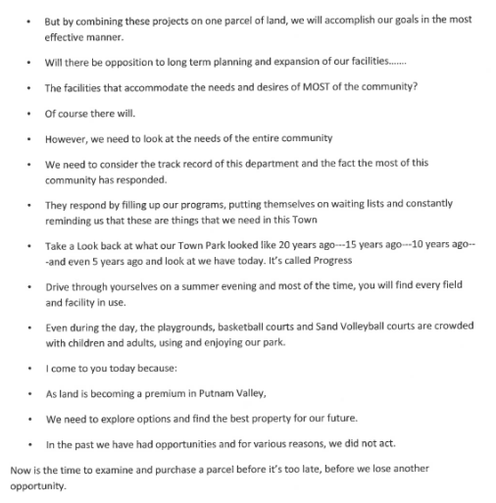

APPROVAL OF TOWN BOARD MINUTES

Presented by Councilwoman Annabi

RESOLUTION # R 15-115

RESOLVED, that the Town Board approve the Town Board Minutes of February 11, 2015 and February 18, 2015.

Seconded by Councilman Mackay, unanimously carried.

SCHOOL DISTRICT REPORT

Councilwoman Annabi announced that the “Harlem Wizards” had a game at the High School, completely sold out and was a lot of fun. This evening at the Putnam Valley Elementary School, the “Science Fair” is going on, also at the high school this evening is the
“Great Works Concert.” The Board of Education will be meeting on March 19, 2015 to discuss the budget. Also school will now be in session on 3/20, 3/30, 3/31 and 4/6 due to the snow days used.

AUTHORIZATION TO GO OUT TO BID-GRASS CUTTING DISTRICT PROPERTIES

Presented by Councilman Luongo

RESOLUTION #R15-116

RESOLVED, that the Town Board authorize District Clerk Judy Travis to go out to bid on grass cutting the district properties.

Seconded by Councilman Mackay, unanimously carried

AUTHORIZE SUPERVISOR TO SIGN AGREEMENT WITH RICHARD COMI D/B/A THE CENTER FOR MUNICIPAL SOLUTIONS

Presented by Supervisor Tendy

RESOLUTION #R 15-117

RESOLVED that the Town Board authorize the Town Supervisor to sign an agreement with Richard Comi d/b/a The Center for Municipal Solutions in regard to cell towers. This would be contingent on Town Counsel Florence’s review of the agreement.

Seconded by Councilwoman Annabi, unanimously carried.

DISCUSSION ON LIFEGUARDS

Supervisor Tendy feels that the Town Board has agreed that if a lifeguard is on call, they should be paid and if it rains all day and they are not on call, they would not get paid. The Town Board needs to further discuss if the Putnam County Health Department closes a beach for a length of time, does the lifeguard get paid? Do we relocate the lifeguard to another beach? We need to come up with a solution.

Councilman Mackay noted that lifeguards pay about $550 for Red Cross training.

Councilman Luongo wants to know if the lifeguard comes on duty at 11:30 and the skies opened up, at what point would they not be on call.

Sherry Howard replied that they are required to stay at the beach for a half an hour and then they are on call to come back to the beach when it stops raining.

Councilwoman Annabi noted that we need someone to check to make sure the lifeguards come back on the beaches of Lake Oscawana.

Councilman Mackay noted that the Town Board has not discussed this position or salary.

Supervisor Tendy replied that it would be similar to the Roaring Brook Lake Superintendent position.

Town Board has decided that further discussion is needed on this topic.

AWARD TRUCK BID-FORD F350

Presented by Councilman Luongo

RESOLUTION #R15-118

RESOLVED, that the Town Board award the 2015 Ford F-350 Truck bid to Park Ford of Mahopac for the price of $34,900.00

Seconded by Councilwoman Annabi, unanimously carried.

PARKS AND RECREATION PERSONNEL APPOINTMENT

Presented by Councilman Luongo

RESOLUTION #R15-119

RESOLVED, that the Town Board approve the following personnel appointment:

- Dawn Elizabeth Miller, Program Instructor, @ $50.00 per hour.
- Patricia Singer, Lifeguard Instructor, @ $25.00 per hour.

Seconded by Councilwoman Annabi, unanimously carried.

BUILDING DEPARTMENT REPORT

Presented by Councilman Mackay

RESOLUTION # R15-120

RESOLVED that the Town Board accept the Building Department report for the month of February 2015, for filing with the Town Clerk.

Seconded by Councilwoman Annabi, unanimously carried.

LAKE PEEKSKILL REPORT

Councilwoman Annabi announced that there will be a District Meeting on 4/25/15 at 10:00 a.m.
The Lake Peekskill Civic Association meets the 2nd Monday of every month at the Lake Peekskill Community Center. Putnam County Deputy Schwartz will be in attendance to speak about the “Neighborhood Watch Program.” Also the LPMA will be cleaning up Lake Peekskill on April 19th, for Earth Day, all volunteers to meet at 9:30 a.m. on Northway.

AUTHORIZE ADVERTISEMENT FOR TWO SEASONAL LABORERS

Presented by Councilwoman Annabi

RESOLUTION # R 15-121

RESOLVED, that the Town Board authorize the District Clerk to advertise for two temporary 2015 seasonal laborers for the Lake Peekskill Improvement District.

Seconded by Councilwoman Whetsel, unanimously carried.

AUTHORIZE ADVERTISEMENT FOR BEACH MONTIORS

Presented by Councilwoman Annabi

RESOLUTION # R 15-122

RESOLVED, that the Town Board authorize the District Clerk to advertise for Beach Monitors for the 2015 Season in Lake Peekskill.

Seconded by Councilman Mackay, unanimously carried.

AUTHORIZATION TO ADVERTISE FOR SEASONAL DISTRICT LABORER

Presented by Councilwoman Annabi

RESOLUTION # R15-123

RESOLVED that the Town Board authorize the District Clerk to advertise for a seasonal laborer for Lookout Manor for the 2015 season.

Seconded by Councilman Mackay, unanimously carried.

AUTHORIZATION TO ADVERTISE FOR HARVESTER OPERATORS

Presented by Councilwoman Whetsel

RESOLUTION # R 15-124

RESOLVED, that the Town Board authorize the District Clerk to advertise for three Harvester Operators for the 2015 season for Lake Oscawana.

Seconded by Councilman Luongo, unanimously carried.

AUTHORIZE ADVERTISEMENT FOR LAKE SUPERINTENDENT

Presented by Councilwoman Whetsel

RESOLUTION # R 15-125

RESOLVED, that the Town Board authorize the District Clerk to advertise for a Lake Superintendent for the Roaring Brook Lake District.

Seconded by Councilman Luongo, unanimously carried.

ADOPT WILDWOOD KNOLLS FACILITIES WARRANT

Presented by Councilwoman Whetsel

RESOLUTION # R 15-126

RESOLVED, that the Town Board adopt the 2015 Wildwood Knolls Facilities Warrant, 19 families at $100.00 each, total $1900.00

Seconded by Councilman Luongo, unanimously carried.

AUTHORIZE ADVERTISEMENT SEASONAL LABORER

Presented by Councilwoman Whetsel

RESOLUTION # R15-127

RESOLVED that the Town Board authorize the District Clerk to advertise for a seasonal laborer for Barger Pond.

Seconded by Councilman Mackay, unanimously carried.

PUBLIC COMMENT

Dan Vera, resident and member of the Putnam Valley Citizen Advisory Committee read the following:

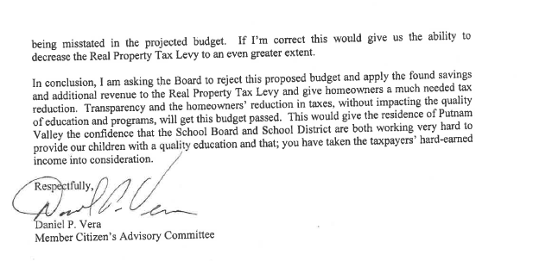

Councilwoman Annabi announced that Town Day will be on September 19th, accepting vendor applications, can email her at annabipvtb@gmail.com. We will be having a float parade so if anyone is interested please contact her. Town’s Bulk Drop off is on April 18th from 8:45 am to 11:45 am, any questions call Susan Manno at 845-526-2121.

BUDGET TRANSFERS & AMENDMENTS

Presented by Supervisor Tendy

RESOLUTION #R 15-128

RESOLVED, that the Town Board approve the following budget transfers and amendments as submitted by Finance Director Angelico:

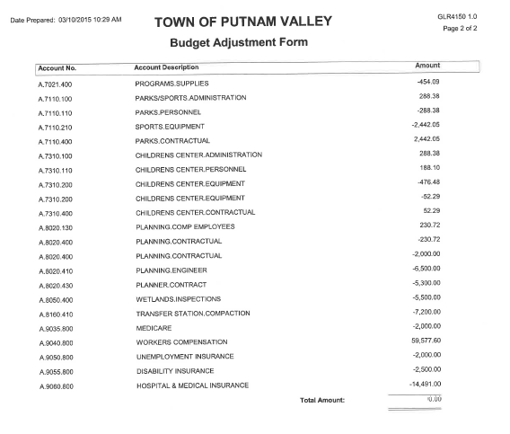

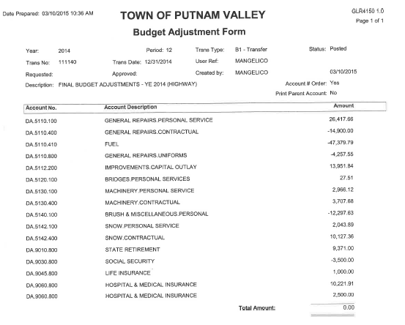

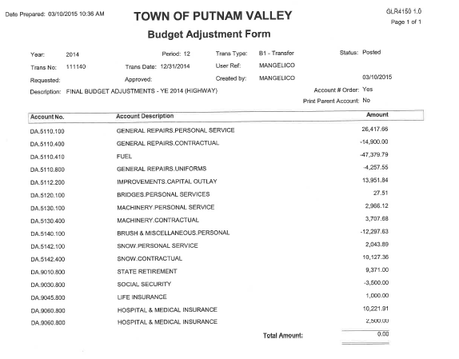
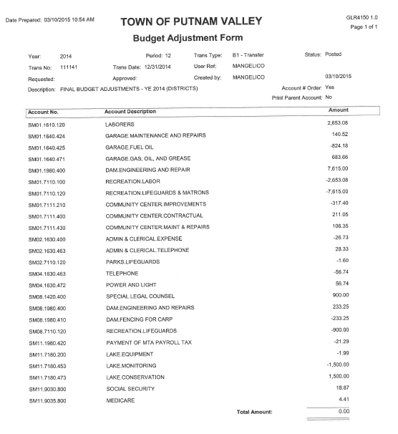

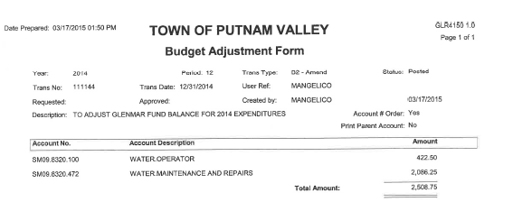

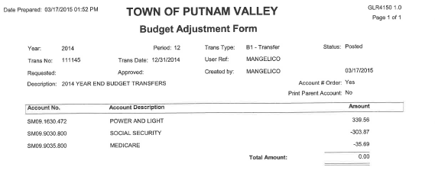

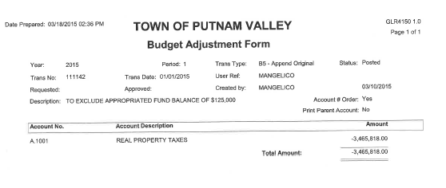

Seconded by Councilman Luongo, unanimously carried.

AUDIT OF MONTHLY BILLS

Presented by Supervisor Tendy

RESOLUTION # R 15-129

RESOLVED, that the Town Board approve the following bills, after audit, being paid:

VOUCHER NUMBERS AMOUNTS
10738-10763, 10781-10797,
10799-10804, 10807-10816,
10830-10839, 10842-10848,
10869-10878, 10880-10892,
10908-10912 $1,013,571.43
10923-10930, 10946-10956,
10974, 10979-10992 $9,217.79
10698-10714, 10719-10725,
10727-10728, 10732,
10894-10907, 10913-10922,
10931-10933, 10943-10945,
10975-10978 $188,827.27
10934-10936, 10938-10942 $11,596.84
10715-10717, 10733-10737,
10805, 10806, 10817, 10822,
10824-10829, 10840, 10841 $49,672.04

Seconded by Councilwoman Annabi , unanimously carried.

Supervisor Tendy motioned to go into Executive Session to discuss contractual matters in regard to the Teamsters contract, NYC Aqueduct and possible litigation at 8:20 p.m. with no further business taking place.

Seconded by Councilwoman Annabi, unanimously carried.

Respectfully submitted,

Eileen Royael
Town Clerk 3-19-15

