PUTNAM VALLEY TOWN BOARD
PUBLIC HEARINGS
WORK SESSION
WEDNESDAY, MARCH 13, 2013
6:00 P.M.

A PROPOSED LOCAL LAW TO AMEND CHAPTER 102 OF THE PUTNAM VALLEY TOWN CODE, EXTENDING COVERAGE OF SAID CHAPTER TO CONSTRUCTION ACTIVITIES RESULTING IN MORE THAN 5000 SQUARE FEET OF SOIL DISTURBANCE WITHIN THE NEW YORK CITY WATERSHED

IMMEDIATELY FOLLOWING
A PROPOSED LOCAL LAW TO AMEND CHAPTER 51 OF THE PUTNAM VALLEY TOWN CODE, SO AS TO CONFER ENFORCEMENT AUTHORITY ON THE PUTNAM COUNTY SOCIETY FOR THE PREVENTION OF CRUELTY TO ANIMALS (“SPCA”)

IMMEDIATELY FOLLOWING
WORK SESSION

1. Waive Fees Associated with Obtaining Building Permit-
Habitat for Humanity-87 Johnson St.
2. Discuss Waiving Civil Penalty-M. Marro
3. Accept Proposal for Debris & Sediment Removal-RBL Stream
4. Authorize Supervisor to Sign Proposal with Princeton Hydro-
Site Visit to Design Carp Barriers-Lake Oscawana Two
Outlets
5. Appoint Part Time Asst. to Finance Director-M. Angelico
6.. Review 3-20-13 Agenda

PUTNAM VALLEY TOWN BOARD
PUBLIC HEARINGS
WORK SESSION
WEDNESDAY, MARCH 13, 2013
6:00 P.M.

Present: Supervisor Tendy
Councilwoman Whetsel
Councilwoman Annabi
Councilman Mackay
Councilman Luongo

Also Present: Town Counsel Zutt
Town Clerk Eileen Royael

PUBLIC HEARINGS

Supervisor Tendy opened the Public Hearing at 6:05 p.m.

A PROPOSED LOCAL LAW TO AMEND CHAPTER 102 OF THE PUTNAM VALLEY TOWN CODE, EXTENDING COVERAGE OF SAID CHAPTER TO CONSTRUCTION ACTIVITIES RESULTING IN MORE THAN 5000 SQUARE FEET OF SOIL DISTURBANCE WITHIN THE NEW YORK CITY WATERSHED

Town Counsel Zutt explained that the format we followed from the state missed a section that was left out of Chapter 102, of the Town Code (Stormwater Management and Erosion and Sediment Control). We need to amend this chapter and add “to extend the coverage of the chapter with respect to properties in the New York City watershed, construction activities resulting in more than 5000 square feet of soil disturbance.”

No other comments were made.

Supervisor Tendy closed the public hearing at 6:09 p.m.

Seconded by Councilwoman Annabi, unanimously carried.

IMMEDIATELY FOLLOWING

Supervisor Tendy opened the Public Hearing at 6:09 p.m.

A PROPOSED LOCAL LAW TO AMEND CHAPTER 51 OF THE PUTNAM VALLEY TOWN CODE, SO AS TO CONFER ENFORCEMENT AUTHORITY ON THE PUTNAM COUNTY SOCIETY FOR THE PREVENTION OF CRUELTY TO ANIMALS (“SPCA”)

Supervisor Tendy read emails and letters in support of conferring enforcement authority on the Putnam County Society for the Prevention of Cruelty to Animals (“SPCA”)
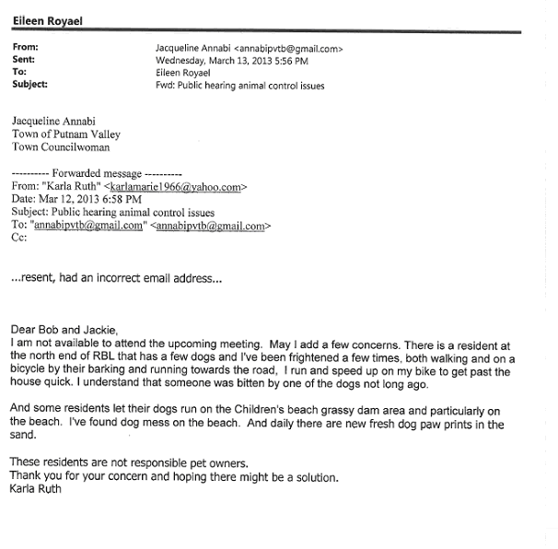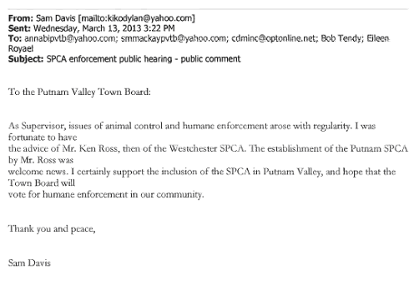

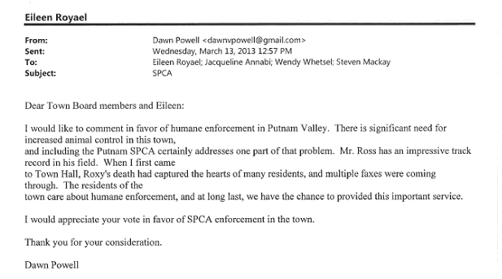

Supervisor Tendy told the audience that the emails express concerns of some people who let their dogs run free, and this has become a problem. Councilwoman Annabi contacted Ken Ross
from the SPCA to help when residents contacted her on the weekend. Councilwoman Annabi read Ken Ross’s email dated March 13, 2013.
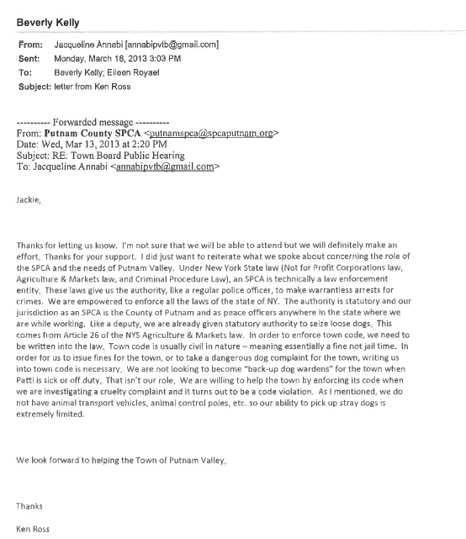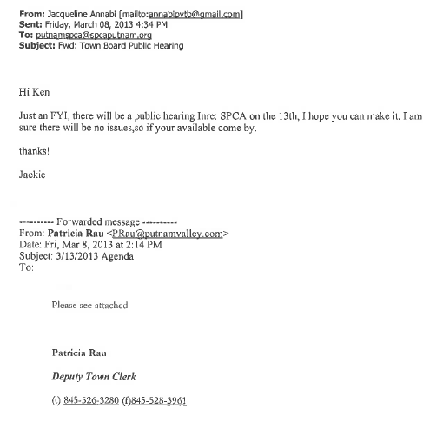

Supervisor Tendy has some questions in regard to the Town Board conferring enforcement authority on the PC SPCA. They would have the authority to make warrantless arrests throughout New York State; he is not sure how they coincide with our law enforcement officers. We need to look into if this would be a liability for us. Based on Mr. Ross’s email they can only help the town if they are investigating a cruelty complaint, they are not looking to be a dog warden. Supervisor Tendy thought after the last meeting that Mr. Ross’s would assist the town when our dog warden was not available. Our residents’ concerns are real; we have irresponsible dog owners.

Councilwoman Annabi told the Town Board that Mr. Ross could respond in regard to a dog barking, to see if it is a case of animal cruelty. As far as stray dogs, he can’t transport the dogs to the Putnam County Humane Society but he could bring them to our dog shelter. If there is a dog on the street chasing a resident, the resident would need to come in and file a complaint with our Dog Control Officer, Patti Smith.

Councilman Mackay wants to know who a resident calls if a young boy is walking and gets bit by a dog.

Councilwoman Annabi responded that the resident would need to call the Sheriff’s Department.

Councilman Mackay noted that it seems that the only service that Mr. Ross from the Putnam County SPCA can provide is “animal cruelty”.

Supervisor Tendy added that he would not want Mr. Ross to come to his house on a complaint that his dog got loose.

Town Counsel Zutt noted that a “dog at large” is a violation of our Chapter 51. He added that if the intent of the SPCA was to provide a different service then we need to get clarity, the understanding after the last meeting was that they would provide the same service as a dog warden.

A resident from Roaring Brook Lake noted that some dog owners are responsible; it seems that the SPCA’s role is to protect the animal not the resident.

Supervisor Tendy agreed with the resident, but that was not the Town Board understanding. He also added that residents are unwilling to file a complaint and without a written complaint, there is no enforcement unless a police officer or the Dog Control Officer witnesses the incident.

Councilman Luongo and Councilwoman Whetsel questioned if the resident needs to come in person and file the complaint or could they call it in.

Supervisor Tendy said no, they need to file the complaint in person.

Ula Swenson a resident in Roaring Brook Lake told the Town Board that they had signed a complaint and that person is now in the courts, he has been fined and threatened jail time and yet his dog was at large again on Saturday.

Councilman Mackay suggested that she make it known to the Town Prosecutor.

Another resident feels like the residents are not being protected and added that most dog attacks are on weekends. This one dog has bitten another resident and chased two others.

Supervisor Tendy wonders why this dog has not been taken away. He does not know the status of this case in court but will check into it.

Ula Swenson added that many people would walk around the lake, but now don’t in fear of this
dog chasing them.

Councilwoman Whetsel asked why they can’t take the dog away until the resident pays the fines.

Supervisor Tendy responded that because of due process-cannot take people’s property until they are found guilty.

Councilwoman Annabi told the residents that the Town Board is trying to stop this from happening. Mr. Ross’s email gave us a lot of questions. She would still advise the residents to call the SPCA as she feels that they will be able to help in some way.

Supervisor Tendy told the residents that maybe we need to make our laws more stringent and that the SPCA would be authorized to accept a written complaint.

Councilwoman Annabi told the residents that the SPCA’s # is 845-520-6915, 24 hours a day.

Esther McHenry a resident from Brookdale Gardens told the Town Board that they have the same problem there. She is in favor of the Town Board giving the authority to the PC SPCA, as they will be able to do things that our Dog Control Officer cannot. It will be an enhancement to the town, does not see how the Town can lose.

Maryann Arrien is also in favor of giving the SPCA the authority in Town. By involving this agency she feels that 9 out of 10 times they will be able to help.

Councilwoman Whetsel is also in favor of giving the SPCA the authority in Town. It is not normal for a dog to be aggressive.

Supervisor Tendy motioned to hold open the public hearing until 3-20-13 at 6:00 p.m.

Seconded by Councilwoman Annabi, unanimously carried.

COUNCILWOMAN ANNABI LEFT AT 6:58 P.M.

IMMEDIATELY FOLLOWING
WORK SESSION

Supervisor Tendy opened the Work Session at 6:58 p.m.

AMENDMENTS TO THE AGENDA

Presented by Supervisor Tendy

RESOLUTION #R 13- 126

RESOLVED that the Town Board amend the agenda to add the following:

Add Executive Session to discuss contractual matters in regard to Elite Environmental and the Putnam Valley Volunteer Ambulance Corps. Contracts

#2a –Authorize Supervisor to Sign Contract with PKF O’Connor Davies LLP
Change #1 to #2 on the agenda and #2 to #1.

Seconded by Councilman Mackay, unanimously carried.

DISCUSS WAIVING CIVIL PENALTY-M.MARRO

Presented by Supervisor Tendy

RESOLUTION # R13-127

RESOLVED that the Town Board waive the Civil Penalties imposed on Matt Marro for finishing his basement without going through the proper channels, due to family hardships.

Seconded by Councilman Luongo, unanimously carried.

SUPERVISOR TENDY MOVED TO GO INTO EXECUTIVE SESSION AT 7:02 P.M. TO DISCUSS CONTRACTUAL MATTERS IN REGARD TO ELITE ENVIRONMENTAL AND THE PUTNAM VALLEY VOLUNTEER AMBULANCE CORPS. CONTRACTS.

SECONDED BY COUNCILMAN MACKAY, UNANIMOUSLY CARRIED.

Note that Councilman Luongo recused himself from the discussion of the Putnam Valley Volunteer Ambulance Corps. Contract

Meeting resumed at 7:35 p.m.

AMEND AGENDA –ADD ADDITIONAL ITEMS

Presented by Supervisor Tendy

RESOLUTION # R13-128

RESOLVED that the agenda be amended to add the following:

#2b- Authorize Supervisor to Sign Contract with Elite Environmental to provide remediation services in connection with underground injection well.
#2c- Authorize Supervisor to Sign Contract with Putnam Valley Volunteer Ambulance Corps.

Seconded by Councilman Mackay, unanimously carried.

WAIVE FEES ASSOCIATED WITH OBTAINING A BUILDING PERMIT-HABITAT FOR HUMANITY-87 JOHNSON STREET

Presented by Supervisor Tendy

RESOLUTION # R13-129

RESOLVED that the Town Board waive all fees associated with obtaining a building permit for Habitat for Humanity in regard to 87 Johnson Street.

Seconded by Councilman Mackay, unanimously carried.

AUTHORIZE SUPERVISOR TO SIGN CONTRACT WITH PKF O’CONNOR DAVIES LLP

Presented by Supervisor Tendy

RESOLUTION # R13-130

RESOLVED that the Town Board authorize the Town Supervisor to sign a contract with PKF O’Connor Davies LLP, Town Auditors for the years 2012, 2013 and 2014 at an annual cost of $43,500 per year.

Seconded by Councilman Luongo, unanimously carried.

AUTHORIZE SUPERVISOR TO SIGN CONTRACT WITH ELITE ENVIRONMENTAL TO PROVIDE REMEDIATION SERVICES IN CONNECTION WITH UNDERGROUND INJECTION WELL.

Presented by Supervisor Tendy

RESOLUTION # R13-131

RESOLVED that the Town Board authorize the Town Supervisor to sign a contract with Elite Environmental to provide remediation services at the Putnam Valley Highway Department in connection with contamination from the underground injection well at the cost of $16,702.00.

Seconded by Councilman Mackay, unanimously carried.

AUTHORIZE SUPERVISOR TO SIGN CONTRACT WITH PUTNAM VALLEY VOLUNTEER AMBULANCE CORPS

Presented by Supervisor Tendy

RESOLUTION # R13-132

RESOLVED that the Town Board authorize the Town Supervisor to sign the Putnam Valley Volunteer Ambulance Corps contract for the year 2013 at the annual cost of $245,892.60.
The Town is seeking guidance from the NYS Comptroller and the NYS Association of Towns with respect to the proper funding of Ambulance Corps. services hereunder including, but not limited to, the setting, collection, and distribution of fees charged by the Ambulance Corps. for its services. To the extent that the advice given and/or opinions rendered by the NYS Comptroller and/or the NYS Association of Towns warrant one or more revisions to this agreement, the Agreement shall be promptly so revised to reflect said changes and, if necessary, new accounts and procedures established to implement the advice, guidance, and opinions so received by the Town."

Seconded by Councilman Mackay, motion carried with three ayes as Councilman Luongo recused himself.

ACCEPT PROPOSAL FOR DEBRIS & SEDIMENT REMOVAL-RBL STREAM

Presented by Supervisor Tendy

RESOLUTION # R13-133

RESOLVED that the Town Board authorize the Town Supervisor to sign a contract with Ken
Fiorentino and accept his proposal for the debris and sediment removal from the stream at Roaring Brook Lake Dam in the amount of $18,000.00 and;

BE IT FURTHER RESOLVED that the Town Board authorize the budget transfer of $3000.00 as only $15,000.00 was budgeted for dam engineering and repairs in 2013.

Seconded by Councilman Mackay, unanimously carried.

AUTHORIZE SUPERVISOR TO SIGN PROPOSAL WITH PRINCETON HYDRO-SITE VISIT TO DESIGN CARP BARRIERS-LAKE OSCAWANA TWO OUTLETS

Presented by Supervisor Tendy

RESOLUTION # R13-134

RESOLVED that the Town Board authorize the Town Supervisor to sign a proposal from Princeton Hydro for a site visit to take the necessary measurements for the design of a carp barrier in the two outlets of Lake Oscawana, cost is $700.00.

Seconded by Councilman Luongo, unanimously carried.

APPOINT PART TIME ASSISTANT TO FINANCE DIRECTOR-M. ANGELICO

Presented by Supervisor Tendy

RESOLUTION # R13-135

RESOLVED that the Town Board appoint Maria Angelico as Part Time Assistant to the Director of Finance at the rate of $17.25 per hour, 9 hours per week effective March 11, 2013.

Seconded by Councilman Mackay, unanimously carried.

REVIEW 3-20-13AGENDA

Supervisor Tendy reviewed the 3-20-13 agenda with the Town Board.

Councilman Luongo would like to add to next week’s agenda a presentation from the Putnam Valley Fire Department Chief to the young man who pulled his grandmother out of a car, he will let the Town Clerk know if this is going to happen.

Supervisor Tendy also added that there maybe two presentations to two Eagle Scouts, Matt Brady and Troy Eliopoulis.

Supervisor Tendy motioned to close the meeting at 7:45 p.m.

Seconded by Councilman Luongo, unanimously carried.

Respectfully submitted,

Eileen Royael
Town Clerk 3-19-13

