PUTNAM VALLEY TOWN BOARD
REGULAR TOWN BOARD MEETING
WEDNESDAY, FEBRUARY 20, 2013

COMMITTEE REPORTS-6:30 P.M.

7:00 P.M.

REGULAR TOWN BOARD MEETING

AGENDA

      - Pledge of Allegiance
      - Supervisor’s Opening Comments
      - Parks & Recreation Maintenance Building Update-F. DiMarco
      - ORPS-Certificate of Excellence Presentation-S. Luongo
5. County Legislator Oliverio’s Report
6. Approval of Town Board Minutes
7. School District Report
8. Leprechaun Resolution
9. Adopt Local Law to Amend Putnam Valley Code Chapter 165
Zoning to Correct an Erroneous Cross-Reference to
Section 165-91.1 in Section 165-90B
10. Adopt Local Law to Amend Putnam Valley Town Code Chapter
66 (Buildings, Unsafe) to Correct an Erroneous Cross Reference
to Section 165-88 of the Town Code (Zoning)
11. Award Appraisal Proposal-Loterdan Properties
12. Appoint Nicole Prontelli as Temporary Part Time Court Clerk

DEPARTMENTS
13. Parks & Recreation
a. Personnel Appointments/Adjustments
b. Refunds
c. Award Bid- Overhead Doors Maintenance Building

14. Building Department
a. Report for January 2013-

15. Highway Department
a. Appoint Snow Plow Riders

16. DISTRICTS
- a. Lake Peekskill
- District Report
- Declare Vehicles as Surplus and Authorize District
Clerk to Advertise bids for the Sale or Scrap of \
Vehicles
3. Salary Adjustment-LPID Laborer

b. Roaring Brook
1. Authorization to Go Out to Bid-Valve
Replacement at Dam

17. Public Comment
18. Budget Transfers & Amendments
19. Audit of Monthly Bills

PUTNAM VALLEY TOWN BOARD
REGULAR TOWN BOARD MEETING
WEDNESDAY, January 16, 2013
7:00 P.M.

PRESENT: Supervisor Tendy
Councilwoman Whetsel
Councilwoman Annabi
Councilman Mackay
Councilman Luongo

ALSO PRESENT: Town Clerk Eileen Royael
Town Counsel Zutt

Supervisor Tendy opened the meeting at 7:05 p.m.

AMENDMENTS TO THE AGENDA

Presented by Supervisor Tendy

RESOLUTION#R 13- 108

RESOLVED that the Town Board amend the agenda to add the following:
Add an Executive Session to discuss contractual matters in regard to the Teamsters & CSEA Union Contracts and personnel matter at end of meeting.
#5a County Legislator Scuccimara Comments
#5b Add Executive Session to discuss a contractual matter and Loterdan litigation
#13d- Award Fencing Bid –Johnson Field-Town Park

SUPERVISOR’S OPENING COMMENTS
No comments

PARKS & RECREATION MAINTENANCE BUILDING UPDATE-F. DIMARCO

Frank DiMarco gave an update on the progress of the Maintenance Building. On March 4, 2012, the building in the Town Park burnt down, and there was quite a lot of equipment that was lost. It was decided that we rebuild a bigger building to accommodate the equipment. We were able to save a lot of money with the help of the highway department. The cost for the foundation and the erection of the new building was $179,000. The first phase will be completed by 2-28-13. The 2nd phase will include the electric; plumbing and we estimate this phase will cost approximately $100,000. Engineering costs came to about $30,000, when it is all said and done the approximate cost will be around $400,000, which is what we estimated it to be. We have received reimbursement over $340,000 from the insurance company; some of that money was used to replace the equipment that was lost. The balance of the money will come out of the capital fund.

Councilman Mackay asked if there is a completion date.

Frank DiMarco replied that he hopes by mid-summer. He added that the Town did also receive $120,000 from the Wagner Fund which specified what type of improvements should be made, fixing up the basketball court and replacing old fencing etc..

Councilman Luongo thanked Frank DiMarco for the updates. It helps us answer the questions presented to us.

ORPS-CERTIFICATE OF EXCELLENCE PRESENTATION-S. LUONGO

John Petrino, from New York State Office of Real Property presented Putnam Valley Town Assessor, Sheryl Luongo with the 2012 Certificate of Excellence in Equity Award.

COUNTY LEGISLATOR OLIVERIO’S REPORT

County Legislator Oliverio thanked the Putnam County Highway Dept. and the Putnam Valley Highway Dept. for a great job during the last snowstorm. The trucks continuously plowed and at no point were the roads impassable. He noted that Larry Cobb is an impressive Highway Superintendent. He also told the residents that if they want to opt out - Putnam County Pistol License holder FOIL “Opt Out” form is available on the Putnam County website. Once again, Putnam County has a tree program where residents can purchase plants, this ends on March 12th.
The County is also looking into what would service our schools best since the tragedy at Newtown. Looking into hiring retired officers to supplement the staff already present at the schools.

COUNTY LEGISLATOR SCUCCIMARA COMMENTS

County Legislator Scuccimarra told the Town Board that she has the list of counties and municipalities petitioning the ramifications of the NY Safe Act, it is a complicated law. Our Putnam County Sheriff Smith issued a letter to the governor supporting some aspects of the law but not all. She added that Putnam County negotiated for electronic recycling pickup and the trailer is already here in Putnam Valley. The Health & Safety Committee is anti-brine on county roads. She also mentioned that NYS Dept. of Health and NYS DEC will postpone high volume
Fracking, further studies need to be done.

Supervisor Tendy motioned to go into Executive Session at 7:33 p.m. to discuss litigation and contractual matters in regard to Loterdan Properties.

Seconded by Councilwoman Annabi, unanimously carried.

Town Board Meeting resumed at 8:01 p.m.

APPROVAL OF TOWN BOARD MINUTES

Presented by Supervisor Tendy

RESOLUTION # R 13- 109

RESOLVED, that the Town Board approve the Town Board Minutes of January 2, 2013, January 9, 2013 and January 16, 2013

Seconded by Councilman Mackay, unanimously carried.

SCHOOL REPORT

Supervisor Tendy announced that Jerry Zupan, a teacher at the high school has become a finalist “WeareTeachers.com”, he is asking for everyone to cast a vote for him, voting ends at midnight on 2-21-13.

Supervisor Tendy told the audience that three Putnam Valley High School Seniors will be attending Division 1 colleges. Rahhim Shillingford signed on with Bryant, Erin McCrudden signed on with Louisville and John Van deVerrdonk signed on with Georgetown.
He also congratulated Chris Bruno and A.J. Mirabel as they achieved over 100 wrestling wins and Carissa Burgard, was presented with “Pride in Putnam Valley” for her amazing scale model of the Putnam Valley High School Building.

Councilman Mackay added that the Putnam Valley Varsity Basketball team is in the Sectionals at the Westchester County Center. This is a first for Putnam Valley and he encouraged all to attend the game on 2-27-13 at 4:45 p.m.

Supervisor Tendy also added that there will be a free concert at the Putnam Valley High School on March 6, 2013 at 7:00 p.m. Great Works Concerts “The Civil War”, snow date March 7, 2013.
LEPRECHAUN RESOLUTION

Presented by Councilman Luongo

RESOLUTION # R13-110

LEPRECHAUN RESOLUTION
By Herman Taub, Past Town Attorney

WHEREAS, it has come to the attention of the Town Board of the Town of Putnam Valley, that spirits, goblins, wee folk, fairies, and leprechauns do appear at strange and eerie hours and areas and more specifically are wont to do so on the night before St. Patrick’s Day; and

WHEREAS, these ethereal beings are usually involved in mischievous and frivolous behavior; and

WHEREAS, the Town Board recognizes that these other world beings are generally recidivists and cannot be reformed no matter how much mischief they cause and notwithstanding the punishment that is prescribed; and

WHEREAS, it would be to no avail to provide for corporal or other punishments since fairies, spirits, wee folk, leprechauns and goblins of the hob type are incorrigible; and

WHEREAS, it is known that these wee folk have the power to appear and disappear at will and take the form of humans or animals; and

WHEREAS, on past occasions on the night before St. Patrick’s Day a Shamrock has miraculously appeared on the road at the intersection of Oscawana Lake Road and Peekskill Hollow Road; and

WHEREAS, these mischievous doings have been heretofore erroneously ascribed to human sources; and

WHEREAS, after diligent study and consultation with our law enforcement officials, the Town Board has concluded that the appearance of said shamrock can only be due to the doings of creatures not of this corporeal world,

NOW, THEREFORE, BE IT RESOLVED, that for the period from 12:01 a.m. on March 13, 2013 to 5:00 a.m. on March 17, 2013, should there be any artistic drawings mysteriously appearing on the pavement of the road at Oregon Corners by spirits or ethereal beings of an unknown nature, a period of amnesty and freedom from corporal punishment and corporeal and “incorporeal” restraint of the alleged perpetrators is hereby declared only for the period and purposes set forth above.

Seconded by Councilman Mackay, unanimously carried.

ADOPT LOCAL LAW TO AMEND PUTNAM VALLEY CODE CHAPTER 165 ZONING TO CORRECT AN ERRONEOUS CROSS-REFERENCE TO SECTION 165-91.1 IN SECTION 165-90B

Presented by Councilwoman Annabi

RESOLUTION # R13-111
LOCAL LAW #2-2013

A LOCAL LAW to amend Putnam Valley Code Chapter 165 (“Zoning”) so as to correct an erroneous cross-reference to Sect. 165-91.1 in Sect. 165-90B.

BE IT ENACTED by the Town Board of the Town of Putnam Valley as follows:
(1) Section 165-90B of the Town Code be and is hereby amended so as to delete its reference to Sect. 165-91.1, and replace it with a reference to Sect. 165-91.2.

(2) This Local Law shall take effect upon its filing with the New York State Secretary of State.
Dated: Putnam Valley, New York

February 20, 2013

Seconded by Councilman Mackay
Voting in Favor Voting Against

Councilman Luongo AYE
Councilman Mackay AYE
Councilwoman Annabi AYE
Councilwoman Whetsel AYE
Supervisor Tendy AYE

Motion carried with five ayes

ADOPT LOCAL LAW TO AMEND PUTNAM VALLEY TOWN CODE CHAPTER 66 (BUILDINGS,UNSAFE) TO CORRECT AN ERRONEOUS CROSS REFERENCE TO SECTION 165-88 OF THE TOWN CODE (ZONING)

Presented by Councilman Mackay

RESOLUTION # R13-112
LOCAL LAW #3- 2013

A LOCAL LAW to amend Putnam Valley Town Code Chapter 66 (“Buildings, Unsafe”) so as to correct an erroneous cross-reference to Section 165-88 of the Town Code (“Zoning”).

BE IT ENACTED by the Town Board of the Town of Putnam Valley as follows:

(1) Section 66-4 of the Town Code be and is hereby amended so as to delete the phrase “within the prescribed time of 14 days” therefrom, and to change the reference therein from “Section 165-88 of Chapter 165, Zoning” to “Section 165-91.2, of Chapter 165, Zoning”.

(2) This Local Law shall take effect upon its filing with the New York State Secretary of State.
Dated: Putnam Valley, New York

February 20, 2013

Seconded by Councilwoman Annabi
Voting in Favor Voting Against

Councilman Luongo AYE
Councilman Mackay AYE
Councilwoman Annabi AYE
Councilwoman Whetsel AYE
Supervisor Tendy AYE

Motion carried with five ayes

AWARD APPRAISAL PROPOSAL-LOTERDAN PROPERTIES

Presented by Supervisor Tendy

RESOLUTION #R 13-113

RESOLVED that the Town Board award an appraisal proposal and authorize the Town Supervisor to sign a contract with Lane Appraisals at the cost of $9000 for Loterdan Properties, tax map 74.-1-35.1, 74.-1-35.2, 63-3-45, 63-3-50 and 63-3-52 for the years 2006-2011 to be prepared for submission to court, with Ned Ferrarone handling the appraisal himself.

Seconded by Councilwoman Annabi, unanimously carried.

APPOINT NICOLE PRONTELLI AS TEMPORARY PART TIME COURT CLERK

Presented by Councilwoman Whetsel

RESOLUTION #R 13-114

RESOLVED that the Town Board appoint Nicole Prontelli as temporary part time Court Clerk at the rate of $12.94 per hour effective March 4, 2013. The month of March hours not to exceed 5 hours per week, month of April, hours not to exceed 10 hours per week and beginning the month of May hours not to exceed 17 ½ hours per week.

Seconded by Councilman Luongo, unanimously carried.

PARKS & RECREATION- PERSONNEL APPOINTMENTS/ ADJUSTMENTS

Presented by Councilman Mackay

RESOLUTION #R 13- 115

RESOLVED, that the Town Board approve the following additions/changes to personnel

Robert Segnit, Lifeguard Instructor, @ $34.00 per hour.
Nicole Segnit, Ass’t Lifeguard Instructor, @ $21.00 per hour.

Seconded by Councilman Luongo, unanimously carried.

PARKS & RECREATION REFUNDS

Presented by Councilman Mackay

RESOLUTION #R13- 116

RESOLVED, that the Town Board approve the following refunds:

Maureen Pedersen $50.00
580 Oscawana Lake Road Basketball
Putnam Valley, N.Y. 10524 Unable to play

Seconded by Councilwoman Annabi , unanimously carried.

AWARD BID-OVERHEAD DOORS MAINTENANCE BLDG.

Presented by Councilman Mackay

RESOLUTION #R 13- 117

RESOLVED, that the Town Board award the bid to Hudson Valley Overhead Doors, the low bidder, for the installation of two overhead doors for the maintenance building in the park at the cost of $5820.00 for both doors and lifts.

Seconded by Councilman Luongo, unanimously carried.

AWARD FENCING BID-JOHNSON FIELD, TOWN PARK

Presented by Councilman Mackay

RESOLUTION #R 13- 118

RESOLVED, that the Town Board award Future Fence, the low bidder, for the installation of two gates on Johnson Field that would allow better access to the fields for functions at the cost of $1575.00

Seconded by Councilwoman Annabi, unanimously carried.

BUILDING DEPARTMENT REPORT

Presented by Councilman Luongo

RESOLUTION #R13 -119

RESOLVED, that the Town Board accept the Building Department report for the month of January 2013, for filing with the Town Clerk.

Seconded by Councilman Mackay, unanimously carried.

APPOINT SNOW PLOW RIDERS

Presented by Councilwoman Whetsel

RESOLUTION # R13 -120

RESOLVED that the Town Board appoint Kevin Powderly and Andre Hohloch as snow plow riders for the year 2013 at the rate of $11.44 per hour with no benefits.

Seconded by Councilman Luongo, unanimously carried.

LAKE PEEKSKILL REPORT

Ted Muniak asked for volunteers for the CSLAP program. Looking for boy scouts or high school students that are willing to give a couple hours a week sampling the lake. If interested they can call him at 845-528-9979

Supervisor Tendy asked Mr. Muniak if he has contacted the school.

Councilwoman Annabi noted that this was a good public service that a high school student or boy scout could perform.

DECLARE VEHICLES AS SURPLUS AND AUTHORIZE DISTRICT CLERK TO ADVERTISE BIDS FOR THE SALE OR SCRAP OF VEHICLES

Presented by Councilwoman Annabi

RESOLUTION # R13 -121

RESOLVED that the Town Board declare the 1991 Chevy Dump Truck and 1986 Int’l Garbage Truck cab as surplus equipment; and

BE IT FURTHER RESOLVED that the Town Board authorize the District Clerk to advertise for bids for the sale or scrap of this equipment.

Seconded by Councilman Mackay, unanimously carried.

SALARY ADJUSTMENT-LPID LABORER

Presented by Councilwoman Annabi

RESOLUTION # R13 -122

RESOLVED that the Town Board adjust Michael Palazzo, Lake Peekskill Laborer, and rate of pay as $24.98 per hour effective February 25, 2013.

Seconded by Councilman Mackay, unanimously carried.

AUTHORIZATION TO GO OUT TO BID-VALVE REPLACEMENT AT RBL DAM

Presented by Councilwoman Annabi

RESOLUTION # R13 -123

RESOLVED that the Town Board authorize the District Clerk to go out to bid for the replacement of the valve in the Roaring Brook Lake Dam.

Seconded by Councilman Mackay, unanimously carried.

PUBLIC COMMENT

Ted Muniak told the Town Board the next LPCA meeting will be held at Community Center on March 8, 2013, dues are $15.00 a year.

Glen Baisley a resident of Putnam Valley told the Town Board that feral cats are a huge problem in Putnam Valley. He has a cat that has been at his door for over a month. He built it an outdoor shelter on his porch, unfortunately, he cannot keep the cat as the cat tested positive for FIV. This does not mean the cat actually has it, if the cat was immunized for FIV, the test would always show positive. He has other cats in his home and cannot take the chance if the cat actually does have the virus. Glen is looking for a home for this cat; this is an indoor cat, which is lovable and gentle. If anyone is interested in adopting this cat please give him a call at 845-526-6118.

Larry Cobb, Putnam Valley Highway Supt. would like to see the Teamster contract settled as the highway employees go above and beyond to get the job done.

Councilwoman Annabi announced that Town Day will be September 21, 2013. We will again have a parade, rides and vendors. If anyone would like to be a vendor or volunteer, please call her at 845-721-4182 or email annabipvtb@gmail.com.

BUDGET TRANSFERS AND AMENDMENTS

Presented by Supervisor Tendy

RESOLUTION #R 13- 124

RESOLVED, that the Town Board approve the following budget transfers and amendments as submitted by bookkeeper Marianne DeSantis:
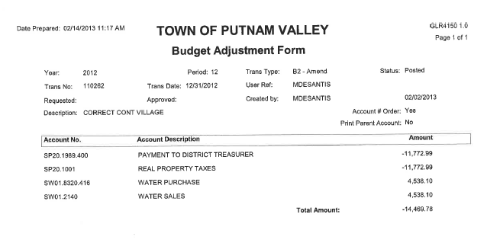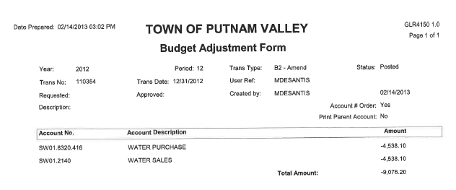
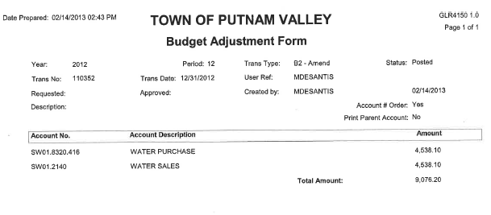
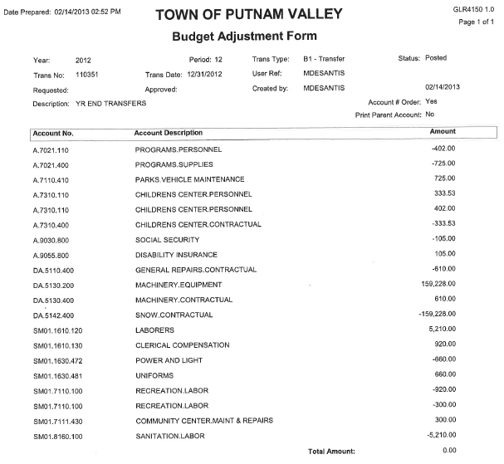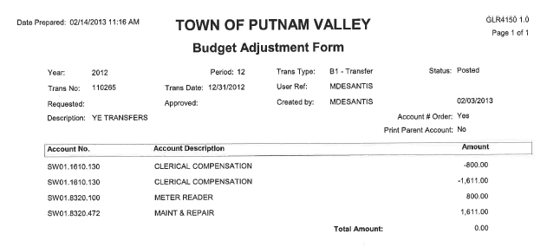
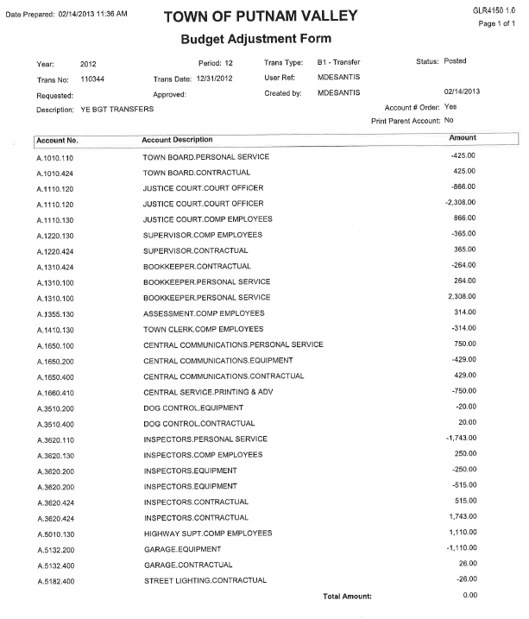
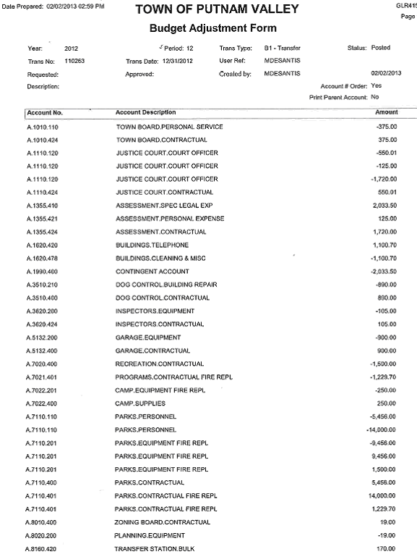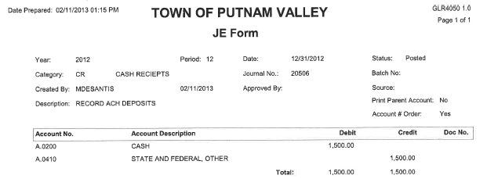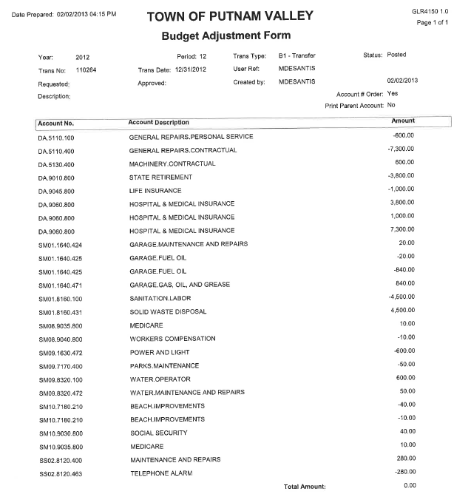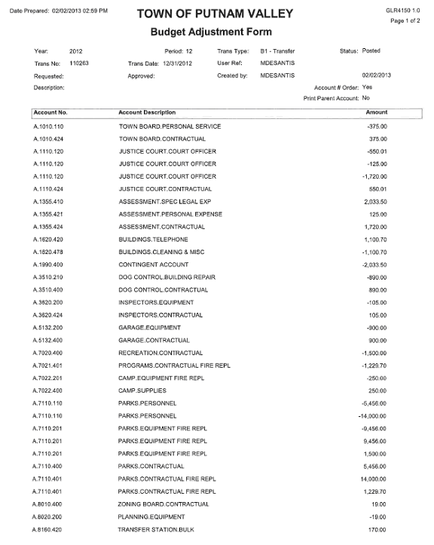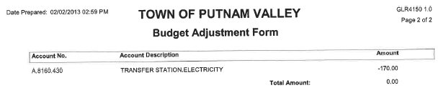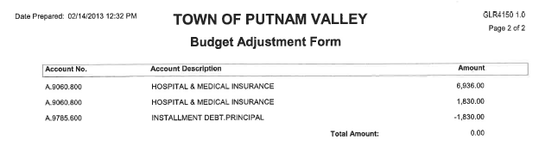

Seconded by Councilwoman Annabi, unanimously carried.

AUDIT OF MONTHLY BILLS

Presented by Supervisor Tendy

RESOLUTION # R 13- 125

RESOLVED, that the Town Board approve the following bills, after audit, being paid:

VOUCHER NUMBERS AMOUNTS
2081-2084, 2096, 2113,
2174, 2235-2236 $161,629.83
2138-2140, 2299 $3,665.44
2159-2164, 2188,
2264-2268, 2305-2306
2311, 2313 $53,921.82
2351 & 2352 $5,881.95
2189-2205, 2207-2226
2269-2297, 2315-2341
2373, 2402, 2410-2419
2423, 2425, 2427, 2432 $116,478.52
2045-2053, 2085-2095
2097, 2102-2105, 2107
2109-2112, 2177, 2179
2182-2183, 2185, 2187
2227-2234, 2237-2240
2259-2262, 2300-2304
2307-2310, 2312, 2314
2343-2348, 2369-2374
2375, 2376, 2403-2409 $161,221.54
2141, 2144-2146, 2148
2377, 2379-2401, 2420-2422
2424, 2426, 2460-2462 $53,823.81
Seconded by Councilman Mackay, unanimously carried.

Supervisor Tendy moved to go into Executive Session at 8:29 p.m to discuss contractual matters in regard to union negotiations and a personnel matter with no further business taking place.

Seconded by Councilman Mackay, unanimously carried.

Respectfully submitted,

Eileen Royael
Town Clerk 2-22-13

