PUTNAM VALLEY TOWN BOARD
REGULAR TOWN BOARD MEETING
WEDNESDAY, FEBRUARY 19, 2014

7:00 P.M.

REGULAR TOWN BOARD MEETING

AGENDA

      - Pledge of Allegiance
      - Supervisor’s Opening Comments
3. County Legislator Oliverio’s Report
4. Approval of Town Board Minutes
5. School District Report
6. Leprechaun Resolution
7. Authorize Attendance to 2014 NYS Town Clerks Association
Conference

DEPARTMENTS
8. Parks & Recreation
a. Refunds

9. Building Department
a. Report for January 2014

10. DISTRICTS
- a. Lake Peekskill
1. District Report
11. Public Comment
12. Budget Transfers & Amendments
13. Audit of Monthly Bills

PUTNAM VALLEY TOWN BOARD
REGULAR TOWN BOARD MEETING
WEDNESDAY, FEBRUARY 19, 2014
7:00 P.M.

PRESENT: Supervisor Tendy
Councilwoman Annabi
Councilman Mackay
Councilman Luongo

ALSO PRESENT: Town Clerk Eileen Royael
Town Counsel Zutt

ABSENT: Councilwoman Whetsel

Supervisor Tendy opened the meeting at 7:00 p.m.

AMENDMENTS TO THE AGENDA

Presented by Supervisor Tendy

RESOLUTION #R 14-94

RESOLVED that the Town Board amend the agenda to add the following:

Add an Executive Session at end of meeting to discuss contractual matters PVVAC, possible litigation with City of Peekskill and personnel matter.

#7a- Certificate of Appreciation to Stacey Tompkins
#7b- Report on Library Repair progress
#8b- Parks and Recreation Personnel Appointments

Seconded by Councilman Mackay, unanimously carried.

SUPERVISOR’S OPENING COMMENTS

Supervisor Tendy thanked the Putnam Valley Highway Department for the great job they did plowing the roads during the recent snowstorms. He also thanked Donald Earle, Head Mechanic for keeping the trucks running.

COUNTY LEGISLATOR’S REPORT

County Legislator Oliverio told the residents that Putnam County terminated the lease with Tilly Foster Farm. An association has been set up to explore other options, his hope being that it could be like Muscoot Farm in Somers. He thanked the Putnam County and Putnam Valley Highway Departments for the phenomenal job they did during the recent snowstorms. In regard to the county owned properties at Oregon Corners and Oscawana Lake Road those properties are in serious discussions as far as being sold. On February 27th at 6:30-7:00 p.m. the Putnam Valley School Board will be holding a public hearing on a veteran’s exemption for the school taxes.

APPROVAL OF TOWN BOARD MINUTES

Presented by Supervisor Tendy

RESOLUTION # R 14-95

RESOLVED, that the Town Board approve the Town Board Minutes of January 3, 2014, January 8, 2014 and January 15, 2014.

Seconded by Councilman Mackay, unanimously carried.

SCHOOL DISTRICT REPORT

County Legislator Oliverio announced that the Putnam Valley Boys’ Varsity Basketball team will be playing in the sectionals at Westchester County Center on February 24th. He also noted that the wrestling team has also done a great job. Councilman Mackay noted that the Putnam Valley Swim Team has also made the sectionals and a shout out goes to Patrick O’Grady who qualified for the sectionals. The spring play will be “Thoroughly Modern Millie”, watch for the dates. Also there are budget concerns, as there may be drastic cuts in staff.

LEPRECHAUN RESOLUTION

Presented by County Legislator Oliverio

RESOLUTION # R14-96

LEPRECHAUN RESOLUTION
By Herman Taub, Past Town Attorney

WHEREAS, it has come to the attention of the Town Board of the Town of Putnam Valley, that spirits, goblins, wee folk, fairies, and leprechauns do appear at strange and eerie hours and areas and more specifically are wont to do so on the night before St. Patrick’s Day; and

WHEREAS, these ethereal beings are usually involved in mischievous and frivolous behavior; and

WHEREAS, the Town Board recognizes that these other world beings are generally recidivists and cannot be reformed no matter how much mischief they cause and notwithstanding the punishment that is prescribed; and

WHEREAS, it would be to no avail to provide for corporal or other punishments since fairies, spirits, wee folk, leprechauns and goblins of the hob type are incorrigible; and

WHEREAS, it is known that these wee folk have the power to appear and disappear at will and take the form of humans or animals; and

WHEREAS, on past occasions on the night before St. Patrick’s Day a Shamrock has miraculously appeared on the road at the intersection of Oscawana Lake Road and Peekskill Hollow Road; and

WHEREAS, these mischievous doings have been heretofore erroneously ascribed to human sources; and

WHEREAS, after diligent study and consultation with our law enforcement officials, the Town Board has concluded that the appearance of said shamrock can only be due to the doings of creatures not of this corporeal world,

NOW, THEREFORE, BE IT RESOLVED, that for the period from 12:01 a.m. on March 13, 2014 to 5:00 a.m. on March 17, 2014, should there be any artistic drawings mysteriously appearing on the pavement of the road at Oregon Corners by spirits or ethereal beings of an unknown nature, a period of amnesty and freedom from corporal punishment and corporeal and “incorporeal” restraint of the alleged perpetrators is hereby declared only for the period and purposes set forth above.

Seconded by Councilman Mackay, unanimously carried.

CERTIFICATE OF APPRECIATION

Supervisor Tendy presented Stacey Tompkins with a Certificate of Appreciation for her dedication to our town. He also congratulated her on receiving Putnam County Chamber of Commerce “Mature Trailblazer Award.”

LIBRARY REPAIR PROGRESS

The library is still open to reserve books and residents can still pick up and drop off books. The construction should be starting within the next two weeks weather permitting. Information is on putnamvalleylibrary.org or residents can visit our Facebook page.

AUTHORIZE ATTENDANCE TO 2014 NYS TOWN CLERKS ASSOCIATION CONFERENCE

Presented by Supervisor Tendy

RESOLUTION # R14-97

RESOLVED that the Town Board authorize Eileen Royael, Town Clerk to attend the 2014 NYS Town Clerks Association Conference in Saratoga Springs, April 27, 2014 to April 29, 2014 total cost $611.66

Seconded by Councilman Luongo, unanimously carried.

PARKS & RECREATION REFUNDS

Presented by Supervisor Tendy

RESOLUTION #R14-98

RESOLVED, that the Town Board approve the following refunds:
Frank Keller $30.00
224 Pudding St. Chess
Putnam Valley, NY 10579 Unable to play

Seconded by Councilwoman Annabi, unanimously carried.

PARKS & RECREATION- PERSONNEL APPOINTMENTS/ ADJUSTMENTS

Presented by Supervisor Tendy

RESOLUTION #R 14-99

RESOLVED, that the Town Board approve the following additions/changes to personnel:

- Paul Sacco, Basketball assistant, @ $10.00 per hour.
- Doreen Piacente, Teen Center Director, @ $26.33 per hour.*
- Phyllis Levesque, Teen Center Ass’t., @ $12.64 per hour.*
- Lynn Sharp, Teen Center Ass’t. @ $12.64 per hour*
- James Piacente, Teen Center Ass’t. @ $13.01 per hour.*
- Kathleen Colonna, Teen Center Ass’t. @ $11.90 per hour.*
- Christopher Cuddihy, Teen Center Ass’t. @ $9.11 per hour*
- Crystal Galloway, Teen Center Ass’t. @ $10.00 per hour.*
- Justin Levesque, Teen Center Ass’t. @ $10.13 per hour.*
- Kelsey McCann, Teen Center Ass’t. @ $9.00 per hour.*
- Michele Munoz, Teen Center Ass’t. @ $11.91 per hour.*
- Cynthia Plescia, Teen Center Ass’t. @ $10.13 per hour.*
- Christopher Piacente, Teen Center Ass’t. @ $11.91 per hour.*
- Jonathan Schultz, Teen Center Ass’t. @ $10.13 per hour.*
- Alice Stockinger, Teen Center Ass’t. @ $9.11 per hour.*
- Natalia Stockinger, Teen Center Ass’t. @ $10.13 per hour.*

*reflects a 2014 1.25% pay increase per budget.
Seconded by Councilwoman Annabi, unanimously carried.
BUILDING DEPARTMENT REPORT

Presented by Supervisor Tendy

RESOLUTION #R14-100

RESOLVED, that the Town Board accept the Building Department report for the month of January 2014, for filing with the Town Clerk.

Seconded by Councilman Mackay, unanimously carried.

LAKE PEEKSKILL REPORT

Councilwoman Annabi reminded the residents of Lake Peekskill that garbage pickup for Route 1 is on Mondays, and Route 2 is on Tuesdays. All Lake Peekskill residents should have received a yellow pamphlet with the garbage schedule in the mail, if not please call the District Clerk at 526-2160. On March 9th there will be a LPCA meeting at 8:00 p.m. at the Lake Peekskill Community Center.

PUBLIC COMMENT

At Niese Farm there will be a Maple Festival on March 22nd, 23rd, 29th and 30th. From 9:00 a.m. to 3:00 p.m. Breakfast will be served, $9.00 Adults and $5.00 Children. There will be hayrides, and maple sugaring demonstrations. On Saturday, February 22nd at 4 p.m. a penny social for “Caitlyn’s Fight” will be held at the Putnam Valley Volunteer Ambulance Corps. Any donations can be dropped off at the Beading Den in town. On March 2nd, Dr. Ruth will be speaking about her life, this event will be held at the Putnam Valley Volunteer Ambulance Corps. at 2:30.
St. Patrick’s Day Parade will be held in Mahopac on March 9th at 2:00 p.m. This parade is being dedicated to the “American Flag” with John J. Callahan as the Grand Marshall. Town Day this year will be held on Saturday September 22, 2014.

BUDGET TRANSFERS AND AMENDMENTS

Presented by Supervisor Tendy

RESOLUTION #R 14-101

RESOLVED, that the Town Board approve the following budget transfers and amendments as submitted by bookkeeper Marianne DeSantis:

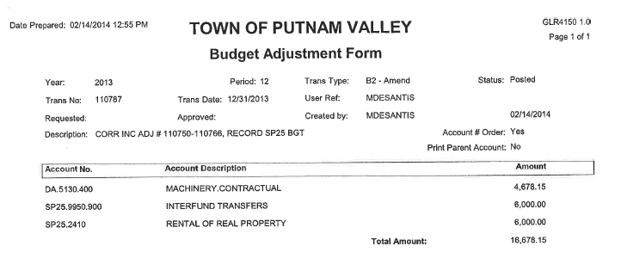
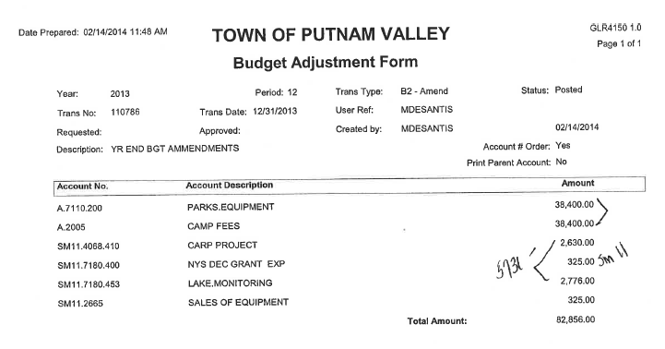
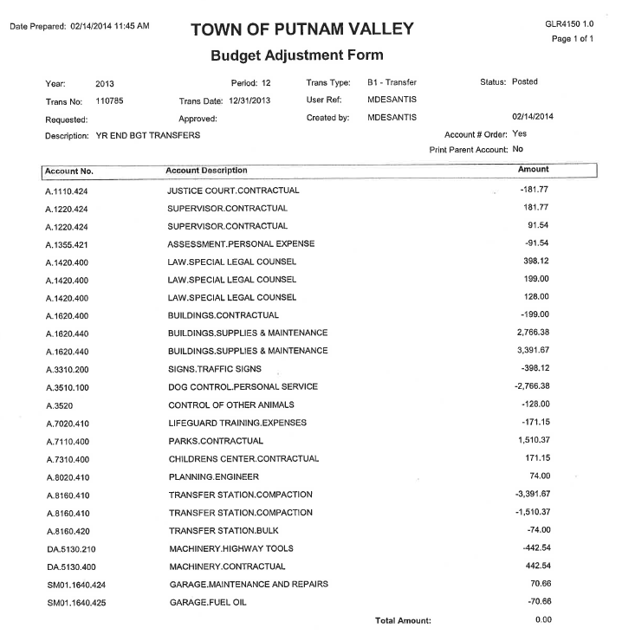

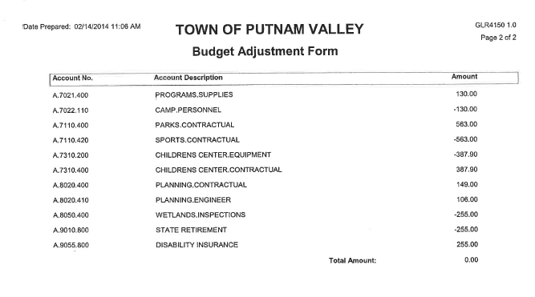
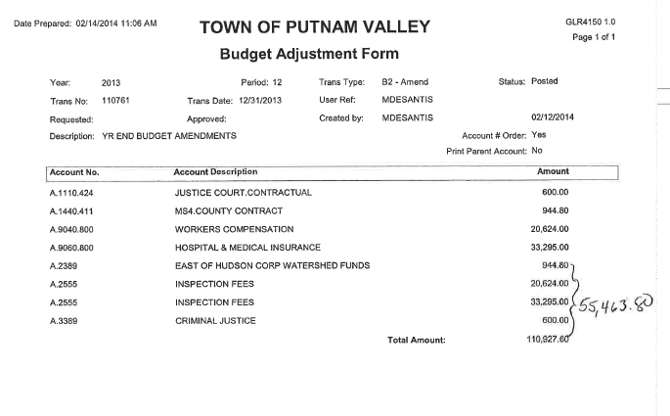
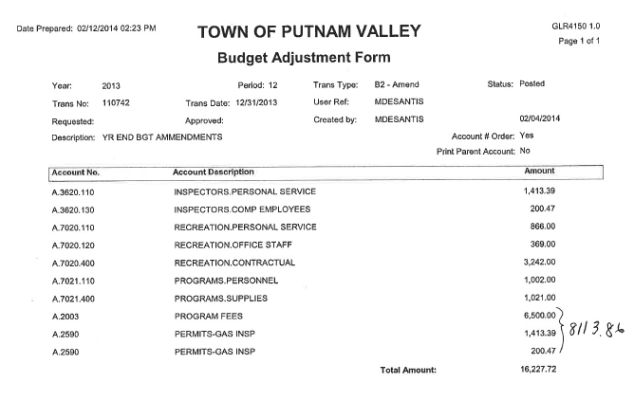
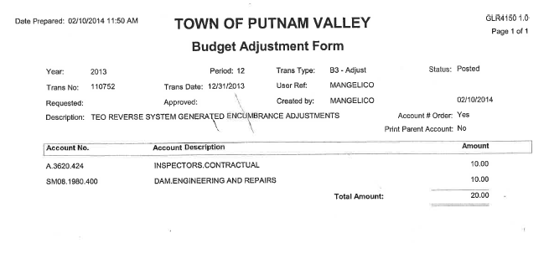
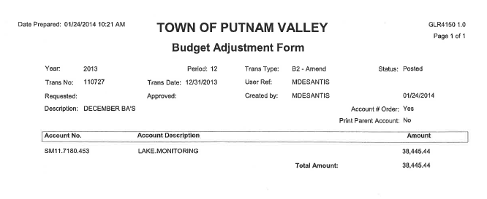
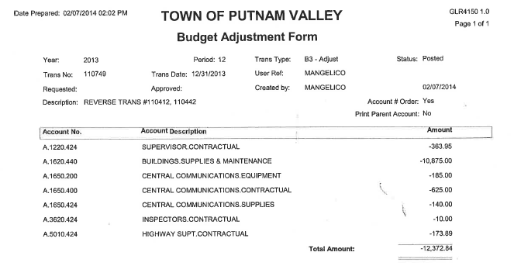
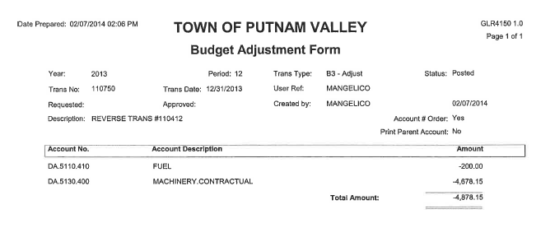
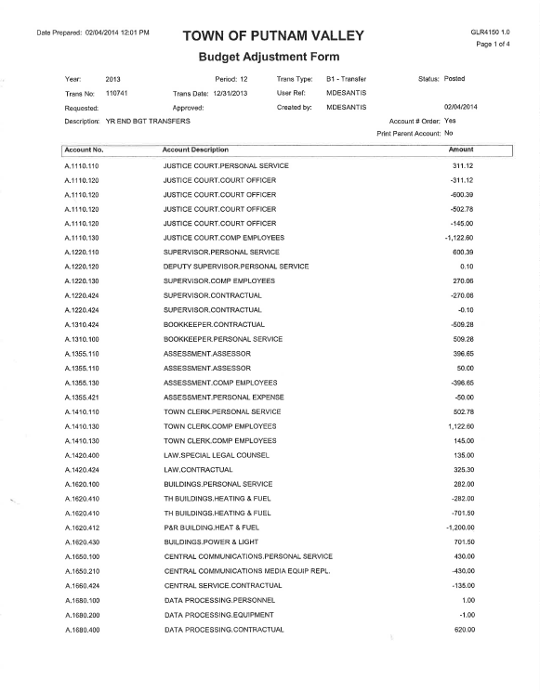

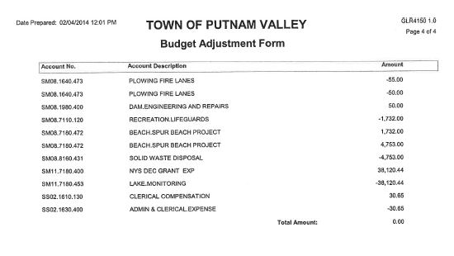

Seconded by Councilman Mackay, unanimously carried.

AUDIT OF MONTHLY BILLS

Presented by Supervisor Tendy

RESOLUTION # R 14-102

RESOLVED, that the Town Board approve the following bills, after audit, being paid:

VOUCHER NUMBERS AMOUNTS
6541-6560, 6562, 6563,
6566, 6568-6570,
6572-6574, 6576-6582,
6584-6605, 6608-6613,
6633-6672, 6674-6676 $229,837.42
6442-6457, 6468,
6519-6528, 6561, 6571
6583, 6606, 6607, 6677
6680 $61,581.71
6296, 6297, 6302-6312,
6314, 6339-6341, 6343,
6401-6414, 6417-6421,
6458-6467, 6469-6472,
6476, 6489-6495,
6535-6540, 6564-6565,
6567, 6575, 6614, 6673 $195,927.20

Seconded by Councilman Mackay, unanimously carried.

Supervisor Tendy moved to go into Executive Session at 7:30 p.m to discuss contractual matters in regard to Putnam Valley Volunteer Ambulance Corps., possible litigation with City of Peekskill and a personnel matter, with no further business taking place.

Seconded by Councilman Luongo, unanimously carried.

Respectfully submitted,

Eileen Royael
Town Clerk 2-24-14

