PUTNAM VALLEY TOWN BOARD

WORK SESSION
WEDNESDAY, FEBRUARY 11, 2015
6:00 P.M.

WORK SESSION
- Authorize Expenditure for Mobile Link Generator Alarm System- Sewer
District
- Authorize Attendance to NY Planning Federation Conference- - Planning Board-M. Raimondi & T. Carano
- Authorize Attendance to NY Planning Federation Conference-Zoning Board- P. Belefant
- Accept Proposal Princeton Hydro Environmental Planners-Restoration Plan – Lake Peekskill
- Authorize Supervisor to Sign Non-Filming Location Agreement-Universal Television LLC
- Authorize Zoning Board Refund- 14 Harrimac Road
- Review of 2-18-15 Agenda

PUTNAM VALLEY TOWN BOARD
PUBLIC HEARINGS/WORK SESSION
WEDNESDAY, FEBRUARY 11, 2015
6:00 P.M.

Present: Supervisor Tendy
Councilwoman Whetsel
Councilwoman Annabi
Councilman Mackay
Councilman Luongo

Also Present: Town Counsel Florence
Town Clerk Eileen Royael

Supervisor Tendy opened the Work Session at 6:00 p.m.

AMENDMENT TO THE AGENDA

Presented by Supervisor Tendy

RESOLUTION #R 15-92

RESOLVED that the Town Board amend the agenda to add the following:

#6a Appoint Snow Plow Rider- J. Anderson
#6b Read Memo from Town Assessor
#6c Approve Community Service Worker-Building Department
Add Executive Session at end of meeting to discuss a personnel matter and a contractual matter with no further business taking place.

Seconded by Councilwoman Annabi, unanimously carried.

AUTHORIZE EXPENDITURE FOR MOBILE LINK GENERATOR ALARM SYSTEM-SEWER DISTRICT

Presented by Supervisor Tendy

RESOLUTION # R 15-93

RESOLVED, that the Town Board authorize the expenditure of $503.00 for the installation and first year of monitoring fees, and thereafter $249.00 per year for a Mobile Link generator alarm system from Essential Power System and;

BE IT FURTHER RESOLVED that the Town Board authorize the Supervisor to sign a three-year contract with Essential Power System for this service.

Seconded by Councilwoman Annabi, unanimously carried.
AUTHORIZE ATTENDANCE TO NY PLANNNING FEDERATION CONFERENCE-PLANNING BOARD-M. RAIMONDI & T. CARANO

Presented by Supervisor Tendy

RESOLUTION # R 15-94

RESOLVED, that the Town Board authorize Michael Raimondi and Tom Carano to attend the NY Planning Federation Conference to be held in Bolton Landing, NY April 12-April 14, Michael Raimondi is requesting the registration fee of $189.00 and the hotel cost $218.00, Tom Carano is requesting the one-day registration fee of $149. Total cost $552.00.

Seconded by Councilwoman Annabi, unanimously carried.

AUTHORIZE ATTENDANCE TO NY PLANNING FEDERATION CONFERENCE-ZONING BOARD-P. BELEFANT

Presented by Supervisor Tendy

RESOLUTION # R 15-95

RESOLVED, that the Town Board authorize Peter Belefant, Zoning Board Member to attend the NY Planning Federation Conference to be held in Bolton Landing, NY April 12--April 14, 2015, registration fee is $189, hotel cost is $218.00, total cost is $407.00

Second by Councilwoman Annabi, unanimously carried.

ACCEPT PROPOSAL PRINCETON HYDRO ENVIRONMENTAL PLANNERS-RESTORATION PLAN-LAKE PEEKSKILL

Presented by Supervisor Tendy

RESOLUTION # R 15-96

RESOLVED, that the Town Board accept the proposal for the development of a restoration plan for Lake Peekskill for the amount of $14,500.00 from Princeton Hydro Environmental Planners, 1108 Old York Road, Ringoes, NJ 18551 and;

BE IT FURTHER RESOLVED that the Town Board authorize the Town Supervisor to sign the contract with Princeton Hydro for the amount of $14,500.00.

Seconded by Councilman Mackay, unanimously carried.

AUTHORIZE SUPERVISOR TO SIGN NON-FILMING LOCATION AGREEMENT-UNIVERSAL TELEVISION LLC

Presented by Supervisor Tendy

RESOLUTION # R 15-97

RESOLVED, that the Town Board authorize the Town Supervisor to sign a Non Filming Location Agreement with Universal Television LLC to use the property located at Wagner Memorial Town Park commencing on February 9, 2015 for the sum of $1500.00

Seconded by Councilwoman Annabi, unanimously carried.

AUTHORIZE ZONING BOARD REFUND-14 HARRIMAC ROAD

Presented by Supervisor Tendy

RESOLUTION # R 15-98

RESOLVED, that the Town Board refund Anthony Bondi of 14 Harrimac Road his applicant fee of $250.00 for the Zoning Board as the ZBA determined that a variance was not required.

Seconded by Councilman Luongo, unanimously carried.

APPOINT SNOW PLOW RIDER

Presented by Supervisor Tendy

RESOLUTION # R 15-99

RESOLVED that the Town Board appoint Jake Anderson as a snow plow rider for the 2015 snow season. Jake Anderson will be paid an hourly wage of $11.44 per hour with no benefits.

Seconded by Councilman Luongo, unanimously carried.

MEMO FROM PUTNAM VALLEY TOWN ASSESSOR

Councilwoman Annabi read memo from Sheryl Luongo, Town Assessor
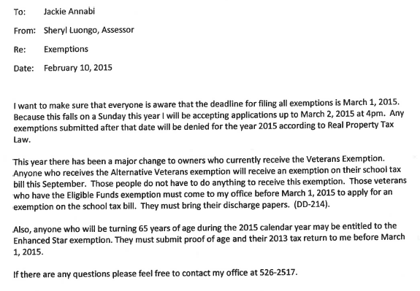

APPROVE COMMUNITY SERVICE- BUILDING DEPARTMENT

Presented by Supervisor Tendy

RESOLUTION # R 15-100

RESOLVED that the Town Board approve Community Service to be performed by Tiffany Walters in the Building Department helping to condense their files for a file scanning project.

Seconded by Councilman Mackay, unanimously carried.

REVIEW OF 2-18-15

Supervisor Tendy reviewed the 2-18-15 Agenda with the Town Board, no comments were made.

Supervisor Tendy motioned to go into Executive Session at 6:10 p.m. to discuss a contractual and a personnel matter with no further business taking place,

Respectfully submitted,

Eileen Royael
Town Clerk 2-12-15

