PUTNAM VALLEY TOWN BOARD

REGULAR TOWN BOARD MEETING

WEDNESDAY, DECEMBER 18, 2013

7:00 P.M.

REGULAR TOWN BOARD MEETING

AGENDA

      - Pledge of Allegiance
      - Supervisor’s Opening Comments
      - Certificate of Appreciate-Trinity Gross & Shawn Keeler
      - County Legislator’s Report
      - Approval of Town Board Minutes
      - School District Report
7. Authorize Highway Equipment Ban Renewal
8. Authorization to Apply for 2014 Funding Through Putnam
County Youth Bureau- PV Parks & Rec. Teen Center and PV
Volunteer Youth Ambulance Corps Program
9. Discussion on Waiving Civil Penalty-19 Luigi Road
10. Authorization to Issue Bond Anticipation Note-RBL
11. Release Erosion & Sediment Control Cash Bond-SMP Builders
12. Approve 2014 Putnam Valley Volunteer Ambulance
Contract and Authorize Supervisor to Sign Contract
13. Approve Fee Schedule for- Putnam Valley Volunteer
Ambulance Corps
14. Approve 2014 MedEx Billing Contract and Authorize
Supervisor to Sign Contract

15. Highway
a. Award Bid for 2014 Materials Bid

16. Parks & Recreation
a. Refunds

17. Building Department
a. Report for November 2013

18. DISTRICTS
a. Lake Peekskill
1. District Report
b. Mill Ponds
1. Accept Mill Ponds End of Year Revenue
Report
19. Public Comment
20. Budget Transfers & Amendments
21. Audit of Monthly Bills
22. Adjournment

PUTNAM VALLEY TOWN BOARD
TOWN BOARD MEETING
WEDNESDAY, DECEMBER 18, 2013
7:00 P.M.

Present: Supervisor Tendy
Councilwoman Annabi
Councilman Mackay
Councilman Luongo

Also Present: Eileen Royael, Town Clerk
William Zutt, Town Counsel

Absent: Councilwoman Whetsel

Supervisor Tendy opened the meeting at 7:00 p.m.

AMENDMENTS TO THE AGENDA

Presented by Supervisor Tendy

RESOLUTION #R 13- 354

RESOLVED that the Town Board amend the agenda to add the following:

Remove Items #12, #13 and #14
Add
#14a Appoint Temporary Maintenance Worker-Frank Cassidy
#14b Authorize Reduction of Performance Bond-Tompkins Landscaping
#15b Appoint Snow Plow Riders

Seconded by Councilwoman Annabi, unanimously carried.

SUPERVISOR’S OPENING COMMENTS

Supervisor Tendy asked everyone to think about those serving our country. Those in the military are not with their families this holiday season; they make tremendous sacrifices for our country. On January 2, 2014 we will be have the Re-Organization Meeting at 6:00 p.m. Supervisor Tendy wished everyone a Merry Christmas, Happy Kwanza and a wonderful holiday season.

CERTIFICATE OF APPRECIATION-TRINITY GROSS & SHAWN KEELER
Supervisor Tendy presented Trinity Gross with a Certificate of Appreciation. This wonderful little girl took it upon herself to make and sell bracelets. She donated the $350.00 she made on the selling of the bracelets to “Wounded Warriors” This was a very kind and generous gesture. The Putnam County Sheriff’s Dept. also presented Trinity with a Certificate of Accommodation for her outstanding dedication to the veterans. Senator Ball’s office presented Trinity with a Proclamation.

Supervisor Tendy presented Shawn Keeler with a Certificate of Appreciation for serving three terms as the Putnam Valley Volunteer Fire Dept. Chief. Shawn has given outstanding dedication to the Town of Putnam Valley for over 22 years.

Shawn Keeler told the Town Board it was an honor and privilege to serve as the Chief of the fire department; he could not have done it without the support of his family and the members of the fire department.

COUNTY LEGISLATOR REPORT

County Legislator Oliverio thanked the town and county highway workers for their outstanding work during the past two storms. This Friday, the Legislators will be having the audit and year end meeting at 5:00 p.m. Their reorganization meeting date has not been set yet, however beginning in 2014, meetings will be on the first Wednesday of each month instead of the first Tuesday of each month. He wished everyone a happy holiday, Happy Kwanza and a Merry Christmas.

APPROVAL OF TOWN BOARD MINUTES

Presented by Supervisor Tendy

RESOLUTION # R 13- 355

RESOLVED, that the Town Board approve the Town Board Minutes of November 6th, November 13th, November 20th and November 25th.

Seconded by Councilwoman Annabi, unanimously carried.

SCHOOL DISTRICT REPORT

Supervisor Tendy talked about the high school’s past performance of the “Twelve Angry Jurors”. He could not attend but he had heard that it was a wonderful production.

County Legislator Oliverio reminded everyone that the schools will be closed December 23rd and reopen January 2, 2014.

AUTHORIZE HIGHWAY EQUIPMENT BAN RENEWAL

Presented by Councilwoman Annabi

RESOLUTION # R 13 -356

RESOLVED, that the Town Board authorize the Highway Equipment Bond Anticipation Note (BAN) renewal in the amount of $47,700 for highway equipment purchase. This amount
represents the current balance of a 2009 note for purchase of highway equipment. The renewal rate is 1.5% and the note will be held by Putnam County Savings Bank.

Seconded by Councilman Mackay, unanimously carried

AUTHORIZATION TO APPLY FOR 2013 FUNDING THROUGH PUTNAM COUNTY YOUTH BUREAU-PV PARKS & REC. TEEN CENTER AND PUTNAM VALLEY VOLUNTEER YOUTH AMBULANCE CORPS PROGRAM

Presented by Councilman Luongo

RESOLUTION #R13-357

RESOLVED, that the Town Board authorize the Parks and Recreation Department and the Facilities Department to apply for 2014 funding through the Putnam County Youth Bureau on behalf of the Parks & Recreation Teen Center Program and the Putnam Valley Volunteer Youth Ambulance Corps Program. Funding is provided by New York State Office of Children and Family Services, amount has not been determined at this time.

Seconded by Councilman Mackay, unanimously carried.

DISCUSSION ON WAIVING CIVIL PENALTY-19 LUIGI ROAD

Discussion
Supervisor Tendy told the Town Board that they erected a pool and deck without the proper permits but they have since legalized the deck and the pool. He has no problem waiving the penalty. The Town Board agreed.

Presented by Supervisor Tendy

RESOLUTION #R13-358

RESOLVED, that the Town Board waive the Civil Penalty for 19 Luigi Road, Marisol and Cesare Medici.

Seconded by Councilwoman Annabi, motion carried with three ayes, as Councilman Luongo recused himself as they are his neighbors.

AUTHORIZATION TO ISSUE BOND ANTICIPATION NOTE –RBL

Presented by Councilman Mackay

RESOLUTION #R13-359

RESOLVED, that the Town Board authorizes a Bond Anticipation Note Issuance in the amount of $100,000 for Roaring Brook Lake Improvement District Valve Replacement. The rate is 1.5% and the note will be held by Putnam County Savings Bank.

Seconded by Councilwoman Annabi, unanimously carried.

RELEASE EROSION & SEDIMENT CONTROL CASH BOND-SMP BUILDERS

Presented by Councilwoman Annabi

RESOLUTION #R13-360

RESOLVED, that the Town Board authorize the release of an Erosion & Sediment Bond in the amount of $4500 to SMP Builders.

Seconded by Councilman Mackay, unanimously carried.

APPOINT TEMPORARY MAINTENANCE WORKER-FRANK CASSIDY

Presented by Supervisor Tendy

RESOLUTION #R13-361

RESOLVED, that the Town Board appoint Frank Cassidy as a temporary Maintenance Worker for the time period of December 17th through December 31, 2013 at $15.00 per hour with no benefits as he will be filling in for Manual Sanjaus as he is attending a family emergency.

Seconded by Councilman Mackay, unanimously carried.

AUTHORIZE REDUCTION OF PERFORMANCE BOND-TOMPKINS LANDSCAPING

Presented by Councilwoman Annabi

RESOLUTION #R13-362

RESOLVED, that the Town Board authorize the reduction of the Performance Bond posted by Tompkins Landscaping for the Lake Oscawana Stormwater Retrofit project to be reduced from $287,302.31 to $28,730.23 as per the recommendation from J.R. Folchetti & Associates, Inc.

Seconded by Councilman Mackay, unanimously carried.

AWARD BID FOR 2014 MATERIALS BID- HIGHWAY

Presented by Supervisor Tendy

RESOLUTION #R13-363

RESOLVED that the Town Board award the following bids for 2014 Highway Materials as recommended by the Highway Superintendent Cobb.

(del) = delivered (FOB) = freight on board or picked up (t) =ton (y) = yard (ft) = foot

Blacktop

Laid in Place: Low bid Kect Construction $78.00t, 2nd low bid Clove
Escavators $78.45t

Cold Patch Low bid Package Pavement $80.00 del & $78.00 FOB
No 2nd bid

Type 1 base coat: Low bid Thalle $70.00t FOB, Tilcon $70.50t FOB

Type 3 binder: Low bid Thalle $70.00t FOB, Tilcon $70.50t FOB

Type 5 shim: Low bid Thalle $75.00t FOB, Peckham $76.00 FOB

Type 6f2 Top: Low bid Thalle $70.00t FOB, Tilcon $71.50t FOB

Curb Mix: Low bid Peckham $80.00t FOB, Thalle $90.00t FOB

Item 4 by the ton

1” minus Low bid Thalle $17.70t del, Putnam Materials and Wingdale
$11.50t FOB. 2nd low bid Harold Lyons&Sons $17.95t del.
Thalle $12.00t FOB

2” minus Low bid Thalle $17.70t del, Putnam Materials and Wingdale
$11.00t FOB. 2nd low bid Harold Lyons&Sons $17.95 del
Thalle $12.00t FOB

Shalle Item 4 No bids

Liquid Magnesium Chloride No bids

Bank Run/Top Soil/Sand

Bank Run per yard Low bid Harold Lyons&Sons $25.95y del, Red Wing $24.00y FOB.
2nd low bid Red Wing $33.75y del.

Bank Run per Ton Low bid Red Wing $26.25t del & $18.00t FOB, No 2nd bid
Top Soil per yard Low bid Harold Lyons&Sons $27.50y del & Red Wing $30.00y FOB 2nd low bid Kect $30.00y del

Top Soil per Ton Low bid Red Wing $33.25t del, & $25.00t FOB, No 2nd bid

Washed Concrete Sand Low bid Thalle $25.50y del & $18.50y FOB
By the yard 2nd low bid Kect $28.00y del & Red Wing $27.60y FOB

Washed Concrete Sand Low bid Thalle $19.50t del & Tilcon $12.00t FOB
By the ton 2nd low bid Tilcon $20.25t del & Thalle $13.20t FOB

Pipe N-12 plastic by the foot
12 inch Low bid Chemung $4.20 del & FOB
2nd low bid Expanded Supply and Carmel Winwater $4.24 del & FOB

15 inch Low bid Chemung $5.48 del & FOB 2nd low bid Expanded Supply and Carmel Winwater $5.52 del & FOB

18 inch Low bid Chemung $8.10 del & FOB
2nd low bid Expanded Supply and Carmel Winwater $8.17 del & FOB

24 inch Low bid Chemung $12.70 del & FOB
2nd low bid Expanded Supply and Carmel Winwater $12.74del & FOB

30 inch Low bid Chemung $19.50 del & FOB
2nd low bid Expanded Supply and Carmel Winwater $19.61 del & FOB

36 inch Low bid Chemung $25.10 del & FOB
2nd low bid Expanded Supply and Carmel Winwater $25.12 del & FOB

Round Pipe by the foot

12” 16 guage Low bid Expanded Supply $7.99 del & FOB
2nd low bid Chemung $8.05 del & FOB

15” 16 guage Low bid Chemung $9.95 del & FOB
2nd low bid Expanded Supply $9.99 del & FOB

18” 16 guage Low bid Expanded Supply $12.12 del & FOB
2nd low bid Chemung $12.25 del & FOB

21” 16 guage Low bid Expanded Supply $14.44 del & FOB
2nd low bid Chemung $14.50 del & FOB

30” 14 guage Low bid Expanded Supply $24.57 del & FOB
2nd low bid Chemung $24.75 del & FOB

36” 14 guage Low bid Expanded Supply $29.99 del & FOB
2nd low bid Chemung $30.25 del & FOB

42” 12 guage Low bid Expanded Supply $46.60 del & FOB
2nd low bid Chemung $47.25 del & FOB

48” 12 guage Low bid Expanded Supply $52.63 del & FOB
2nd low bid Chemung $53.00 del & FOB

Arched pipe by the foot

9x14 16 guage Low bid Chemung $9.25 del & FOB
2nd low bid Expanded Supply $9.38 del & FOB

13 x17 16 guage Low bid Expanded Supply $11.07 del & FOB
2nd low bid Chemung $11.10 del & FOB

15x21 16 guage Low bid Expanded Supply $13.22 del & FOB
2nd low bid Chemung $13.25 del & FOB

18x24 16 guage Low bid Chemung $15.25 del & FOB
2nd low bid Expanded Supply $22.48 del & FOB

ARCHED PIPE CONTINUED…………………………………..

20x28 16 guage Low bid Expanded Supply $17.84 del & FOB
2nd low bid Chemung $17.95 del & FOB

23x35 14 guage Low bid Expanded Supply $25.99 del & FOB
2nd low bid Chemung $26.25 del & FOB

29x42 14 guage Low bid Expanded Supply $31.54 del & FOB
2nd low bid Chemung $31.75 del & FOB

33x49 12 guage Low bid Expanded Supply $47.24 del & FOB
2nd low bid Chemung $47.50 del & FOB

38x57 12 guage Low bid Expanded Supply $55.68 del & FOB
2nd low bid Chemung $55.90 del & FOB

6” coil pipe,perforated Low bids Chemung, Expanded Supply & Carmel Winwater
by the foot $.82 per foot

Crushed Trap Rock
By the ton

Light Stone Low bid Thalle $24.75 del & $18.75 FOB
2nd low bid Tilcon $28.25 del, and Putnam Materials and Wingdale
$19.00

¼” Low bid Thalle $23.00 del,& $17.00 FOB
2nd low bid Tilcon $28.25 del & $20.00 FOB

½” Low bid Thalle $23.00 del,& $17.00 FOB
2nd low bid Tilcon $28.25 del & $20.00 FOB

¾ Low bid Thalle $22.00 del,& Thalle, Wingdale, Putnam Materials $16.00 FOB
2nd low bid Putnam Materials $24.50 del & Tilcon $17.00 FOB

3/8” Low bid Thalle $23.00 del,& $17.00 FOB
2nd low bid Tilcon $28.25 del & $20.00 FOB

1” Low bid Thalle $23.00 del,&Thalle & Tilcon $17.00 FOB
2nd low bid Tilcon $25.25 del
CRUSHED TRAP ROCK CONTINUED………………………….

1 ¼” Low bid Thalle $23.00 del,& $17.00 FOB
2nd low bid Tilcon $26.25 del & $18.00 FOB

1 ½” Low bid Thalle $22.00 del, Putnam Materials & Wingdale
$16.00 FOB
2nd low bid Putnam Materials $24.50 del, & Thalle $17.00 FOB

1 ¾” Low bid Thalle $23.75 del,& $18.00 FOB
No 2nd low bid

2” Low bid Thalle $23.75 del,& $18.00 FOB
No 2nd low bid

2 ½” Low bid Thalle $23.75 del,& Wingdale $16.00 FOB
2nd low bid Wingdale $25.75 del & Thalle $18.00 FOB

3” – 4” Low bid Thalle $23.75 del,& $18.00 FOB
2nd low bid Tilcon $28.25 del & $20.00 FOB

Catch Basins

30x30x35 Low bid Chemung $259.00 del & FOB
2nd low bid Expanded Supply $260.00 del & FOB

30x30x36 Low bid Mid Hudson Concrete $200.00 del, $145 FOB
2nd Chemung $259.00 del and FOB

30x48x48 Low bid Mid Hudson Concrete $225.00 del, $175.00 FOB
2nd low bid Expanded Supply $395.00 del & FOB

30x48x36 Low bid Expanded Supply $320.00 del & FOB
2nd low bid Chemung $324.00 del & FOB

24x24x24 Low bid Mid Hudson Concrete $175.00 del, & 100.00 FOB
2nd low bid Expanded Supply $194.50 del, & FOB

24x24x36 Low bid Mid Hudson Concrete $200.00 del, $100.00 FOB
2nd low bid Chemung $228.00 del & FOB

Frames & Grates

30x30x35 Low bid Carmel Winwater $201.18 del & FOB
2nd low bid Chemung $239.00 del & FOB

30x30x36 Low bid Carmel Winwater $201.18 del & FOB
2nd low bid Chemung $239.00 del & FOB

FRAMES & GRATES CONTINUED………………………

30x48x48 Low bid Expanded Supply $408.00 del & FOB
2nd low bid Carmel Winwater $408.53 del & FOB

30x48x36 Low bid Expanded Supply $408.00 del & FOB
2nd low bid Carmel Winwater $408.53 del & FOB

24x24x24 Low bid Carmel Winwater $137.35 del & FOB
2nd low bid Expanded Supply $140.00 del & FOB

24x24x36 Low bid Carmel Winwater $137.35 del & FOB
2nd low bid Expanded Supply $140.00 del & FOB

SOLID LIDS

30x30x35 Low bid Expanded Supply & Carmel Winwater $125.00
del & FOB. No 2nd bid

30x30x36 Low bid Expanded Supply & Carmel Winwater $125.00 del
& Mid Hudson Concrete $65.00 FOB
^{2nd} low bid Mid Hudson Concrete $135.00 del, & Expanded Supply & Carmel Winwater $125.00 FOB

30x48x48 Low bid Mid Hudson Concrete $225.00 del, & $170.00 FOB
2nd low bid Expanded Supply and Carmel Winwater $249.00
del, and FOB

30x48x36 Low bid Expanded Supply & Carmel Winwater $249.00 del & FOB
No 2nd low bid

24x24x24 Low bid Expanded Supply & Carmel Winwater $94.00 del,
Mid Hudson Concrete $40.00 FOB
2nd low bid Mid Hudson Concrete $125.00 del and Expanded Supply,
Carmel Winwater $94.00 FOB

24x24x36 Low bid Expanded Supply & Carmel Winwater $94.00 del,
Mid Hudson Concrete $40.00 FOB
2nd low bid Mid Hudson Concrete $125.00 del and Expanded Supply,
Carmel Winwater $94.00 FOB

Guide Rail

Rustic w/beam Low bid Chemung $79.60 del, Expanded Supply $57.30 FOB
2nd low bid Chemung $79.60 FOB

Rustic flared ends Low bid Chemung $29.80 del, Expanded Supply $21.35 FOB
2nd low bid Chemung $29.80 FOB

Rustic wraps Low bid Chemung $49.20 del, Expanded Supply $29.78 FOB
2nd low bid Chemung $49.20 FOB

GUIDE RAIL CONTINUED…………………………..

Rustic curved Low bid Chemung $119.00 del, Expanded Supply $72.47 FOB w/beam 2nd low bid Chemung $119.00 FOB

Rustic 6” I posts Low bid Chemung $49.85 del, Expanded Supply $42.70 FOB
2nd low bid Chemung $49.85 FOB

Rustic 3” I posts Low bid Chemung $47.60 del, & FOB
2nd low bid Expanded Supply $48.31 FOB

5/8” x 1 ¼” Low bid Chemung $.99 del, Expanded Supply $.64 FOB
Splice bolt & nut 2nd low bid Chemung $.99 FOB

5/8” x 2” Low bid Chemung $.99 del, Expanded Supply $.67 FOB
Post bolt, nut 2nd low bid Chemung $.99 FOB

5/16” x 1 ¾” Low bid Chemung $.99 del, Expanded Supply $.84FOB
Post bolt, nut 2nd low bid Chemung $.99 FOB

double nuts, Low bid Chemung $.99 del, Expanded Supply $.73 FOB
½” x 1 ½” 2nd low bid Chemung $.99 FOB

concrete anchors Low bid Chemung $495.00 del, Expanded Supply $404.49 FOB
2nd low bid Chemung $495.00 FOB

concrete anchors Low bid Chemung $1494.00 del
installed No 2nd bid

complete layout Low bid Chemung $249.00 hr. del
& installation of No 2nd bid
rustic w/beam
guide rail and posts

Seconded by Councilman Mackay, unanimously carried.

APPOINT SNOW PLOW RIDERS

Presented by Supervisor Tendy

RESOLUTION # R13 - 364

RESOLVED that the Town Board appoint the following as snow plow riders for the year 2013-2014 at the rate of $11.44 per hour with no benefits:

Zack Brown
Chris Brunke
Jeff Lutz
John Kilmer
Thomas Farone

Seconded by Councilman Mackay, unanimously carried.

AMEND PARKS & RECREATION REFUNDS

Presented by Councilman Luongo

RESOLUTION #R13-365

RESOLVED, that the Town Board amend Resolution # R13-338 as to remove Ann Dalton and correct name, Kaidan Patterson is the child, and check should be made out to:

Thomas Patterson $95.00
5 Rose Street Basketball
Putnam Valley, NY 10579 Unable to play

Seconded by Councilman Mackay, unanimously carried.

BUILDING DEPARTMENT REPORT

Presented by Councilman Luongo

RESOLUTION # R13 -366

RESOLVED that the Town Board accept the Building Department report for the month of November 2013, for filing with the Town Clerk.

Seconded by Councilwoman Annabi, unanimously carried.

LAKE PEEKSKILL REPORT

Councilwoman Annabi thanked Jean Gallinger and the Lake Peekskill Youth Committee for the great job they did at the Holiday Party last Sunday. A lot of kids were present as well as Santa.

ACCEPT MILL PONDS END OF YEAR REVENUE REPORT

Presented by Supervisor Tendy

RESOLUTION # R13-367

RESOLVED that the Town Board accept the 2013 year end Mill Pond Water District Revenue Report:

Water Bills 10/01/2012 – 12/31/2012: $13,930.44
Collected: $10235.61
Unpaid bills to be put on 2013 tax roll: $3694.99
Interest and Penalties: $271.37
Total amount to be added to 2014 tax rolls: $3966.24
Water bills 1/1/2013– 10/1/2013 $37971.16
Collected: $28,265.40
Unpaid bills to be put on 2014 tax roll $9705.88
Outstanding credit to be collected $187.62
Total amount to be added to 2014 tax rolls: $9893.50
TOTAL RELEVY SENT TO PUTNAM COUNTY - $14589.74
Seconded by Councilman Mackay, unanimously carried.

PUBLIC COMMENT

Supervisor Tendy reminded the residents to apply for the New York State Star Program by December 31st, if they don’t apply they will not receive the savings.

Town Clerk Royael told the residents that this Friday, December 20th from 4:00-8:00 p.m. the girl scouts are accepting cookies for the Putnam Valley Food Pantry. Their goal is for each family to receive a tray of cookies.

Councilman Luongo reminded residents to clean their vehicles after a storm before they drive, it is dangerous and can injure others.

BUDGET TRANSFERS & AMENDMENTS

Presented by Supervisor Tendy

RESOLUTION #R 13-368

RESOLVED, that the Town Board approve the following budget transfers and amendments as submitted by bookkeeper Marianne DeSantis:
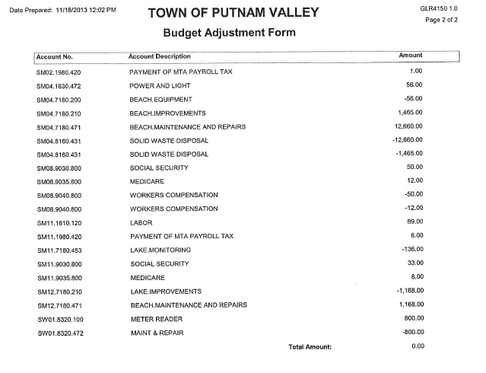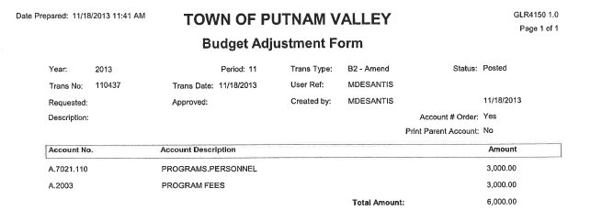

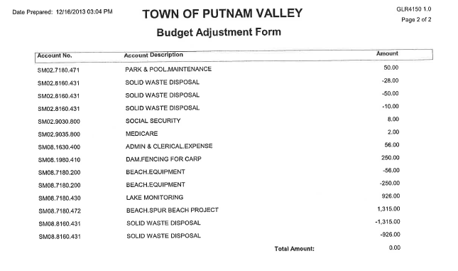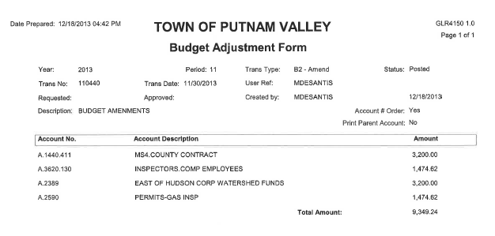
Seconded by Councilman Luongo, unanimously carried.

AUDIT OF MONTHLY BILLS

Presented by Supervisor Tendy

RESOLUTION #R13-369
RESOLVED, that the Town Board approve the following bills, after audit, to be paid:

VOUCHER NUMBERS AMOUNTS
5743 & 5850 $23,234.66
5744-5757, 5786-5791,
5801-5814, 5816-5843
5845, 5847-5849, 5852,
5833, 5855, 5908 $70,822.91
5909-5931, 5933,
5942-5954, 5971-5990 $182,699.27
5758-5776, 5785, 5789,
5792-5800, 5868-5871,
5903-5904, 5907, 5934,
5939-5941 $93, 783.47

Seconded by Councilwoman Annabi, unanimously carried.

Supervisor Tendy moved to close the meeting at 7:40 p.m.

Seconded by Councilman Mackay, unanimously carried.

Respectfully submitted,

Eileen Royael
Town Clerk 12-19-13

