REGULAR TOWN BOARD MEETING

WEDNESDAY, DECEMBER 16, 2015

7:00 P.M.

REGULAR TOWN BOARD MEETING

AGENDA

      - Pledge of Allegiance
      - Supervisor’s Opening Comments
      - Certificate of Appreciation-K. Whittaker
      - County Legislator’s Report
      - Approval of Town Board Minutes
      - School District Report
      - Appoint Deputy Town Clerk-K. McKeown
      - Authorize BAN Renewal-RBL Valve Dam Replacement
      - Resolution-Cable Transfer of Ownership
      - Resolution Increased Funding from NYS-Local Transportation Funding

11. Parks & Recreation
a. Refunds
b. Personnel
c. Accept Resignation of Senior Clerk-S. Howard
12. Building Department
a. Report for November 2015

13. DISTRICTS
a. Lake Peekskill
1. District Report
2. Authorize C-Slap Expenditure
b. Mill Ponds
1. Accept Mill Ponds End of Year Revenue
Report
14. Public Comment
15. Budget Transfers & Amendments
16. Audit of Monthly Bills
17. Adjournment
PUTNAM VALLEY
TOWN BOARD MEETING
7:00 P.M.
WEDNESDAY, DECEMBER 16, 2015

Present: Supervisor Tendy
Councilwoman Whetsel
Councilwoman Annabi
Councilman Mackay
Councilman Luongo

Also Present: Patricia Rau, Deputy Town Clerk
William Florence, Town Counsel

Supervisor Tendy opened the meeting at 7:02 pm.

AMENDMENTS TO THE AGENDA

Presented by Supervisor Tendy

RESOLUTION #R15-311

RESOLVED that the Town Board amend the agenda to include the following:

#10a- Discussion on work at Spur Beach
#10b- Discussion on Moratorium on development of cemeteries & burial grounds
#11d- Appoint Clerk for Parks & Recreation
#11e- Accept Parks & Recreation Commission Member’s Resignation- J. LaPorte
Executive Session at close of meeting with no further action taking place- Possible Litigation

Seconded by Councilman Mackay, unanimously carried.

Supervisor’s Opening Comments

Supervisor Tendy reviewed this day in history and Councilman Mackay reminded everyone to visit Niese’s Maple Farm for Christmas Presents and delicious maple bacon.

Certificate of Appreciation-K. Whittaker

Councilwoman Whetsel said this certificate was a long time coming for the work Kevin Whittaker did on repairing the grange roof, which was falling down. He took it upon himself and he and other people repaired the roof. He could not be at the meeting, but he was very deserving of the certificate.

County Legislator’s Report

Councilman Mackay said that County Legislator Scuccimarra was unable to attend the meeting tonight and that Councilwoman Annabi would read County Legislator Gouldman’s report.

Councilwoman Annabi read County Legislator Gouldman’s report.

Putnam County is currently accepting applications for 2016 Pilot Program Student Internship Program. This is for High School, College and Graduate School Students to Intern in many departments throughout the county. This program give young people a hands on real world experience and also gives them a chance to learn the role of county government in our community. The application deadline is January 15th. So you still have time. If you know some who would be interested in this go onto the Putnam County Website or just let me know. This is a great program, take advantage of it.

The Home Energy Assistance Program (HEAP) is available to all residents who qualify. It is a program that assists low income New Yorkers with the cost of heating their home. HEAP also offers an emergency benefit for households in a heat or heat related Emergency. If you need assistance please call the Putnam Department of Social Services at 845-808-1500 or go on their website.

On Dec. 10, Putnam County was granted funds through the New York State Regional Economic Development Council (REDC) initiative to develop a cooperative county-wide blueprint for the future. The state is supplying $50,000 for Putnam to lead a feasibility study with the other nine municipalities within its borders that offers solutions to critical issues pertaining to economic development and tourism throughout the county. The study is intended to be the first-step in a multiphase plan. Once the study determines ways to promote tourism and improving the hamlets and commercial districts, a strategic approach will be used to make the best use of available funding process

That’s it for me. If you would like to contact Bill, please call him at our office 845-808-1020 or email him at William.Gouldman@PutnamCountyNy.gov.

Approval of Town Board Minutes

Presented by Councilwoman Annabi

RESOLUTION #R15-312

RESOLVED, that the Town Board approve the Town Board minutes of November 4 and November 18, 2015.

Seconded by Councilman Luongo, unanimously carried.

School District Report

Supervisor Tendy didn’t have any update from the school, he asked Sam Oliverio if he did.

Mr. Oliverio stated that the 23rd is a half day for students, it is the last day before the holiday break.

Appoint Deputy Town Clerk-K. McKeown

Presented by Councilman Luongo

RESOLUTION #R15-313

RESOLVED that the Town Board appoint Kimberly McKeown as Clerk for the Town Clerk’s Office on Step 3 of the CSEA contract at $39,826 effective 1/1/2016 as she was appointed from CR-6 Civil Service Eligible List.

Seconded by Councilman Mackay, unanimously carried.

Authorize BAN Renewal-RBL Valve Dam Replacement

Presented by Councilman Mackay

RESOLUTION #R15-314

RESOLVED, that the Town Board issue a Bond Anticipation Note (renewal) in the amount of $60,000 for the Roaring Brook Lake Improvement District Valve Replacement. This amount represents the current balance of a 2013 note. The renewal rate if 1.75% and the note will be held by PCSB Bank.

Seconded by Councilman Luongo, unanimously carried.

Cable Transfer of Ownership

Discussion

Town Attorney Florence explained that this resolution came about as a request for the Town to endorse Altice’s acquisition of Cablevision Systems of Westchester. There was some back and forth between the Town and Altice but in the end, the Town was able to include a paragraph whereby Altice will honor past, current and future obligations. He added that this is not a license renewal, just an endorsement of the change. A license renewal will be coming up in May.

Presented by Councilwoman Whetsel

RESOLUTION #R15-315

RESOLUTION APPROVING THE CHANGE OF INDIRECT CONTROL OF THE
FRANCHISEE UNDER THE CABLE TELEVISION FRANCHISE

WHEREAS, Cablevision Systems Westchester Corporation ("Franchisee") owns, operates and
maintains a cable television system (the "System") in the Town of Putnam Valley, New York
pursuant to a cable television franchise ("Franchise") granted by the governing body of the Town
of Putnam Valley (the "Franchise Authority"), and Franchisee is the current duly authorized
holder of the Franchise; and

WHEREAS, pursuant to an Agreement and Plan of Merger ("Agreement"), Neptune Merger
Sub Corp., a Delaware corporation and a subsidiary of Altice N.V. ("Acquiror"), will merge with
Cablevision Systems Corporation ("Cablevision") (which owns 100olo of the ownership interests
in Franchisee), and, as a result, the indirect control of Franchisee will change (the "Change of
Control"); and

WHEREAS, Franchisee and Acquiror have requested the consent of the Franchise Authority to
the Change of Control in accordance with the requirements of the Franchise and have filed an
FCC Form 394 with the Franchise Authority (the "Application"); and

WHEREAS, the Franchise Authority has reviewed the Application, followed all required
procedures in order to consider and act upon the Application, considered the comments of all
interested parties, and concluded that Acquiror has the legal, financial and technical
qualifications of Acquiror to indirectly control Franchisee; and

WHEREAS, neither the Change of Control, nor the Franchise Authority's consent to the Change
of Control, shall modify the rights and obligations of the Franchisee or the Franchise Authority
under the Franchise as compared to the period prior to the Change of Control; and neither the
Change of Control, nor the Franchise Authority's consent to the Change of Control, shall relieve
the Franchisee or the Acquiror, or any of their successors in interest, of any responsibilities,
obligations or past, present or future liability under the Franchise, subject to applicable law,

NOW, THEREFORE, BE IT RESOLVED AS FOLLOWS:

SECTION 1. The Franchise Authority hereby accepts the Application and consents to the
Change of Control, all in accordance with the terms of the Franchise and applicable law.

SECTION 2. Subject to compliance with the terms of this Resolution, any action necessary
with respect to the Change of Control has been duly and validly taken.

SECTION 3. This Resolution shall be deemed effective as of the date of its passage.
This Resolution shall have the force of a continuing agreement with Franchisee and Acquiror,
and Franchise Authority shall not amend or otherwise alter this Resolution without the consent of
Franchisee and Acquiror.

Seconded by Councilman Mackay

Voting in Favor
Hon. Louie Luongo AYE
Hon. Steve Mackay AYE
Hon. Jacqueline Annabi AYE
Hon. Wendy Whetsel AYE
Hon. Supervisor Tendy AYE

MOTION CARRIED WITH FIVE AYES.

Increased Funding from NYS-Local Transportation Funding- TABLED

Discussion

Councilwoman Annabi read the following memo from Highway Superintendent Cobb

Supervisor Tendy said that this is important to do- we need parity of funding with the MTA, which we currently do not have. He asked Highway Superintendent Cobb if this was time of the essence. He replied that it was not, Supervisor Tendy moved to table the item until next month to provide time to look it over once more.

Discussion on work at Spur Beach

Supervisor Tendy said that the best cause of action right now would be to not do the project at this time. By the time the lake is low enough the water could freeze and the project wouldn’t be able to happen. What they are going to do is get the County Engineer and Health Department down to the beach before swim season, maybe get a variance, then do any work next fall.

Councilwoman Annabi said that right now we have a resolution to drop the lake 3.5 feet and the project would require it be dropped another 2 feet. Right now, it is too late in the year to drop the lake that much. They are working with the Board of Health and DEC- they are going to take preliminary measurements. If the slopes are safe, we will try to get a waiver to open it. She added that the bid has been given to Tompkins so it’s ready when the lake is ready. If we cancel the project, we will need to start all over with plans and approvals. We want to keep everything as is.

Supervisor Tendy said it looks like more water is coming out than there really is. It is monitored daily and ½” is coming out per day.

Councilwoman Annabi referred to the following letter from the Roaring Brook Lake Property Owners Association.

To: Putnam Valley Town Council Members
Cc. Sam Oliverio, Putnam Valley Town Supervisor Elect, and RBLPOA Board Members
Subject: Request to postpone Roaring Brook Lake lowering and Spur Beach repair

Dear Putnam Valley Town Council Members:
I am writing to request that you postpone Roaring Brook Lake lowering and Spur Beach repair at this time for the following reasons:
- Even with a best case scenario, the timing is not good. In 2008, the Spur Beach project was started in the early spring and resulted in the lake not refilling for the entire year, Since that time, the community has had a commitment (from Supervisor Tendy) that beach repair requiring additional lake lowering would be started only in the fall
- To start the third Spur Beach Project now requires an additional 2 foot draw down (a total of 6 feet). That would take at least 3 weeks, longer if there is rain. Construction would therefore begin in the winter with a high chance that it could not be completed before the time the valve should be closed to start the refilling of the lake in early spring.
- The project does not need to be done now. True, it would be pleasant to have it completed. But it would be a disaster for all of us if it were rushed to start and then not able to be finished on a timely basis because of unforeseen circumstances, e.g. winter/spring weather conditions, equipment failure, unanticipated environmental challenges.
In conclusion, ladies and gentlemen, there are many sound reasons to wait to make repairs to Spur Beach and not one good reason to risk it now.

Thank you,
Ina Cholst, President
Roaring Brook Lake Property Owners Association (RBLPOA)

A roaring Brook lake resident stated that she appreciates that they are not lowering the lake now.

Councilwoman Annabi said the lake health could be affected by lowering it too much. There is no need to rush a project just to get it done. She said she’ll keep everyone in the loop.

Discussion on Moratorium on development of cemeteries & burial grounds

Town Attorney Florence explained that there are a number of different cemeteries and burial grounds in town that are currently inactive with some of them having never been registered with New York State. There is currently some interest in reactivating them, but we do not have a zone for cemeteries. There is a lot to consider in thinking of whether there should be.

Parks & Recreation- Refunds

Presented by Councilman Mackay

RESOLUTION #R15-316

RESOLVED, that the Town Board approve the following refunds:

Katey Morley $110.00
17 Sassinoro Dr. Wrestling Club
Putnam Valley, NY 10579 Cancelled

Eileen Kelly $110.00
9 Homesdale Dr Wrestling Club
Putnam Valley, NY 10579 Cancelled

Domenica South $220.00
11 Traverse Rd Wrestling Club
Lake Peekskill, NY 10537 Cancelled

Stephen Tesher $100.00
77 Lake Drive Basketball
Lake Peekskill, NY 10537 Now coaching

David Jenness $100.00
1173 Oregon Road Basketball
Cortlandt Manor, NY 10579 Now coaching

Anthony Letizia $100.00
109 Linda Place Basketball
Cortlandt Manor, NY 10567 Now coaching

Robert Walsh $100.00
71 Sherwood Road Basketball
Cortlandt Manor, NY 10567 Now coaching

Mike Carducci $100.00
35 Sunset Hill Road Basketball
Putnam Valley, NY 10579 Now coaching

Seconded by Councilwoman Annabi, unanimously carried.

Parks & Recreation-Personnel

Presented by Councilman Mackay

RESOLUTION #R15-317

RESOLVED, that the Town Board approve the following additions/changes to personnel

- Zulima Dath, Rec Ass’t, @ $12.00 per hour.
- Patti Singer, Rec. Ass’t, @ $15.00 per hour.
- Theresa Orlando, Rec. Ass’t, @$15.00 per hour.
- Brittany Case, PVCC Rec. Ass’t., @ $9.00 per hour.
- John Taboda, Rec. Ass’t. @ $15.00 per hour.
- John Taboda, Basketball ref., @ $25.00 per hour.

Seconded by Councilwoman Annabi, unanimously carried.

Accept Resignation of Senior Clerk-S. Howard

Presented by Councilman Mackay

RESOLUTION #R15-318

RESOLVED that the Town Board accept the resignation of Sherry Howard effective January 1, 2016.

Seconded by Councilwoman Whetsel, unanimously carried.

Appoint PARKS & RECREATION Clerk-T. ORLANDO

Presented by Councilman Mackay

RESOLUTION #R15-319

RESOLVED that the Town Board appoint Theresa Orlando as Parks & Recreation Clerk on Step 1 of the CSEA contract at $37,407 effective 1/1/2016 as she was appointed from CR-6 Civil Service Eligible List.

Seconded by Councilwoman Annabi, unanimously carried.

Accept Parks & Recreation Commission Member’s Resignation- J. LaPorte
Presented by Councilman Mackay

RESOLUTION #R15-320

RESOLVED that the Town Board accept the resignation of James LaPorte as member of the Parks and Recreation commission effective December 31, 2015.

Seconded by Councilwoman Annabi, unanimously carried.

Accept Building Department Report for November 2015

Presented by Councilman Luongo

RESOLUTION #R15-321

RESOLVED, that the Town Board accept the Building Department report for the month of November 2015, for filing with the Town Clerk.

Seconded by Councilman Mackay, unanimously carried.

Lake Peekskill- District Report

Councilwoman Annabi said that holiday party last weekend was a great success and well attended.

Authorize C-Slap Expenditure- Lake Peekskill

Presented by Councilwoman Annabi

RESOLUTION #R15-322

RESOLVED that the Town Board authorize the expenditure of $410.00 for the volunteers in Lake Peekskill to participate in the New York Federation of Lakes C-slap program (Citizens Statewide Assessment program) for 2016. $360 covers the participation fee and $50 covers the NYSFOLA membership fee.

Seconded by Councilman Mackay, unanimously carried.

Accept Mill Ponds End of Year Revenue Report

Presented by Councilwoman Annabi

RESOLUTION #R15-323

RESOLVED that the Town Board accept the 2015 year end Mill Pond Water District Revenue Report:
Water Bills 10/01/2014 – 12/31/2014: $16,440.37
Collected: $13,455.25
Unpaid bills to be put on 2015 tax roll: $2,985.12
Interest and Penalties: $239.23
Total amount to be added to 2015 tax rolls: $3224.35

Water bills 1/1/2015– 10/1/2015 $54,421.72
Collected: $41,838.72
Unpaid bills to be put on 2015 tax roll $12,583.00
Outstanding credit to be collected $241.80
Total amount to be added to 2015 tax rolls: $12,824.80

TOTAL RELEVY SENT TO PUTNAM COUNTY - $16,049.15

Seconded by Councilman Mackay, unanimously carried.

Public Comment

Patty Villanova spoke about the school referendum vote for the $10 million reserve fund. A lot of people did not know about the vote- she asked the school to hold the vote in May so more people would know about it but they held it in December. The referendum passed by 44 votes and less than 10% of voters turned out. She and Dan Vera are taking an appeal to the Commissioner of Education to put the vote aside and have a new vote in May. If anyone is interested to get involved please contact her or Dan Vera- both of them are listed. Time is limited- they need people who didn’t know about the vote to come forward- they only need 50 names. She concluded by wishing Supervisor Tendy good luck in the District Attorney’s office.

Maaike Hoekstra from the Tompkins Corners Cultural Center invited the community to their next event, Master Storyteller Jonathan Kruck on Friday, December 18 at 7pm. They have had several wonderful events at the Center, including one organized by a student and performed by students that was excellent. She also asks if anyone can make a year-end donation to help the Tompkins Corners Cultural Center. For donation and event information, please visit their website www.tompkinscorners.org

Councilman Mackay wanted to remind everyone to reach out to Senator’s Katz & Serino regarding the Pudding Street Bridge. If the citizens of this community do not write to them, the project will get misplaced once again.

Sam Oliverio said will be leaving Putnam Valley High School as Assistant Principle next week. Ryan Odell will be the new assistant principal. He is a very caring and compassionate person. He also wanted to thank Supervisor Tendy foe being such a great asset in his transition to Town Supervisor. He is looking forward to next year and feels the District Attorney’s Office is in good hands with Supervisor Tendy.

Councilwoman Annabi wanted to say goodbye to Supervisor Tendy. She said it was a pleasure working with him and she enjoyed being his deputy.

Councilman Luongo wished Supervisor Tendy good luck.

Councilman Mackay wanted to thank Supervisor Tendy. He said it was a pleasure working with him for the last four years. He said he finds Supervisor Tendy to be honorable and moral and that is what they need in the District Attorney’s office.

Supervisor Tendy said it was been a pleasure and an honor serving as the Town Supervisor. His advice to board if to keep the politics out of it and keep the best interest of the Town and its residents when making decisions.

Budget Transfers & Amendments

Presented by Supervisor Tendy

RESOLUTION #R15-324

RESOLVED, that the Town Board approve the following budget transfers and amendments as submitted by bookkeeper Maria Angelico:



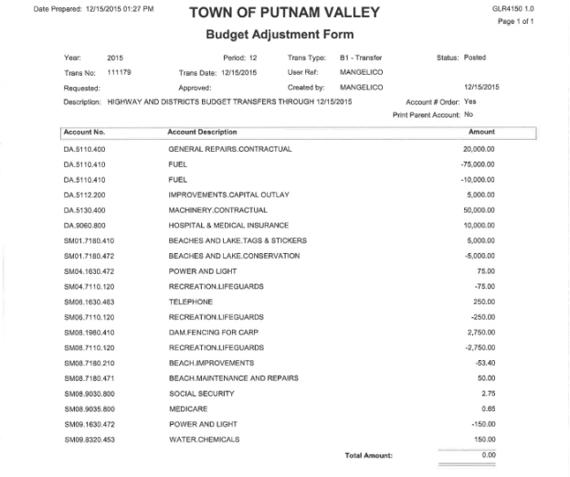

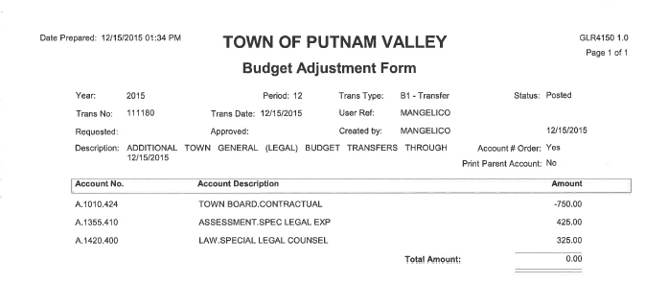

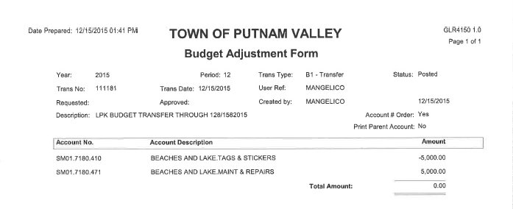
Seconded by Councilwoman Annabi, unanimously carried.

Audit of Monthly Bills

Presented by Supervisor Tendy

RESOLUTION #R15-325

RESOLVED, that the Town Board approve the following bills, after audit, to be paid:

VOUCHER AMOUNT
13874-13879; 13899-13905; 13923-13932;
13937-13942; 13944-13945; 13954-13988 $42,904.41
13711-13713;13804-13825; 13838-13839;
13880-13886; 13933-13936; 13946 $58,003.25
13776; 13779; 13781; 13783-13793, 13840-13848;
13887-13893; 13895-13898;13947-13953 $41,345.04
13751-13780; 13782; 13794-13803; 13826-13837 $73,456.48

Seconded by Councilwoman Whetsel, unanimously carried.

Supervisor Tendy moved to go into Executive Session regarding possible litigation with no further business taking place at 7:57 PM. Seconded by Councilman Mackay, unanimously carried.

Respectfully submitted,

Patricia Rau
Deputy Town Clerk
12-21-2015

