PUTNAM VALLEY TOWN BOARD
PUBLIC HEARINGS
6:00 P.M.
WEDNESDAY, NOVEMBER 5, 2014

PUBLIC HEARINGS
6.00 P.M.
TO HEAR PUBLIC COMMENTS ON A PROPOSED LOCAL LAW TO OVERRIDE THE TAX LEVY LIMIT ESTABLISHED IN GENERAL MUNICIPAL LAW-3C.

IMMEDIATELY FOLLOWING
TO HEAR PUBLIC COMMENTS ON THE 2015 PUTNAM VALLEY VOLUNTEER FIRE DEPARTMENT CONTRACT

IMMEDIATELY FOLLOWING
TO HEAR PUBLIC COMMENTS ON THE 2015 PRELIMINARY TOWN/HIGHWAY AND DISTRICT BUDGET

PUTNAM VALLEY TOWN BOARD
PUBLIC HEARINGS
6:00 P.M.
WEDNESDAY, NOVEMBER 5, 2014

Present: Deputy Supervisor Annabi

Councilwoman Wendy Whetsel
Councilman Mackay
Councilman Luongo

Absent: Supervisor Tendy
Town Counsel Zutt

Also Present: Eileen Royael, Town Clerk
Maria Angelico, Finance Director

TO HEAR PUBLIC COMMENTS ON A PROPOSED LOCAL LAW TO OVERRIDE THE TAX LEVY LIMIT ESTABLISHED IN GENERAL MUNICIPAL LAW-3C.

Deputy Supervisor Annabi opened the Public Hearing at 6:00 p.m.

Deputy Supervisor Annabi explained that under Municipal Law, the tax cap limit pursuant by law can be overridden by 60% of the vote of the Town Board. This year’s statuary cap is 1.56% and if the law is adopted it will permit the Town Board to override the tax cap if necessary.

No comments

Deputy Supervisor Annabi motioned to close the public hearing at 6:01 p.m.

Seconded by Councilman Mackay, unanimously carried.

AMENDMENTS TO THE AGENDA

Presented by Deputy Supervisor Annabi

RESOLUTION # R 14-288

RESOLVED, that the Town Board amend the agenda to add an Executive Session just before the 2015 Town/Highway public hearing to discuss personnel matters.

Seconded by Councilman Mackay, unanimously carried.

TO HEAR PUBLIC COMMENTS ON THE 2015 PUTNAM VALLEY VOLUNTEER FIRE DEPARTMENT CONTRACT

Deputy Supervisor Annabi opened the Public Hearing at 6:02 p.m.

Jim LaPorte, Chairman of the Putnam Valley Volunteer Fire Dept. read the following letter:

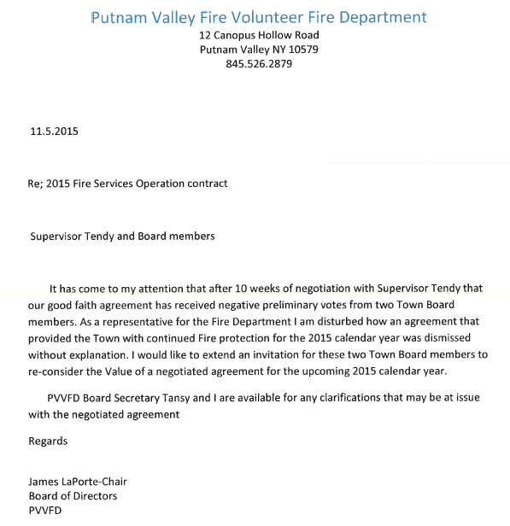

Councilwoman Annabi told Mr. LaPorte that she did not receive your budget contract proposal until last week and the numbers we were working with we believed were true and accurate. Reducing the LOSAP from $185,000 to $150,000 is not a good idea in her opinion. She recommended leaving the LOSAP at $185,000. She added that the Tentative Budget was at $920,000, it was knocked down last week to $813,000.

Frank Tansey, member of the Board for the Putnam Valley Volunteer Fire Dept. told the Town Board members that the original amount requested was $969,925.

Councilwoman Annabi told the members of the fire department that the Town Board is looking to meet them half way.

AMENDMENT TO THE AGENDA

Presented by Deputy Supervisor Annabi

RESOLUTION # R 14-289

RESOLVED, that the Town Board amend the agenda to add an Executive Session to discuss contractual matters.

Seconded by Councilman Mackay, unanimously carried.

Deputy Supervisor Annabi motioned to go into Executive Session at 6:10 p.m. to discuss contractual matters.

Seconded by Councilman Mackay, three ayes, Councilman Luongo recused himself.

SUPERVISOR TENDY ENTERED PUBLIC HEARING AT 6:10 P.M.

Public Hearing resumed at 6:28 p.m.

Jim LaPorte, Chairman of the Putnam Valley Volunteer Fire Dept. thanked the Town for supporting the fire department.

Councilman Luongo noted that he chose not to be part of the fire department’s budget discussion due to his involvement in the fire department.

Town Board has agreed to put the Putnam Valley Volunteer Fire Dept.’s budget at $900,000 and to put LOSAP at $185,000.

Supervisor Tendy moved to close the Public Hearing at 6:30 p.m.

Seconded by Councilman Mackay, unanimously carried.

TO HEAR PUBLIC COMMENTS ON THE 2015 PRELIMINARY TOWN/HIGHWAY AND DISTRICT BUDGET

Supervisor Tendy opened the Public Hearing at 6:30 p.m.

Faith Oland, member of the Putnam Valley Free Library Board told the Town Board that the library received no notification that their budget request was reduced. The library has been open during the construction; employees have been working and have been paid. We have no budget surplus and have not received any grant money. They are continuing to apply for aid for the stream erosion, will have to replace bridge and pedestrian bridge due to the erosion from the storm water. The library needs to continue to receive town aid.

Kathleen McLaughlin added that the library’s electrical and snow removal lines are over. The staff has continued to work during the construction and roof leaks have been repaired. The library has been notified that they need to upgrade their software. The library cannot afford to have the budget cut.

A resident who uses the library told the Town Board that libraries are an important part of communities. She has joined the Book Club and visits the library weekly. The library has to be considered part of our educational system. She asked for their budget not to be cut.

Councilwoman Whetsel agrees that the library is an important part of our community. It is a place where our residents go and we need to continue to support the library.

Supervisor Tendy suggested keeping the budget line at the 2014 budget level, $278,307.00 instead of reducing it to $228,307.00. It would be reckless of this Town Board to reduce the budget to $228,307. He noted that we have to take care of our residents. No one can say that this Board hasn’t been responsible with the budget. New York State wants us to meet the cap, they do not cut their expenses, but expect the municipalities to cut the expenses and reduce the services to our residents. I think we should ignore the tax cap, 2%-3% increase use to be a great budget.

Councilwoman Whetsel agrees but would like to keep the increase at no more than 2%.

Councilman Mackay added that we can’t have it both ways. You can’t keep the budget at 2% and still be able to provide the services to our residents.

Councilwoman Annabi disagrees; she suggested the library’s budget line go back to the 2013 level at $272,850, find ways to make that work.

Faith Oland asked what the Town Board suggests the library cut in order to stay at the 2013 level.

Councilwoman Annabi noted that there is a $77,000 difference in the library’s revenue line from what the budget request was for 2015. She asked if they get donations for this line to be increased this much.

Kathleen McLaughlin told the Town Board that the Library Board prepares the budget. The expenses and revenue lines are projections, not actual. During the course of the year she has to make cuts so the budget lines don’t go over.

Supervisor Tendy added that he can’t think of a single group or department that could work off a 2013 budget line.

Kathleen McLaughlin told the Town Board that they work very hard to maintain the services the library provides. Town of Patterson’s library budget is $603,000 and the Town of Kent’s library budget is $564,000. We can’t do with less employees, if we do we would be cutting safety issues.

Councilman Luongo added that the Town Board has more information on the costs of running the library than in the past. He feels that they have enough information to figure out what to do. He knows people who use the library daily.

Faith Oland invited the Town Board to stop by the library, you will see residents using the library.

Councilwoman Annabi added that the library offers a lot to the residents at no cost, but the Town Board’s job is to go line by line to try to save money.

Town Board decided to put the library’s 2015 budget at $278,307 (2013 level).

George Stockinger, President of the Putnam Valley Ambulance Corps and Captain Danielle Diorio apologized to the Town Board as they thought that a 2015 budget request was submitted. They told the Town Board that they are okay with what the 2014 budget was ($245,893), medical supplies has increased, we have to buy EBOLA equipment and have monthly training on it, as mandated by New York State. If they keep cutting corners they will not have enough money left by August 2015. They are asking for the budget not to be cut by $45,893.

Supervisor Tendy asked if it is possible to do it on the 2014 level.

Councilman Mackay suggests putting their budget line to the 2014 level, as he envisions the rigs to be shorts of supplies by next August.

Councilman Luongo agrees that their budget line should be at the 2014 level and not cut. Asked for them to submit more information before the next meeting.

Supervisor Tendy motioned to go into Executive Session to discuss personnel matters at 7:15 p.m.

Seconded by Councilman Mackay, unanimously carried.

Public Hearing resumed at 7:51 p.m.

Supervisor Tendy discussed the Management increases for the 2015 Town/Highway/District Budget.
Building Inspector line to be $51,510, plus his other lines which will bring total salary to $64,000.
Finance Director- $60,000
Supervisor, Administrative Secretary, and part-timers to get 2.5% increase
Assessor- 3% increase
Facilities Manager- 3% increase
Highway Superintendent- 4 % increase
Court Judges -5 % increase
Town Clerk -3%
Parks & Recreation Director- 3%
Town Videographer- 3%
Supervisor Tendy noted that until this year the Manager’s salaries have been below the inflation rate, and this needs to be addressed every year.

Councilman Luongo asked before the salary changes, where we are now with no fund balance being taken:
Library $278,307
Fire Department $900,000 plus $185,000 LOSAP
Ambulance Corps $245,893

Finance Director Angelico responded it would be a 4.3% tax increase
If we took $105,000 out of fund balance it would be a 3.2% increase
If we took $125,000 out of fund balance it would be a 3% increase, on a home assessed at $500,000 there would be a $71.29 increase in taxes.

Councilwoman Annabi asked what it would be if we took $175,000 out of fund balance.

Finance Director Angelico responded 2.48% tax increase.

Councilman Mackay noted that next year we will have to start consolidating services.

Supervisor Tendy added that he does not know what else we can consolidate as we have consolidated as much as we can.

Esther McHenry, told the Town Board that they could take the $1000 out of the Putnam Valley Arts line as that committee has not met in three years.

Councilwoman Annabi responded that it does exist.

Supervisor Tendy wants to leave the $1000 in that line and encourage rejuvenation of that committee.

Supervisor Tendy moved to adjourn the public hearing at 8:06 p.m. on a daily basis until November 12, 2014. Seconded by Councilman Mackay, unanimously carried.

Respectfully submitted,

Eileen Royael
Town Clerk 11-7-14

