PUTNAM VALLEY TOWN BOARD
TOWN BOARD MEETING
7:00 P.M.
WEDNESDAY, NOVEMBER 20, 2013

1. Pledge of Allegiance
2. Supervisor’s Opening Comments
3. Accept Proposal-Unique ATM Solutions-TABLED 11-13-13
4. ENERPATH Lighting Program Presentation-D. Andrick
5. Approval of Town Board Minutes
6. County Legislators Report
7. School District Report
8. Accept 2014 CSEA Holiday Schedule
9. Authorize Glenmar Gardens Water Improvement Ban
Renewal

10. Parks & Recreation
a. Refunds
b. Personnel

11. Building Department
a. Report for October 2013

12. Highway
a. Appoint Snow Plow Riders

13. DISTRICTS
a. Lake Peekskill
1. District Report
b. Wildwood Knolls
1. Accept Wildwood Knolls Revenue Report

14. Public Comment
15. Budget Transfers & Amendments
16. Audit of Monthly Bills
17. Adjournment

PUTNAM VALLEY TOWN BOARD
TOWN BOARD MEETING
WEDNESDAY, NOVEMBER 20, 2013
7:00 P.M.

Present: Supervisor Tendy
Councilwoman Whetsel
Councilwoman Annabi
Councilman Mackay
Councilman Luongo

Also Present: Eileen Royael, Town Clerk
William Zutt, Town Counsel

Supervisor Tendy opened the meeting at 7:00 p.m.

AMENDMENTS TO THE AGENDA

Presented by Supervisor Tendy

RESOLUTION #R 13- 333

RESOLVED that the Town Board amend the agenda to add the following:

Remove #3- Accept Proposal-Unique ATM Solutions
#9a Authorize Town Clerk (License Issuing Agent) to sign New York State DEC License Issuing Agent Agreement
#10c Amend Resolution R13-201 for additional work charged for guardrail work at Town Park-F.W.Rush Construction
Add Executive Session to discuss personnel matter.
Seconded by Councilwoman Annabi, unanimously carried.

SUPERVISOR’S OPENING COMMENTS
Supervisor Tendy read a letter that he received from a resident who appreciated all the help they received from John Landi, Putnam Valley Building/Zoning Inspector, Larry Cobb, Putnam Valley Highway Superintendent/Putnam Valley Volunteer Fire Dept. President and the Putnam Valley Volunteer Fire Department. Supervisor Tendy thanked them all and noted that this is a well-deserved recognition. He added that on December 14th, the annual Holiday Event will be happening at the Town Park at 6:00 p.m. They will be collecting food for the food pantry as well as writing letters to soldiers. Santa will also be visiting. On November 30th, December 1st, 2nd, 7th and 8th the annual Holiday Boutique will be taking place at the Putnam Valley Historical Museum. The week of December 2nd- December 6th, there will be a movie being filmed on Lake Oscawana, so there will be some traffic in town.
ENERPATH LIGHTING PROGRAM PRESENTATION-D Andrick
Mr. Andrick never showed up at meeting
APPROVAL OF TOWN BOARD MINUTES
Presented by Councilman Luongo

RESOLUTION # R 13- 334

RESOLVED, that the Town Board approve the Town Board Minutes of October 2, October 9, October 16 and October 23, 2013.
Seconded by Supervisor Tendy, unanimously carried.
COUNTY LEGISLATOR REPORT
County Legislator Oliverio told the residents that the final 2014 County Budget came in at 1.65% and at this point we are wrapping the year end up balancing the books. He congratulated Anthony DiCarlo and Kevin Wright for their election wins and he added that Kevin Wright will be taking Richie Othmer’s seat on the legislature as he will be the Kent Highway Superintendent in January. He wished everyone a wonderful Thanksgiving.
LIBRARY REPORT
Priscilla Keresey, President of the Putnam Valley Library Board along with other board members asked the Town Board if they had any questions in regard to the construction at the library.
Supervisor Tendy responded that a lot of their questions were answered at the last meeting but would like to know how long the bridge will be out as he is concerned that it is not in good shape. If we get a ton a rain he is concerned that there will be more damage to the bridge. He also told the Library Board members that if there is anything that the town can do to help, please let us know.
Priscilla Keresey told the Town Board that their engineers and contractors felt that they could get the building done quickly in order to get it open. She asked the Town Board for a letter of support as they will be submitting for grant. A lot of the damage to the building and bridge is from Hurricane Irene and Sandy. The hill behind the library is like a waterfall during a big rainstorm. After the repairs are made the library is looking to build a retaining wall along the stream. If anyone has any questions as there is a lot of misinformation out there they can contact Priscilla at 914-672-9741 or Terry at 914-954-5388 or email Kathleen McLaughlin at kmclaughlin@putnamvalleylibrary.org.
SCHOOL DISTRICT REPORT
On December 13th, 14th and 15th the High School will be performing the “Twelve Angry Jurors”, on December 17th the 5& 6th grade Chorus will be performing at 7:00 p.m. and on December 18th, the 7th & 8th graders Chorus will be performing at 7:00 p.m. The PTSA will be holding an auction on November 23rd at the Putnam Valley Ambulance Corps building.
County Legislator Oliverio noted that an organization called “Coalition that Cares” is tackling high level issues facing our youngsters in Putnam County. Parents are not alone, as this organization is there to help with the serious heroin drug problem in our town, they meet every month in Putnam Valley.
ACCEPT 2014 CSEA HOLIDAY SCHEDULE
Presented by Councilman Mackay
RESOLUTION # R 13-335
RESOLVED, that the Town Board accept the 2014 CSEA Holiday Schedule
The CSEA Union respectfully requests the following holidays as per our contract:
January 1 | Wednesday | New Year's Day
January 20 | Monday | Martin Luther King Jr. Day
February 17 | Monday | President's Day
April 18 | Friday | Good Friday
May 26 | Monday | Memorial Day
July 4 | Friday | Independence Day
September 1 | Monday | Labor Day
October 13 | Monday | Columbus Day
November 11 | Tuesday | Veteran's Day
November 27 | Thursday | Thanksgiving
November 28 | Friday | Day after Thanksgiving
December 24 | Wednesday | Christmas Eve
December 25 | Thursday | Christmas Day
December 31 | Wednesday | New Year's Eve

Seconded by Councilwoman Annabi, unanimously carried.
AUTHORIZE GLENMAR GARDENS WATER IMPROVEMENT BAN RENEWAL
Presented by Councilwoman Whetsel

RESOLUTION #R13- 336

RESOLVED, that the Town Board authorize the Glenmar Garden Water Improvement Bond Anticipation Note Renewal in the amount of $45,000.00 for the Glenmar Gardens Water Project. This amount represents the current balance of a 2002 note. The renewal note is 1.5% and the note will be held by Putnam County Savings Bank.
Seconded by Councilwoman Annabi, unanimously carried.
AUTHORIZE TOWN CLERK (LICENSE ISSUING AGENT) TO SIGN New York STATE DEC LICENSE ISSUING AGENT AGREEMENT
Presented by Supervisor Tendy

RESOLUTION #R13- 337

RESOLVED, that the Town Board authorize the Town Clerk, the License Issuing Agent, to sign the New York State DEC License Issuing Agent Agreement.
Seconded by Councilman Luongo, unanimously carried.
PARKS & RECREATION REFUNDS

Presented by Councilwoman Annabi

RESOLUTION #R13- 338

RESOLVED, that the Town Board approve the following refunds:

Karen Curtis $50.00
102 Lake Drive LPCC
Lake Peekskill, NY 10537 Partial Refund

Anne DaHon $50.00
9 Northway Basketball
Lake Peekskill, NY 10537 Unable to play

Mrs. Acosta $50.00
20 Rock Hill Road Basketball
Putnam Valley, NY 10579 Overpaid

Daniela Spitzer $95.00
21 Watson Way Basketball
Putnam Valley, NY 10579 League Cancelled

Kaiden Patterson $95.00
5 Rose Street Basketball
Putnam Valley, NY 10579 Unable to play

Ann Dalton $50.00
9 Northway Basketball
Lake Peekskill, NY 10537 Unable to play

Seconded by Councilman Mackay, unanimously carried.

PARKS & RECREATION- PERSONNEL APPOINTMENTS/ ADJUSTMENTS

Presented by Councilwoman Annabi

RESOLUTION #R 13- 339

RESOLVED, that the Town Board approve the following additions/changes to personnel:

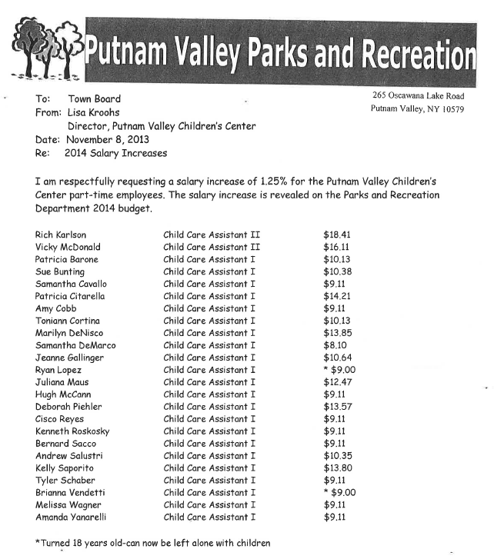

- Michael Rufo, Children’s Center Ass’t. - Increase from $9.00 to $10.00 an hour as he is now the Gym Supervisor .
- Brian Fitzmaurice, Children’s Center Ass’t, @ $10.00 per hour.
- Kelsey McCann, Rec. Ass’t, @ $9.00 pr hour.
- Crystal Galloway, Rec. Ass’t, 2 $10.00 per hour.
- Mike Camastro, Wrestling Coordinator, $1500.00 for program.
- Charles Stockinger, $45.00, basketball ref.
- Michael Rufo, $15.00 for door monitor @ basketball.
- Michael Rufo, $25.00, basketball ref.
- Bernie Sacco, $15.00 for door monitor.
- Bernie Sacco, $25.00, basketball ref.
- Anthony Tyndal, $15.00, door monitor.
- Anthony Tyndal, $25.00, basketball ref.
- Kristie Dini, basketball evals. $15.00 per hour.
- Kristie Dini, Basketball ref. $30.00 basketball ref.
- Tom McMahon, Basletball Ref. @ $45.00 per hour.
- Ray Straub, Basketball League Coordinator, @ $500.00 for season.
- David Dorion, Basketball Ref., @ $45.00 per hour.
18.William Lambert, Basketball Ref., $45.00 per hour.

Seconded by Councilman Luongo, unanimously carried.

AMEND RESOLUTION #R13-201 ADDITIONAL WORK CHARGED FOR GUARDRAIL WORK AT TOWN PARK-F.W. RUSH CONSTRUCTION

Presented by Supervisor Tendy

RESOLUTION #R13 - 340

RESOLVED, that the Town Board amend Resolution # R13-201 , the previously approved contract from F.W. Rush General Construction in the amount of $16,500 to $18,700, a total of $1,950 in order to allow for changes that were requested by this department due to the extensive amount of rock removal.

Seconded by Councilman Mackay, unanimously carried.

BUILDING DEPARTMENT REPORT

Presented by Councilman Luongo

RESOLUTION #R13 - 341

RESOLVED, that the Town Board accept the Building Department report for the month of October 2013, for filing with the Town Clerk.

Seconded by Councilwoman Annabi, unanimously carried.

APPOINT SNOW PLOW RIDERS

Presented by Councilman Mackay

RESOLUTION # R13 - 342

RESOLVED that the Town Board appoint the following as snow plow riders for the year 2013-2014 at the rate of $11.44 per hour with no benefits:

1. Paul Benben 8. Meagan Mckin
2. Jason Cobb 9. Kevin Powderly
3. Travis Gembecki 10. Tyler Quast
4. Joe Grieco 11. Jovan Rondon
5. Andre Halloch 12. Jonathan Schulz
6. Chris Lutz 13. Jonathan Warden
7. Jimmy Lutz 14. Jeremy Whalen
15. William Kneuer
Seconded by Councilman Luongo, unanimously carried.
LAKE PEEKSKILL REPORT

Councilwoman Annabi announced that on December 14th “Meet Santa” will be taking place at the Lake Peekskill Community Center from 1:00 p.m. to 3:00 p.m.

ACCEPT WILDWOOD KNOLLS REVENUE REPORT
Presented by Councilwoman Whetsel
RESOLUTION # R 13-343
RESOLVED, that the Town Board accept the 2013 year end Wildwood Knolls Facilities Revenue Report, total facilities revenue $1,000.00. Original warrant presented in March was $1,900, but nine families chose not to use this facility in 2013.
Seconded by Councilman Luongo, unanimously carried.
DISCUSSION ON PROPOSED TOWN HALL ADDITION
Supervisor Tendy told the residents that the town had received a $250,000 grant from NYS to put an addition onto Town Hall along with a $60,000-$70,000 grant for photovoltaics to go onto the proposed addition roof. We are running out of room, we have files everywhere. There is also a security issue for the court that must be corrected in the next couple of years and this will be mandatory. The grant money will pay for 1/3 of the cost of the addition and if we don’t use that money we will lose it, eventually we will have to build an addition and it is in our best interest to do that work now. The New York State Troopers have shown an interest in taking a room in our Parks & Recreation building, which would put them local. We are planning on putting the Assessor, Building, Planning and Zoning in the new addition as they all share the same records. Parks and Recreation could then come over here and take those offices.
Susan Manno, Town Facilities Manager explained that the new addition would be 3100 square feet and house the departments that Supervisor Tendy stated. We went out to bid and the first time we received only one bid so we went back out to bid and then received three bids. She noted that we are almost at capacity in regard to files and storage. We store some records at the county and we have a trailer in the back of our town hall that houses files.
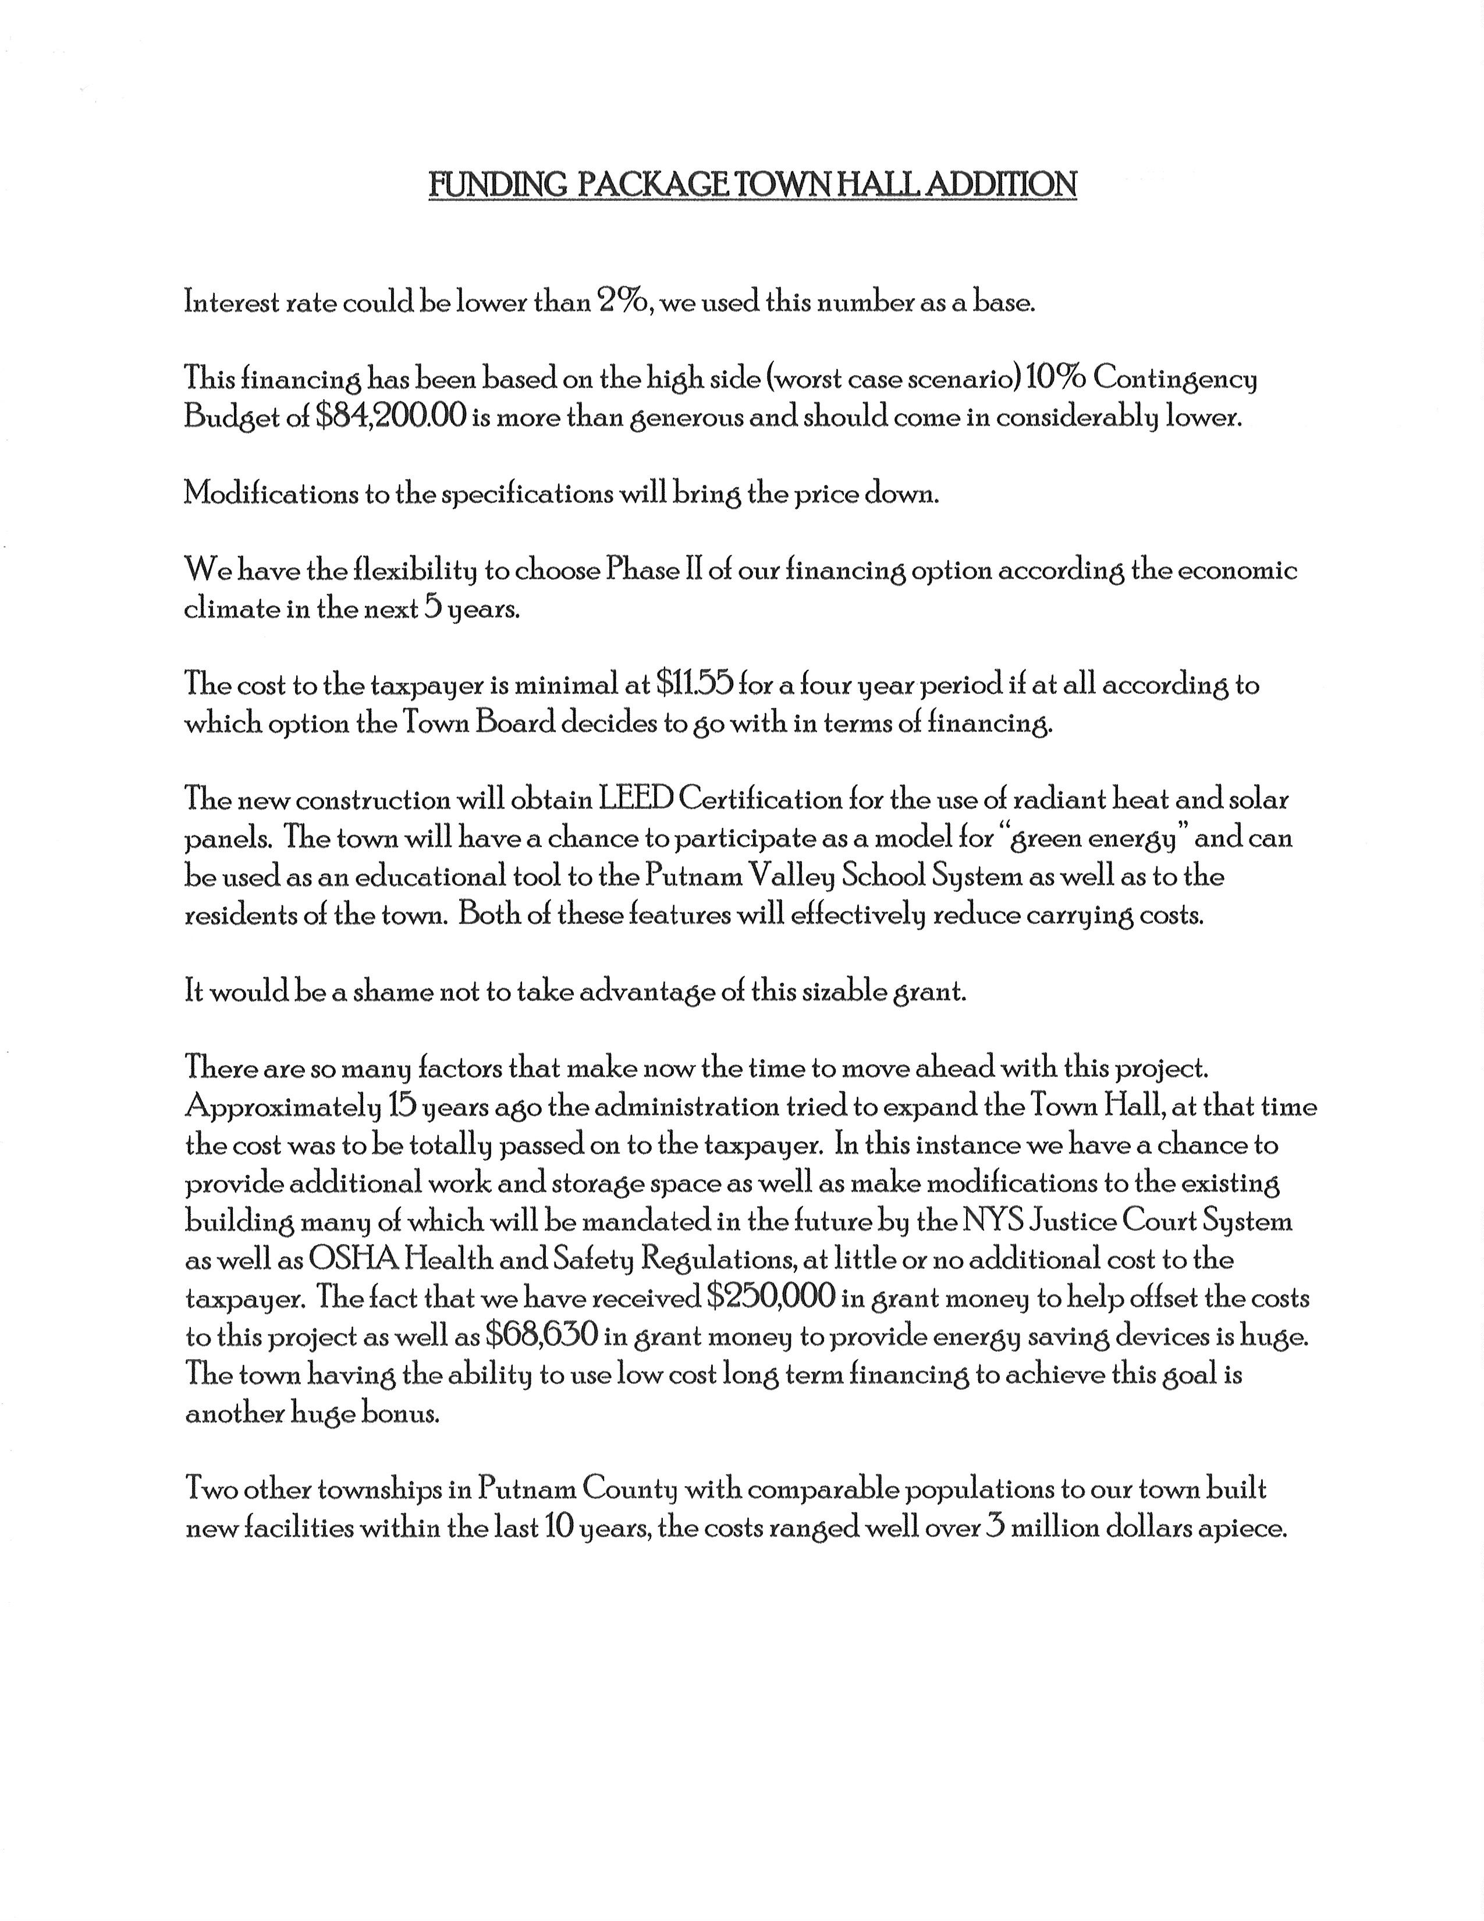
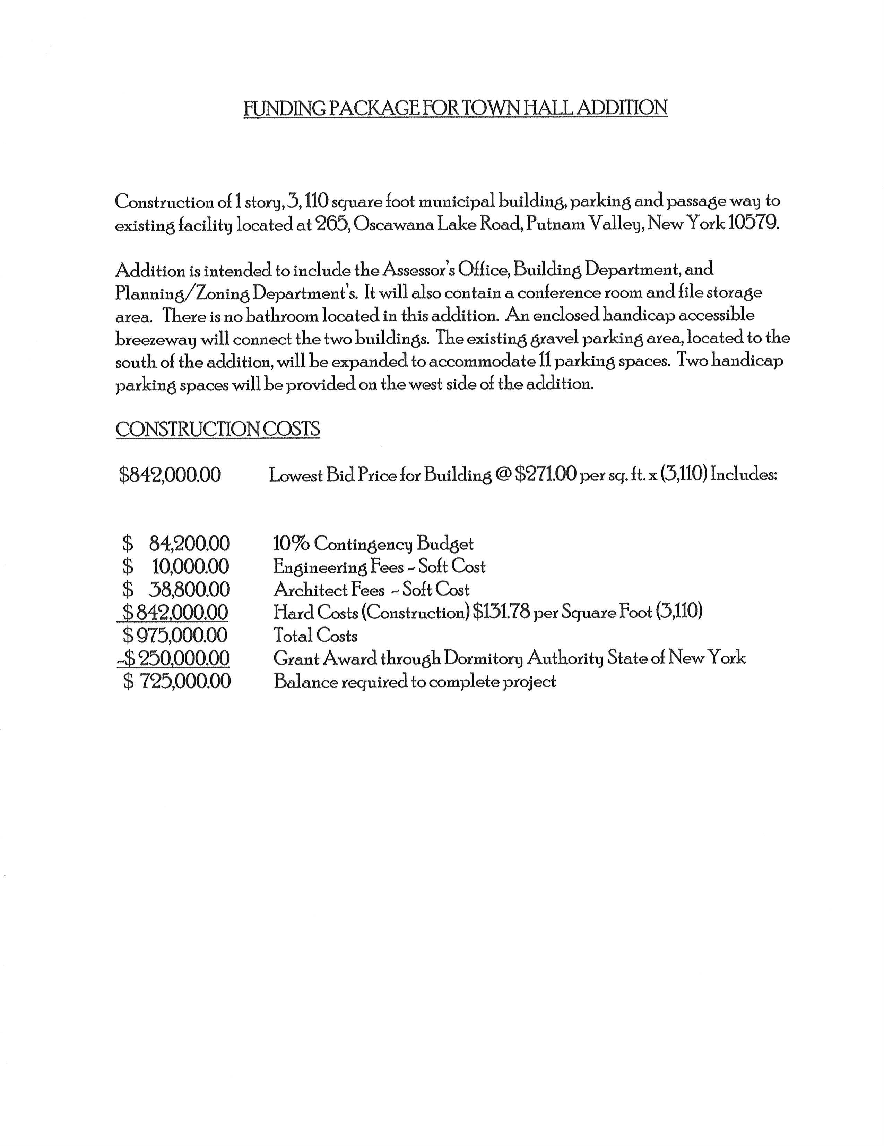
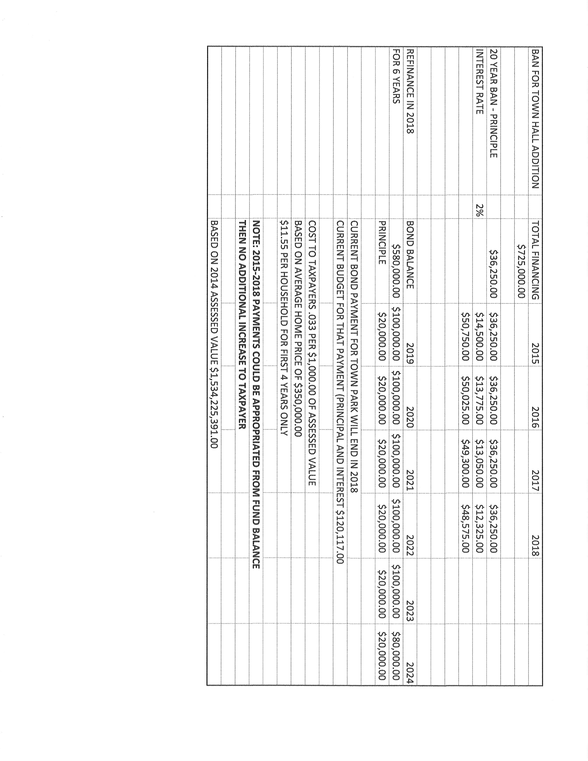
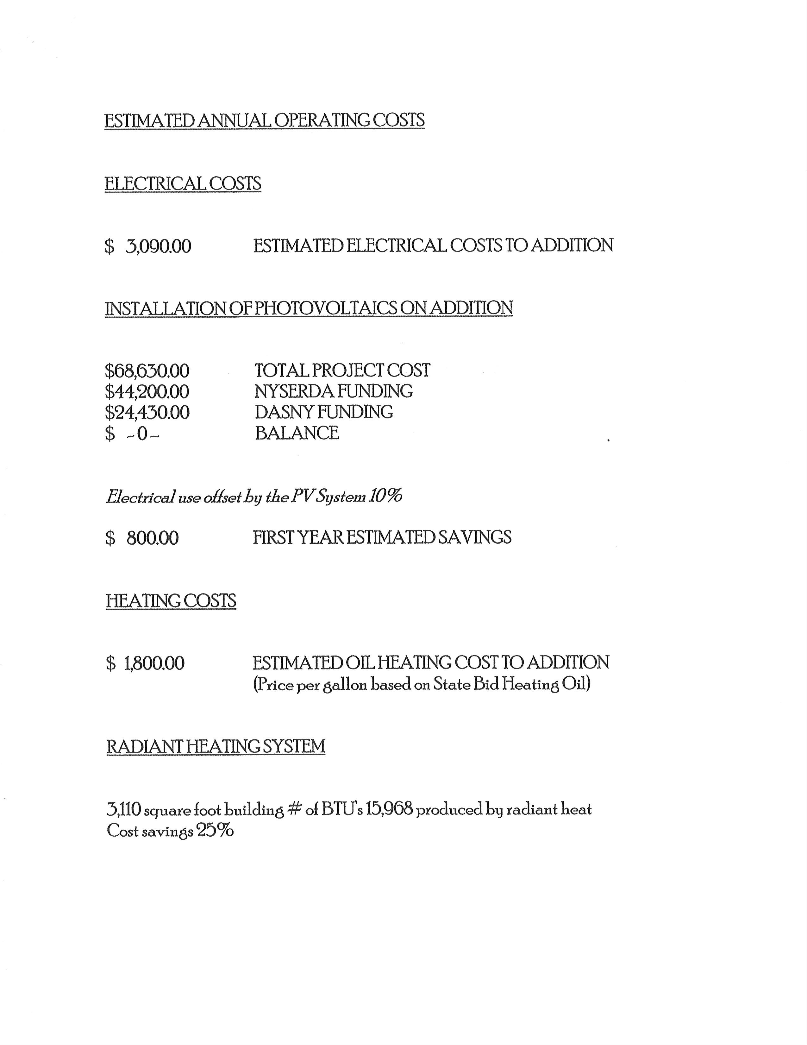
John Landi, Building/Zoning Inspector added that there are space constraints with personnel and files. He added that he and the Town Engineer are evaluating the heating system to bring the costs down.
Councilwoman Annabi would like to see if there is a way to bring the costs down.
John Landi noted that because the town has to pay prevailing wage the cost is tripled.
Supervisor Tendy feels that we have to do this and maybe put it on the agenda in December.
PUBLIC COMMENT

Supervisor Tendy announced that on November 21st at 6:00 p.m., Senator Ball will be holding the 3rd Annual Veterans Hall of Fame at Mahopac Falls Elementary School. Laurence Gibbs, a resident of Putnam Valley will be receiving this award.

Supervisor Tendy also noted that this Sunday, November 24th, at Elizabeth Ann Seton Church, the Readers Theatre will be presenting “Touching the Soul”, from 4:00 -6:00 p.m.

Councilwoman Annabi added that on December 14th at the “Holiday Event” at the Town Park, the scouts will be having a special ceremony to burn torn old flags at 5:00 p.m.

Supervisor Tendy also noted that the Boy Scouts will be selling the Christmas Trees at Adams Corners and also Christmas Wreaths at Oregon Corners.

Councilwoman Whetsel announced that there will be a Holiday Boutique on December 14th at the Putnam Valley Grange.

BUDGET TRANSFERS AND AMENDMENTS

Presented by Supervisor Tendy

RESOLUTION #R 13- 344

RESOLVED, that the Town Board approve the following budget transfers and amendments as submitted by bookkeeper Marianne DeSantis:

Seconded by Councilman Luongo, unanimously carried.

AUDIT OF MONTHLY BILLS

Presented by Supervisor Tendy

RESOLUTION # R 13-345

RESOLVED, that the Town Board approve the following bills after audit, being paid:

VOUCHER NUMBERS AMOUNTS
5439 & 5440 $73,532.37
5359-5375, 5377-5384,
5423-5434, 5436-5438,
5451-5460, 5467-5469,
5499-5515, 5549-5565 $77,474.01
5630, 5632, 5633, 5635,
5639-5642, 5645, 5646,
5648-5650, 5652-5674,
5685-5690, 5693-5702 $76,755.03
5246-5248, 5302-5308,
5328, 5385-5400,
5486-5498, 5516-5530,
5566, 5575-5580,
5620-5622, 5675-5676 $103,820.87
5441-5450, 5461-5466,
5531-5548, 5567-5684,
5703-5707 $50,256.61

Seconded by Councilwoman Annabi, unanimously carried.

Supervisor Tendy moved to go into Executive Session to discuss a personnel matter at 8:20 p.m. with no further business taking place.
Seconded by Councilwoman Annabi, unanimously carried.

Respectfully submitted,

Eileen Royael
Town Clerk 11-27-13

