PUTNAM VALLEY TOWN BOARD
PROPOSED 2016 PRELIMINARY TOWN/HIGHWAY BUDGET WORK SESSION
6:00 P.M.
TOWN BOARD MEETING
7:00 P.M.
WEDNESDAY, October 21, 2015

1. Pledge of Allegiance
2. Supervisor’s Opening Comments
3. NYS Department in Taxation and Finance- Excellence in
Equity Award
4. School District Update-Superintendent Fran Willis
5. County Legislator’s Report
6. Certificate of Appreciation-Achievement of Girl Scout
Silver Award
7. Approval of Town Board Minutes
8. School District Report
9. Set Public Hearing on Proposed Local Law to Override Tax
Levy Limit Established in General Municipal Law-3C
10. Set Public Hearing Date for Public Comment on the
2016 Putnam Valley Volunteer Fire Dept. Contract
11. Set Public Hearing Date for Public Comment on the
Proposed 2016 Town/Highway/District Preliminary Budget
12. Discussion on Transfer Station

DEPARTMENTS
13. Parks & Recreation
a. Personnel
14. Building Department
a. Report for September 2015
15. Highway
a. Authorize Highway Department to Go Out to Bid for
2016 Materials
16. DISTRICTS
a. Lake Peekskill
1. District Report
2. Appoint Temporary Laborer
17. Public Comment
18. Budget Transfers & Amendments
19. Audit of Monthly Bills
20. Adjournment
PUTNAM VALLEY TOWN BOARD
2016 PRELIMINARY BUDGET WORK SESSION
6:00 p.m.
REGULAR TOWN BOARD MEETING
7:00 P.M.
WEDNESDAY, OCTOBER 21, 2015

PRESENT: Supervisor Tendy
Councilwoman Whetsel
Councilwoman Annabi
Councilman Mackay
Councilman Luongo

ALSO PRESENT: Town Clerk Eileen Royael
Town Counsel Florence
Finance Director Angelico

2016 PRELIMINARY BUDGET WORK SESSION

Supervisor Tendy told the residents that at last weeks’ Budget Work Session, they were able to bring the budget down to 4.01%. If our town would have come in at 0% we still would have come in at 3% due to the state mandates. New York State wants us to cut services to get to the tax cap; we can’t keep taking out of our fund balance to reduce the budget.

Maria Angelico, Finance Director noted that Councilwoman Annabi raised the valid point of the calculation for the tax cap. When she filled out the New York State Form, our tax cap is still .73%, we get no relief for growth factor. Based on the last meeting including the managers raises 2% across the board, and taking out $20,000 each from the retirement and health coverage, took a little from other lines it brought us down to 4.01%

Councilwoman Annabi feels there are additional lines that can be cut. Highway Superintendent Cobb said he can take from their fund balance so there won’t be an increase in the highway budget. We took down the Parks & Rec Sports line by $5,000, but Frank DiMarco said we need to put it back in as it is needed for the programs. The day camp revenue line can be increased by $10,000 and we have had discussions on a salary reduction for the maintenance position that will be open in 2016.

Supervisor Tendy asked Finance Director Angelico what the percent change will be with these additional changes.

Finance Director Angelico responded 3.16%

Councilwoman Annabi met with the fire department and they have agreed to reduce their request by $7,000. She would also like more money taken from the retirement and health coverage.

Finance Director Angelico is not comfortable doing that. She explained that the state gives us a range so the $20,000 we took out is it.

Councilman Mackay and Supervisor Tendy agree with Finance Director Angelico, not to decrease those lines anymore.

Councilwoman Whetsel asked what the tax increase will be if we took $50,000 out of fund balance.

Finance Director Angelico responded that it would put us at 2.58%.

Councilman Luongo doesn’t want to burn up our savings. He asked the Finance Director to give it to us in dollars.

Finance Director Angelico told the Town Board without taking fund balance money, on a $300,000 home; the increase would roughly be about $35 per household.

Councilwoman Annabi also would like to decrease A1110.424 by $1000, which would put the line at $9,000. She said she spoke to the Court Clerk and that would be fine. She would like each department to decrease their supplies line.

Councilwoman Whetsel noted that we still have $50,000 in the Contingency Fund.

Finance Director Angelico told Councilwoman Whetsel that the money is gone for 2015.

Councilwoman Whetsel asked if we allotted money for that fund for 2016.

Finance Director Angelico responded that we did. She also noted without taking out of fund balance the increase would be 3.09% with $50,000 from fund balance the increase would be 2.58%.

Councilman Mackay asked if the Town Board decided on the salaries for the incoming Town Clerk and Town Supervisor.

Supervisor Tendy feels those lines should stay the same as the 2015 budget.

Councilman Mackay noted that no one comes into the position with the experience; he would like to see the lines decreased.

Supervisor Tendy noted that certain skills are needed and he feels that Councilwoman Annabi has these skills.

Supervisor Tendy closed the Proposed Preliminary Budget Work Session at 6:28 p.m. Seconded by Councilman Luongo, unanimously carried.

REGULAR TOWN BOARD MEETING

Supervisor Tendy opened the Town Board Meeting at 7:00 p.m.

AMENDMENTS TO THE AGENDA

Presented by Supervisor Tendy

RESOLUTION #R 15-259

RESOLVED, that the Town Board add the following amendments to the agenda:

Add an Executive Session at the beginning of the meeting to discuss a contractual matter in regard to the Orlando Property-Transfer Station

#11a Set Public Hearing to exempt eligible veterans residing in co-op’s from local town taxation

#11b Waive Building Department Operating Fee-Tompkins Corners Cultural Center

Add Executive Session at end of meeting to discuss possible litigation and a contractual matter in regard to the SPCA contract

Seconded by Councilman Luongo, unanimously carried.

Supervisor Tendy motioned to go into Executive Session at 7:04 p.m. to discuss a contractual matter in regard to the Orlando Property-Transfer Station. Seconded by Councilman Mackay, unanimously carried.

Meeting resumed at 7:19 p.m.

SUPERVISOR’S OPENING COMMENTS

Supervisor Tendy wished everyone a Happy Halloween. He also noted what happened in history on this day.

NYS DEPARTMENT IN TAXATION AND FINANCE-EXCELLENCE IN EQUITY AWARD

Stephen Hartnett, from New York State Department of Taxation and Finance presented the “Excellence in Equity Award” to Assessor Luongo and Anthony Toteda who have conducted the assessments in the Town of Putnam Valley and have met the high standards of New York State.

SCHOOL DISTRICT UPDATE-SUPERINTENDENT WILLS

Dr. Fran Wills, Superintendent of the Putnam Valley Central School District told the residents that they have had a wonderful start to the school year. She introduced the new high school principal, Sandy Intrier. Principal Intrier has a Facebook page and she is very knowledgeable in technology. She is part of the introduction of the “STANT” Program, which will move our school into the 21st century.

Sandy Intrier, Putnam Valley High School Principal told the residents that the students demonstrate good character and the parents support their children, community and school.

Dr. Fran Wills told the residents that on December 8th, there will be a special vote from 3:00 p.m.-9:00 p.m., asking the residents to vote on an establishment of a Capital Reserve for the school district. It is a savings account to save for the big ticket items down the road. This reserve cannot be used for anything but capital improvements.

Councilman Luongo asked where the funding for the reserve will come from.

Dr. Fran Wills responded that it will come from unexpended funds. She also noted that the district has received a report from NYS DOT, that they are scheduling the construction of the overpass on Pudding Street for 2020. She would like the community to come together and start a letter campaign to get this construction done sooner than 2020. On October 25th, the annual “Trunk or Treat” will be taking place. On November 3rd, we invite the public to join the teachers from 8-9:30 a.m. to partake in a conversation on how we can raise expectations from the students. The sports teams are doing very well. On November 17th, our theater program will be performing “Death of a Salesman, Friday at 8:00 p.m. and Saturday at 2:00 p.m. Our music department will be performing at the Tompkins Corner Cultural Center and our bands will be playing at sport events.

COUNTY LEGISLATOR’S REPORT

County Legislator Scuccimarra told the residents that the Legislators have been working hard on the budget; the mandates are crippling our budget. There is a public hearing set for Monday, October 26th. She noted that she would like to get the Pudding Street overpass constructed before 2020, when it comes to the safety of our children we have to speed things up.

Councilman Mackay added that Senator Serino noted that this project was going out to bid in 2016 for the plans.

County Legislator Scuccimarra added that Jill Varricchio has been appointed as the President of the Putnam County Economic Development Corporation. There will be a free rabies clinic on November 7th; on October 27th flu shots will be given at the TOPS Building. She also noted that County Legislator Gouldman thanked everyone who attended the workshop on credit card fraud and also noted that County Legislator Gouldman’s Child Safety Program was well attended.

CERTIFICATE OF APPRECIATION-ACHIEVEMENT OF GIRL SCOUT SILVER AWARD

Councilwoman Annabi presented Certificates of Appreciation to the following Girl Scouts who have received their Silver Award:

Jackie Vaccaro, Jessica O’Hare, Jaclyn Pedoty, Olivia Roman, Samantha Palmo and Gianna D’Addona.

APPROVAL OF TOWN BOARD MINUTES

Presented by Supervisor Tendy

RESOLUTION # R15-260

RESOLVED, that the Town Board approved the Town Board minutes of September 9 and September 16, 2015.

Seconded by Councilman Mackay, unanimously carried.

SCHOOL DISTRICT REPORT

Report was given by Dr. Wills.

SET PUBLIC HEARING DATE ON A PROPOSED LOCAL LAW TO OVERRIDE THE TAX LEVY LIMIT ESTABLISHED IN GENERAL MUNICIPAL LAW-3C.

Presented by Councilman Luongo

RESOLUTION # R15-261

RESOLVED, that the Town Board set the public hearing date to hear public comments on a proposed Local Law to Override the Tax Levy Limit Established in General Municipal Law 3-c at 6:00 p.m. on November 4, 2015.

Seconded by Councilman Mackay, unanimously carried.

SET PUBLIC HEARING DATE -PUTNAM VALLEY VOLUNTEER FIRE DEPT. 2016 CONTRACT

Presented by Councilman Mackay

RESOLUTION # R15-262

RESOLVED, that the Town Board set the public hearing date to hear public comments on the 2016 Putnam Valley Volunteer Fire Dept. Contract on November 4, 2015 immediately following the first public hearing on a proposed Local Law to Override the Tax Levy Limit Established in General Municipal Law 3-c at 6:00 p.m.

Seconded by Councilwoman Annabi, unanimously carried.

SET PUBLIC HEARING DATE FOR 2016 PRELIMINARY BUDGET- TOWN/HIGHWAY/DISTRICTS

Presented by Councilwoman Annabi

RESOLUTION # R15-263

RESOLVED, that the Town Board set the public hearing date to hear public comments on the 2016 Preliminary Town/Highway/District Budgets on November 4, 2015 immediately following the second public hearing on the 2016 Putnam Valley Volunteer Fire Department Contract.

Seconded by Councilman Luongo, unanimously carried.

SET PUBLIC HEARING TO EXEMPT ELIGIBLE VETERANS RESIDING IN CO-OP’S FROM LOCAL TOWN TAXATION

Presented by Supervisor Tendy

RESOLUTION # R15-264

RESOLUTION TO EXEMPT ELIGIBLE VETERANS RESIDING
IN COOPERATIVE APARTMENTS FROM LOCAL TOWN
TAXATION – PUBLIC HEARING

WHEREAS the Town of Putnam Valley wishes to recognize veterans for certain real estate benefits for which they are eligible under New York State Real Property Tax Law Section 458; and

WHEREAS the Town of Putnam Valley wishes to provide real property tax relief for eligible veterans who reside in cooperative apartments; and

WHEREAS the Town of Putnam Valley desires to have the implementation of this legislation or resolution, be determined and implemented by the Town assessor;

NOW THEREFORE BE IT RESOLVED that a public hearing be held on November 4, 2015, immediately following the public hearing on the Proposed 2016 Town/Highway/District Preliminary Budget for the purposes of receiving public comment for the purpose of adopting a local law, or resolution providing therefor.

Seconded by Councilwoman Annabi, unanimously carried.

WAIVE BUILDING DEPT OPERATING FEE-TOMPKINS CORNERS CULTURAL CENTER

Presented by Supervisor Tendy

RESOLUTION # R15-265

RESOLVED, that the Town Board waive the Building Department’s Operating Fee for Tompkins Corners Cultural Center as they are a 501(c)(3) not for profit organization.

Seconded by Councilwoman Annabi, unanimously carried.

DISCUSSION ON TRANSFER STATION

Supervisor Tendy told the residents that the Town Board has been discussing ways to save money in Lake Peekskill. The communication on this topic has not been communicated well. For 2016, everything is staying the same, there will be no changes. During 2016, the Town Board will continue looking into ways to save money on the garbage and there will be meetings with the Lake Peekskill residents on this.

Nick Mitiano, a resident who works at the Cortlandt Recycling Center volunteered to help as he has been in the sanitation business for 30 years.

PARKS & RECREATION- PERSONNEL APPOINTMENTS/ ADJUSTMENTS

Presented by Councilman Luongo

RESOLUTION # R15-266

RESOLVED, that the Town Board approve the following additions/changes to personnel:

- Brian Gleason, PVCC Ass’t., @$9.00 per hour.
- David Anderson, $15.00 per hour for volleyball net set up and take down.

Seconded by Councilman Mackay, unanimously carried.

BUILDING DEPARTMENT REPORT

Presented by Councilman Mackay

RESOLUTION #R 15-267

RESOLVED, that the Town Board accept the Building Department report for the month of September 2015, for filing with the Town Clerk.

Seconded by Councilwoman Annabi, unanimously carried.

AUTHORIZE HIGHWAY TO BID 2016 MATERIALS

Presented by Councilwoman Whetsel

RESOLUTION # R15-268

RESOLVED that the Town Board authorize the Putnam Valley Highway Department to go out to bid for 2016 materials used by the highway department.

Seconded by Councilman Mackay, unanimously carried.

LAKE PEEKSKILL DISTRICT REPORT

Councilwoman Annabi announced that on Saturday, October 24th from 11-1, the Lake Peekskill Youth Committee will hold their annual Halloween Party. Also invited everyone to stop by at the VFW for the boy scouts tag sale.

APPOINT TEMPORARY LABORER

Presented by Councilwoman Annabi

RESOLUTION #R 15-269

RESOLVED, that the Town Board appoint Joseph Aviles as a temporary laborer at the rate of $11.44 per hour effective October 22, 2015. Mr. Aviles will fill in as needed during the time there is a Lake Peekskill District Crew member on vacation.

Seconded by Councilman Luongo, unanimously carried.

PUBLIC COMMENT

Cathy Hanson, resident of Roaring Brook Lake asked what is being done with the runoff going into the lake. There have been a lot of discussions on this and nothing is being done about it.

Councilwoman Annabi told Mrs. Hanson that Bruce Barber, our Wetlands Inspector, Todd and Jan have spoken to Sam Lee (resident of Roaring Brook) and they are working on plans to conduct a study on those basins and silt ponds. There are issues with the silt pond and the plans are not accurate. There will be a district meeting on this.

Cathy Hanson asked when that meeting will be held and if the residents will be in on the decision making process.

Councilwoman Annabi told her she was not sure when the meeting will be and yes the residents will be involved in the discussions.

Sam Oliverio told the Town Board that residents are asking him about a construction opportunity, like a small strip mall, being constructed at Adams Corners.

Supervisor Tendy told him that there is no strip mall being built there. Mr. Steinmetz and a company he represents wanted to build a business there but nothing has been formally submitted.

Dan Ricci, former Councilman added that this was discussed while he was on the board in 2007, and before that they wanted to build a crematory.

Ellen Hayes a resident of Oscawana Lake Road has been following the budget process and thanked the Town Board for their hard work.

Kate Hoekstra announced that the Tompkins Corners Cultural Center is reviving the Harvest Festival on November 15th; information on this can be obtained at info@tompkinscorners.com. On October 28th, there will be an evening with the best of “Edgar Allen Poe” interpreted by Paul Savior at 8 p.m.

BUDGET TRANSFERS AND AMENDMENTS

Presented by Supervisor Tendy

RESOLUTION #R 15-270

RESOLVED, that the Town Board approve the following budget transfers and amendments as submitted by Finance Director Angelico:

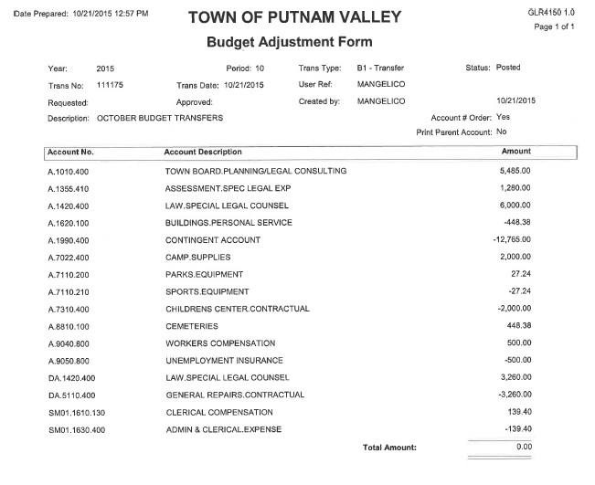
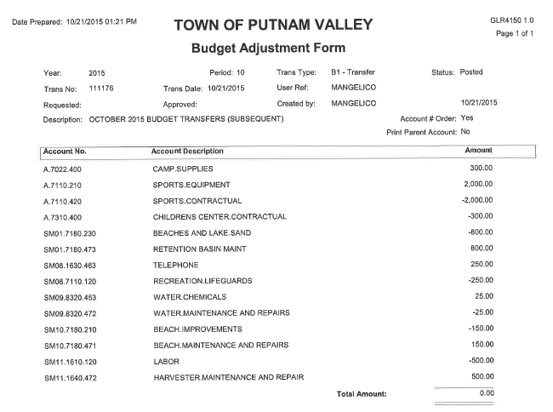

Seconded by Councilman Mackay, unanimously carried.

AUDIT OF MONTHLY BILLS

Presented by Supervisor Tendy

RESOLUTION #R 15-271

RESOLVED, that the Town Board approve the following bills, after audit, to be paid:

VOUCHER NUMBERS AMOUNTS
13110-13118, 13156-13209,
13227-13236, 13244 & 13245 $78,436.75
13246-13257, 13308-13325,
13364-13390 $19,094.07
13258-13307& 13363 $84, 842.98
13134-13155, 13341-13362 &
13391 $43,823.69

Seconded by Councilman Mackay, unanimously carried.

Supervisor Tendy motioned to go into Executive Session at 8:25 p.m. to discuss possible litigation and a contractual matter in regard to the SPCA contract with no further business taking place.

Seconded by Councilwoman Annabi, unanimously carried.

Respectfully submitted,

Eileen Royael
Town Clerk 10-26-15

