PUTNAM VALLEY TOWN BOARD
2014 PRELIMINARY TOWN/HIGHWAY BUDGET WORK SESSION
6:00 P.M.
TOWN BOARD MEETING
7:00 P.M.
WEDNESDAY, October 16, 2013

2014 PRELIMINARY TOWN/HIGHWAY BUDGET WORK SESSION
6:00 P.M.

TOWN BOARD MEETING
7:00 p.m.

1. Pledge of Allegiance
2. Supervisor’s Opening Comments
3. Approval of Town Board Minutes
4. County Legislator’s Report
5. School District Report
6. Set Public Hearing on Proposed Local Law to Override Tax
Levy Limit Established in General Municipal Law-3C
7. Set Public Hearing Date for Public Comment on the
2014 Putnam Valley Volunteer Fire Dept. Contract
8. Set Public Hearing Date for Public Comment on the
Proposed 2014 Town/Highway/District Preliminary Budget
9. Acknowledgement of Town of Putnam Valley Justice Court
Audit
10. Parks & Recreation
a. Refunds
b. Personnel
11. Building Department
a. Report for September 2013
12. Highway
a. Authorize Highway Department to Go Out to Bid for
2014 Materials
13. DISTRICTS
a. Lake Peekskill
1. District Report
2. Authorize Purchase of Int’l Navistar Garbage
Truck Off State Bid
14. Public Comment
15. Budget Transfers & Amendments
16. Audit of Monthly Bills
17. Adjournment

PUTNAM VALLEY TOWN BOARD
2014 BUDGET WORK SESSION
6:00 p.m.
REGULAR TOWN BOARD MEETING
7:00 P.M.
WEDNESDAY, OCTOBER 16, 2013

PRESENT: Supervisor Tendy
Councilwoman Whetsel
Councilwoman Annabi
Councilman Mackay
Councilman Luongo

ALSO PRESENT: Town Clerk Eileen Royael
Town Counsel Zutt

2014 PRELIMINARY BUDGET WORK SESSION

Supervisor Tendy opened the 2014 Preliminary Budget Work Session at 6:08 p.m.

Supervisor Tendy told the residents that there have been no changes to the 2014 Preliminary Budget since the last work session. There will be additional Preliminary Budget Work Sessions on October 23rd at 6:00 p.m. and if needed on October 30th at 6:00 p.m. Right now the Town Budget is at 3.44% and the Highway Budget is at 1.84%, coming in under the 2% Tax Cap at 1.955%, this is subject to change. There has been discussion to give the Putnam Valley Volunteer Fire Dept. an additional $49,000 as their budget has been lean the last couple of years.

Councilwoman Whetsel added that these additional monies has to do with OSHA requirements.

Councilwoman Annabi would like more information as she understood that some of the monies were going to LOSAP.

Supervisor Tendy told the residents that there were no big changes in the districts, most of them have no increases due to a favorable garbage collection contract.

Councilman Luongo noted that all of our managers did a great job staying within their budgets and preparing their 2014 budgets.

Councilman Mackay wanted to squash a rumor that the Town Board members were going to receive raises in 2014, he noted that the Town Board refused a raise.

Supervisor Tendy noted that there is a lot of misinformation out there and his request for a raise is a work in progress.

Supervisor Tendy moved to close the budget work session at 6:15 p.m.

Seconded by Councilman Luongo, unanimously carried.

REGULAR TOWN BOARD MEETING

Supervisor Tendy opened the Town Board Meeting at 7:00 p.m.

AMENDMENTS TO THE AGENDA

Presented by Supervisor Tendy

RESOLUTION #R 13-303

RESOLVED, that the Town Board add the following amendments to the agenda:

Add Executive Session to discuss contractual matters in regard to 2014 Putnam Valley Volunteer Fire Department contract, Oscawana /New York State Project Contract and personnel matters.

Add
#9a Resolution to amend Special Use Permit for Homeland Towers in regard to the revised site plan that includes an increased area of disturbance

#13b Request to Waive Demolition Permit Application fee-Habitat for Humanity

Seconded by Councilman Mackay, unanimously carried.

SUPERVISOR’S OPENING COMMENTS

Supervisor Tendy announced that on October 18th, a variety show will be held at the Putnam Valley High School at 7:00 p.m. Also on October 18th, Burr Johnson will be performing at the Putnam Valley Fire House at 8:00 p.m. This is a free concert which is funded by a grant from the Anastasia Foundation. Burr Johnson is an internationally known musician, he encouraged all to come.

APPROVAL OF TOWN BOARD MINUTES

Presented by Supervisor Tendy

RESOLUTION # R13-304

RESOLVED, that the Town Board approved the Town Board minutes of September 11, and September 18, 2013.

Seconded by Councilwoman Annabi, unanimously carried.

COUNTY LEGISLATOR’S REPORT

County Legislator Oliverio complimented the Putnam County Executive; the 2014 budget will tentatively come in at 1.66%. We are having discussions on some salary increases, trying to give all non-elected personnel a 1.50% increase and some positions are not receiving any raises. He feels it is a good budget.

Councilwoman Annabi asked what is going on with the now county owned property down at Oregon Corners.

County Legislator Oliverio told Councilwoman Annabi that three offers were made on that property and the County is in negotiations with one of them.

Councilman Mackay asked if he felt that the people who are in negotiations on this property have a vital business.

County Legislator Oliverio responded that he feels they do.

County Legislator Oliverio and Councilwoman Whetsel would like the town to pass a resolution on anti-fracking.

Supervisor Tendy noted that the town does not use brine on our roads for de-icing and this can be discussed at another meeting amongst the Town Board members.

County Legislator Oliverio is concerned that down the road when this present Town Board and the present Highway Superintendent are no longer serving the people of Putnam Valley, it may be used on the roads. He feels that a resolution will protect the town.

Supervisor Tendy noted that a resolution is not a law.

SCHOOL DISTRICT REPORT

County Legislator Oliverio told the audience that the turf is now complete at the high school and residents are allowed to use the track when the sports field is not being used. On October 25th at the high school they will be holding a “Stay Awake-A-Thon” from 8:00 pm to 7 a.m. Looking for chaperones and any food donations would be appreciated. This is a fundraiser for “Make A Wish Foundation.”

SET PUBLIC HEARING DATE ON A PROPOSED LOCAL LAW TO OVERRIDE THE TAX LEVY LIMIT ESTABLISHED IN GENERAL MUNICIPAL LAW-3C.

Presented by Councilman Luongo

RESOLUTION # R13-305

RESOLVED, that the Town Board set the public hearing date to hear public comments on a proposed Local Law to Override the Tax Levy Limit Established in General Municipal Law 3-c at 6:00 p.m. on November 6, 2013.

Seconded by Councilwoman Annabi, unanimously carried.

SET PUBLIC HEARING DATE -PUTNAM VALLEY VOLUNTEER FIRE DEPT. 2014 CONTRACT

Presented by Councilwoman Annabi

RESOLUTION # R13-306

RESOLVED, that the Town Board set the public hearing date to hear public comments on the 2014 Putnam Valley Volunteer Fire Dept. Contract on November 6, 2013 immediately following the first public hearing on a proposed Local Law to Override the Tax Levy Limit Established in General Municipal Law 3-c at 6:00 p.m.

Seconded by Councilman Mackay, unanimously carried.

SET PUBLIC HEARING DATE FOR 2014 PRELIMINARY BUDGET-TOWN/HIGHWAY/DISTRICTS

Presented by Councilman Mackay

RESOLUTION # R13-307

RESOLVED, that the Town Board set the public hearing date to hear public comments on the 2014 Preliminary Town/Highway/District Budgets on November 6, 2013 immediately following the second public hearing on the 2014 Putnam Valley Volunteer Fire Department Contract.

Seconded by Councilman Luongo, unanimously carried.

ACKNOWLEDGEMENT OF TOWN OF PUTNAM VALLEY JUSTICE COURT AUDIT

Presented by Councilwoman Whetsel

RESOLUTION # R13-308

RESOLVED that the Town Board acknowledges than an audit was conducted on the Town of Putnam Valley Justice Court records by O’Connor & Davies for the year ending December 31, 2012.

Seconded by Councilwoman Annabi, unanimously carried.

AMENDED SPECIAL USE PERMIT -HOMELAND TOWERS AND NEW CINGULAR WIRELESS

Presented by Councilwoman Annabi

RESOLUTION # R13-309

WHEREAS the Town Board by Resolution #R12-186 conditionally approved a Special Use Permit and Major Grading Permit for the erection of a new cell tower on part of the premises known as 1135 William Drive ( Section 84 Block 2, Lot 48); and

WHEREAS by Resolution adopted on October 17, 2012 the Town Board adopted an amendment to Resolution #R12-186 in respect removal bond requirements of said resolution; and

WHEREAS site excavation work required the use of blasting, which activity was approved by the Planning Board on May 20, 2013; and

WHEREAS said blasting, according to an October 15, 2013 letter of Site Development Manager, Vincent Xavier, generated a need for additional site disturbance beyond that originally approved by the Planning Board; and

WHEREAS the Planning Board, by resolution dated October 7, 2013, modified the Site Plan Resolution so as to approve a revised site plan authorizing said additional site disturbance; and

WHEREAS the Town Board’s prior Special Use Permit Resolution and Amended Resolution referenced the drawings and plans specified in the Planning Board’s original site plan Resolution of March 12, 2012; and

WHEREAS the Planning Board’s October 7, 2013 Resolution is contingent on an amendment to the Town Board’s Special Use Permit Resolution recognizing the recent site plan amendment; and

NOW, THEREFORE, be it
RESOLVED that the third “Resolved” clause in the Town Board’s October 17, 2012 Amended Special Use Permit Resolution be and is hereby amended so as to change the date of the Planning Board’s approved drawings from those approved under that Board’s 3/12/12 Resolution to those approved under its 10/7/13 Resolution.

Seconded by Councilman Mackay, unanimously carried.

PARKS & RECREATION- REFUNDS

Presented by Councilwoman Annabi

RESOLUTION #R 13-310

RESOLVED, that the Town Board approve the following refunds:

Courtney Goodrow $34.00
44 Tinker Hill PVCC
Putnam Valley, NY 10579 Unable to attend

Ed Krajeski $220.00
278 South Road Sports
Holmes, NY 12531 Team Withdrawn

Seconded by Councilman Mackay, unanimously carried.

PARKS & RECREATION- PERSONNEL APPOINTMENTS/ ADJUSTMENTS

Presented by Councilwoman Annabi

RESOLUTION # R13-311

RESOLVED, that the Town Board approve the following additions/changes to personnel:
1 Andre Holhoch, PVCC Ass’t., @ $9.00 per hour
2. Kristen Tyra, PVCC Ass’t., @ $9.00 per hour.
3. Chris Lutz, Volleyball Nets, @ $15.00 per hour.
4. Jonathan Schulz, Rec. Ass’t. @ $10.00 per hour.
5. Natalia Stockinger, Rec. Ass’t. @ $10.00 per hour.
6. Cynthia Plescia, Rec. Ass’t. @ $10.00 per hour.
7. Daniel Carroll, Guitar Teacher, @ $22.00 per hour.
8. Patty Matrone-Squillante, Rec. Ass’t @ $25.00 per hour.
9. Theresa Orlando, Rec. Ass’t. @ $25.00 per hour.
10. Liz Boscarino, Rec. Ass’t. @ $20.00 per hour.
11. Andre Holhoch, Volleyball Nets, @ $15.00 per hour.

Seconded by Councilman Mackay, unanimously carried.

BUILDING DEPARTMENT REPORT

Presented by Councilman Luongo

RESOLUTION #R 13-312

RESOLVED, that the Town Board accept the Building Department report for the month of September 2013, for filing with the Town Clerk.

Seconded by Councilman Mackay, unanimously carried.

AUTHORIZE HIGHWAY TO BID 2014 MATERIALS

Presented by Councilman Mackay

RESOLUTION # R13-313

RESOLVED that the Town Board authorize the Putnam Valley Highway Department to go out to bid for 2014 materials used by the highway department.

Seconded by Councilwoman Annabi, unanimously carried.

LAKE PEEKSKILL REPORT

Councilwoman Annabi reminded Lake Peekskill residents to review their garbage schedule before they put out their garbage. On October 26th, the annual Halloween Party will take place at the Lake Peekskill Community Center at 1:00 p.m.

REQUEST TO WAIVE DEMOLITION PERMIT APPLICATION FEE-HABITAT FOR HUMANITY

Presented by Councilwoman Annabi

RESOLUTION # R13-314

RESOLVED that the Town Board waive the demolition permit application fee for the house on 87 Johnson Street that Habitat for Humanity is renovating.

Seconded by Councilman Mackay, unanimously carried.

AUTHORIZE PURCHASE OF INTERNATIONAL NAVISTAR GARBAGE TRUCK

Presented by Councilwoman Whetsel

RESOLUTION # R13-315

RESOLVED that the Town Board authorize the purchase a new refuse removal truck for the Lake Peekskill Improvement District from Navistar Inc. at the price of $162,266.20. This price was obtained off of the New York State Office of General Services regarding the state price bid. The Lake Peekskill Improvement District currently has $192,564 set aside in their budget for the purchase of truck equipment.

Seconded by Councilwoman Annabi, unanimously carried.

PUBLIC COMMENT

Dawn Powell would of liked the whole garbage collection be looked at before the purchase of a new truck was made. It seems the other districts are paying less for garbage pickup than Lake Peekskill. She also noted that $50,000 a year was set aside in the budgets for new truck equipment and now that we are purchasing one, she would like $50,000 in the 2014 budget to be taken out which would reduce the Lake Peekskill tax rate.

Peter Tarrant noted that Putnam Valley is the only town in Putnam County that has not passed an anti-fracking resolution; he is embarrassed of this and would like to know if there is a reason the town never passed a resolution.

Supervisor Tendy responded that we usually get information on an item before we pass a resolution. We currently do not use brine on our roads and it should not be an embarrassment for him. Once we get the information the Town Board will put it on the agenda and discuss it.

Councilwoman Annabi again reminded everyone at the Lake Peekskill Community Center there will be a Halloween Party on the October 26th at 1:00 p.m. She added that on October 20th, there will be a paint a pumpkin, costume parade and hayride at the Town Park at 2:00 p.m. She also noted that at the Putnam Valley Museum an event called “Haunted History” with author Vincent Dacquino will take place on October 26th at 7pm.

Councilman Luongo told the residents to watch for information on Putnam Valley’s 175th Anniversary which will be in our local stores.

Supervisor Tendy reminded the residents that if they have not heard from the state in regard to the new “Star Applications” to contact New York State at www.tax.ny.gov or call 518-457-2036. The deadline to apply for “Star” is December 31, 2013- if you miss it you will not be able to get it.

BUDGET TRANSFERS & AMENDMENTS

Presented by Supervisor Tendy

RESOLUTION #R 13-316

RESOLVED, that the Town Board approve the following budget transfers and amendments as submitted by bookkeeper Marianne DeSantis:
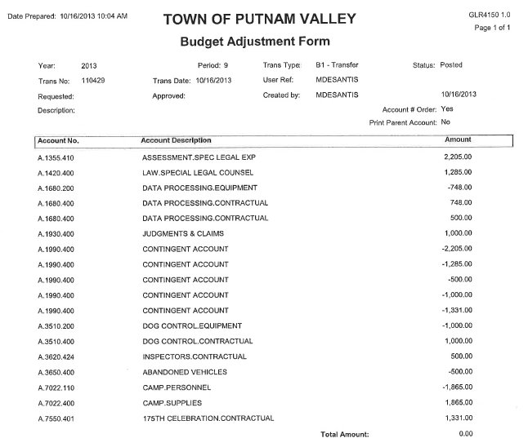

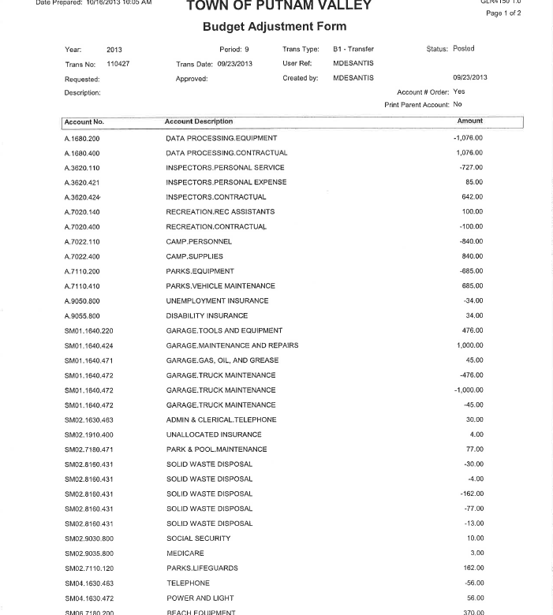
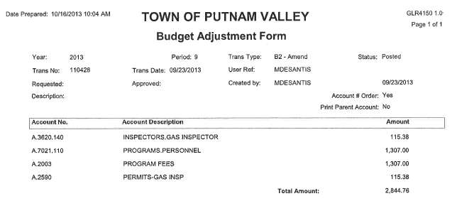

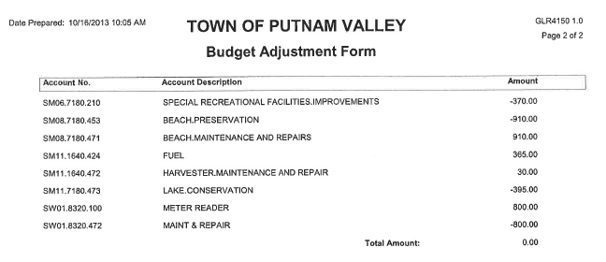
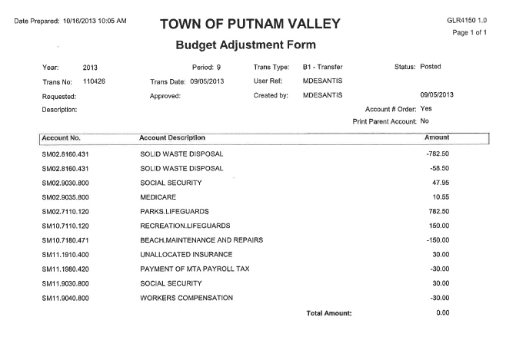
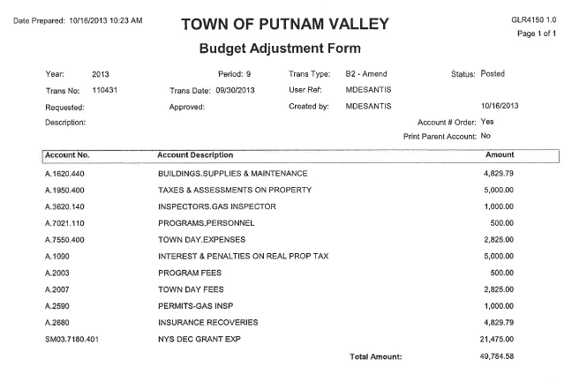
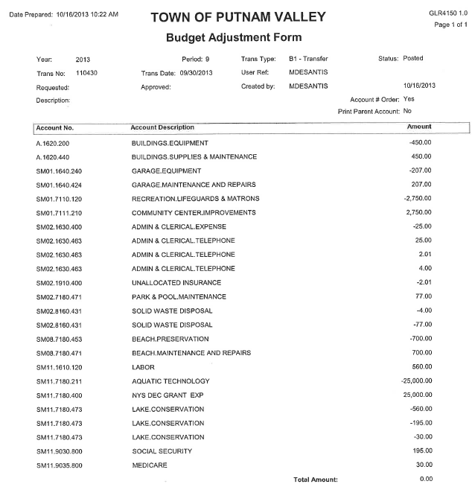

Seconded by Councilman Mackay, unanimously carried.

AUDIT OF MONTHLY BILLS

Presented by Supervisor Tendy

RESOLUTION #R 13-317

RESOLVED, that the Town Board approve the following bills, after audit, to be paid:

VOUCHER NUMBERS AMOUNTS
5031-5045, 5081-5094,
5151-5157, 5160-5199 $77,528.81
5210-5239, 5241-5245,
5249-5261, 5296-5299 $54,310.88
5009-5013, 5046-5060,
5079-5080, 5089,
5095-5100, 5124-5134,
5158-5209, 5240 $73,520.51
5115-5123, 5262-5295,
5300 $45,558.86

Seconded by Councilwoman Annabi, unanimously carried.

Supervisor Tendy motioned to go into Executive Session at 7:38 p.m. to discuss the Putnam Valley Volunteer Fire Department Contract, the Oscawana/New York State Project contract and personnel matters.

Seconded by Councilman Luongo, unanimously carried.

Respectfully submitted,

Eileen Royael-Town Clerk
10/21/13

