PUTNAM VALLEY TOWN BOARD
PUBLIC HEARING 6:00 P.M.
IMMEDIATELY FOLLOWING
WORK SESSION

WEDNESDAY, JANUARY 9, 2013

6:00 P.M.
PUBLIC HEARING ON PROPOSED LOCAL LAW FOR FLOOD DAMAGE PREVENTION AS AUTHORIZED BY THE NYS CONSTITUTION, ARTICLE IX, SECTION 2, AND ENVIRONMENTAL CONSERVATION LAW, ARTICLE 36

IMMEDIATELY FOLLOWING
WORK SESSION

1. Discussion on proposed Local Law to Amend Chapter 51
Of the Town Code So As to Confer Enforcement Authority
On the Putnam County Society for the Prevention of Cruelty
To Animals and Set Public Hearing Date
2. Teamster Contract Impasse Resolution
3. Appoint Snow Plow Rider-L. Cobb & T. Kuchera
4. Amend Resolution #R13-53 to Correct Planning Board Member
Term- A. Babbit
5. Discussion on Keating Sub-Division Extension
6. Review of 1-16-13 Agenda

PUTNAM VALLEY TOWN BOARD
PUBLIC HEARING & WORK SESSION
WEDNESDAY, JANUARY 9, 2013

6:00 P.M.

Present: Supervisor Tendy
Councilwoman Whetsel
Councilman Mackay
Councilman Luongo

Absent: Councilwoman Annabi

Also Present: Town Counsel Zutt
Town Clerk Eileen Royael

Supervisor Tendy opened the Public Hearing at 6:00 pm.

PUBLIC HEARING
6.00 P.M.

TO HEAR PUBLIC COMMENTS ON A PROPOSED LOCAL LAW FOR FLOOD DAMAGE PREVENTION AS AUTHORIZED BY THE NYS CONSTITUTION, ARTICLE IX, SECTION 2, AND ENVIRONMENTAL CONSERVATION LAW, ARTICLE 36

Town Counsel Zutt explained that for the Town of Putnam Valley to maintain eligibility in the National Flood Insurance Program we need to adopt the new Flood Insurance Study and Flood Insurance Rate Maps into our floodplain management regulations. FEMA mandates that the states adopt these maps and the NYS DEC has passed this obligation onto the municipalities. This would only apply to new construction. He also noted that he sent a letter to the NYSDEC on November 29, 2012 with a draft local law adopting FEMA’s new flood insurance rate maps and received a letter back from the NYSDEC and they found our draft law acceptable. Town Counsel Zutt would like those letters to be part of the town’s record.

Supervisor Tendy is concerned that this would cause higher expenses for resident’s structures.

Town Counsel Zutt told Supervisor Tendy he does not have the answer, He does know that this new law is what the DEC is recommending. There is a variance procedure if the engineer costs were to get too expensive.

The Town Board wants to bring this proposed local law to the attention of the people in the construction business.

Town Counsel Zutt told the Town Board that the elaborate construction standards are spelt out and that the Building/Zoning Inspector would have to make sure they comply.

Supervisor Tendy motioned to close the public hearing at 6:06 p.m.

Seconded by Councilman Mackay, unanimously carried.

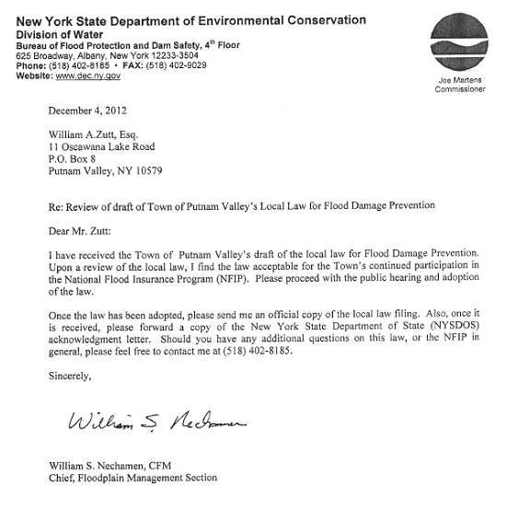
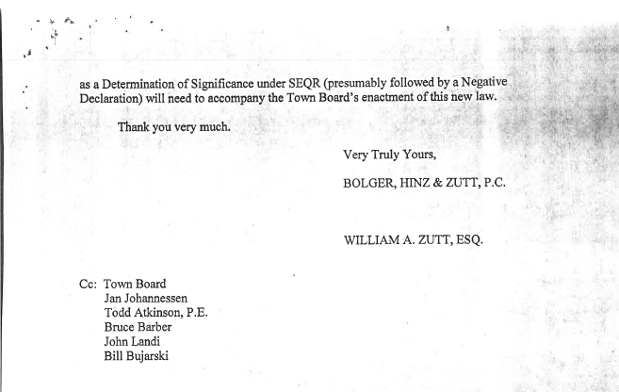

WORK SESSION

Supervisor Tendy opened the Work Session at 6:06 p.m.

AMENDMENTS TO THE AGENDA

Presented by Supervisor Tendy

RESOLUTION # R13-65

RESOLVED that the Town Board amend the agenda to add an Executive Session to seek advice of counsel and discuss contractual matters with the Putnam Valley Volunteer Ambulance Corps.

Seconded by Councilman Mackay, unanimously carried.

Supervisor Tendy moved to go into Executive Session at 6:06 p.m. to seek advice of counsel and discuss contractual matters with the Putnam Valley Volunteer Ambulance Corps.

Seconded by Councilwoman Whetsel, motion carried with three ayes as Councilman Luongo recused himself.

Work Session resumed at 6:31 p.m.

DISCUSSION AND SET PUBLIC HEARING DATE ON PROPOSED LOCAL LAW TO AMEND CHAPTER 51 OF THE TOWN CODE SO AS TO CONFER ENFORCEMENT AUTHORITY ON THE PUTNAM COUNTY SOCIETY FOR THE PREVENTION OF CRUELTY TO ANIMALS

Discussion
Supervisor Tendy noted that this has been brought about by numerous complaints of dog’s at large, residents being chased by large dogs or attacks of dogs. Our dog control officer is not available 24/7. Supervisor Tendy has done some research on the SPCA and not sure if we get them involved if there will be a fee or if it is really necessary to get them involved. It may be something we want to consider or maybe not. He is not sure this is the solution we are looking for. Perhaps we need to look into ways to change the duties of our Dog Control Officer.

Councilwoman Whetsel agreed with Supervisor Tendy.

Councilman Mackay wants to assure that our residents are safe from dogs at large, and we need to figure a way to do this as soon as possible.

Supervisor Tendy noted that some residents want to own large aggressive dogs and it is fine if they are kept in the house but if they get out they are a danger to our residents and we have to do something about this.

Town Counsel Zutt gave an explanation on how this proposed law came about. Councilwoman Annabi received calls from residents trying to reach the dog control officer. Out of frustration she contacted the SPCA and they explained to her that they could seize a dog at large but had not been given the authority to do this in Putnam Valley under our Town Code, Chapter 51.

TEAMSTER CONTRACT IMPASSE RESOLUTION

Discussion

Town Counsel Zutt told the Town Board that he sent this proposed resolution to the Teamsters Business Manager, John Henry, and Mr. Henry requested that one of the paragraphs be removed
from the proposed resolution or they would file an improper practice charge. This is the wording in the paragraph the Teamsters want removed “RESOLVED that, to the extent permitted by law, the terms of this Resolution shall apply to the period commencing January 1, 2011 through and including the commencement date of any new contract negotiated between the Town and the Teamsters, and be at further”.
Town Counsel Zutt suggested that it be removed, and so it was.

Councilman Mackay noted that when they held a public hearing on the Teamster Contract Impasse the Teamsters refused to attend, that public hearing gave them the opportunity to talk to us to resolve this.

Presented by Supervisor Tendy

RESOLUTION # R13-66

TEAMSTER CONTRACT IMPASSE RESOLUTION

WHEREAS Local 456, International Brotherhood of Teamsters (“Teamsters” hereafter) is the recognized Collective Bargaining Agent for all full time Highway Department and Lake Peekskill Improvement District Employees, and

WHEREAS the last Collective Bargaining Agreement (“Contract” hereafter) between the Town and the Teamsters expired on December 31, 2010; and

WHEREAS the parties engaged in direct negotiations for a new contract between October, 2010 and August, 2011; and

WHEREAS the Teamsters filed a formal Declaration of Impasse with the New York State Public Employees Relations Board (“PERB” hereafter) on August 18, 2011; and

WHEREAS PERB, pursuant to Civil Service Law (“CSL” hereafter) Section 209 (3)(a), appointed Ms. Lori L. Matles to serve as mediator on September 20, 2011; and

WHEREAS Ms. Matles conducted mediation sessions with the parties on October 28, 2011, December 7, 2011, and by Conference Call on December 22, 2011; and

WHEREAS exchanges of correspondence and emails were had between the parties at the mediator’s behest; and

WHEREAS the mediation effort failed; and

WHEREAS the Teamsters requested the appointment of a Fact-Finder on May 10, 2012; and

WHEREAS PERB appointed Carol M. Hoffman, Esq., as Fact-Finder pursuant to CSL Section 209 (3) (b); and

WHEREAS a Fact-Finding hearing was conducted by Ms. Hoffman on July 17, 2012 at which both sides presented their positions with respect to the issues; and

WHEREAS Ms. Hoffman issued her Findings of Fact and Recommendations on September 26, 2012; and

WHEREAS the parties could not reach agreement based upon the Fact-Finder’s recommendations; and

WHEREAS Town Supervisor Tendy submitted the Fact Finder’s Findings and Recommendations to the Town Board of Putnam Valley, the Town’s legislative body, as required by CSL Section 209 (3) (e); and

WHEREAS the Town Board scheduled a public hearing for December 27, 2012 pursuant to CSL Section 209 (3) (e) (iii); and

WHEREAS the Teamster’s Counsel, Emily Roscia, Esq., was notified of the public hearing time and date, invited to participate, and to submit the Teamsters’ recommendations for settling the dispute; and

WHEREAS the public hearing was held on December 27, 2012; and

WHEREAS no one appeared at said hearing in behalf of the Teamsters, nor were any written submissions made in its behalf; and

WHEREAS the Town Attorney reviewed the chronological history of negotiations between the parties, the issues discussed and presented before the Fact-Finder, and the limitations imposed upon the Town Board by CSL Section 209 – a(1)(e), i.e.: the so-called “Triboro Rule”) when exercising its legislative authority under CSL Section 209 (3) (e) (iv); and

WHEREAS the following documents were received, among others, into the public hearing record:

(1) August 8, 2012 letter of Town Attorney William A. Zutt, Esq. to Fact-Finder Carol M. Hoffman;

(2) August 9, 2012 letter of Teamster Attorney Emily Roscia, Esq. to Fact-Finder Carol M. Hoffman;

(3) Line and Bar graph data comparing Putnam Valley’s wage rates in 5 labor titles over the past 12 years with those of 4 of the 5 other Putnam County Towns (Town of Patterson records being unavailable);

(4) Line Graph Data comparing Putnam Valley’s Longevity Payment schedule over the past 12 years with the same 4 Putnam County Towns;

(5) Findings and Recommendations of Ms. Carol M. Hoffman; and

WHEREAS the above documents, and others referenced in the Fact-Finders Report indicate that the wage rates and longevity payments provided for in the expired Teamster contract exceed, in most cases, those received for the same or similar job titles in other Putnam County Towns, and that over the 12 year period prior to December 31, 2010 the Putnam Valley Highway Department employees annual wage rate increases substantially exceeded the increases in the Consumer Price Index; and

WHEREAS the Town is operating on an extremely tight budget and, by State Law, may not exceed a 2% annual increase without Local Law approval; and

WHEREAS the real property tax burden on Putnam Valley taxpayers is already extremely high;

NOW, THEREFORE, be it

RESOLVED that the terms of the Teamster Contract which expired on December 31, 2010 be and are hereby continued without change until a new Agreement is negotiated unless the Teamsters, during such negotiations or prior to their resolution engage in conduct violative of CSL Section 210 (1), and be it further

RESOLVED that the Town Board deems the within Resolution to be in the public interest, including the interest of the public employees involved.

Dated: Putnam Valley, New York
January 9, 2013

Seconded by Councilman Mackay

NAMES VOTING FOR VOTING AGAINST
Hon. Louie Luongo, Councilman Aye

Hon. Steven MacKay, Councilman Aye

Hon. Wendy Whetsel, Councilwoman Aye

Hon. Robert Tendy, Supervisor Aye
Motion carried four with ayes.

APPOINT SNOW PLOW RIDERS

Presented by Supervisor Tendy

RESOLUTION # R13-67

RESOLVED that the Town Board appoint Larry Cobb Jr. and Taylor Kuchera as snow plow riders for the year 2013 at the rate of $11.44 per hour with no benefits.

Seconded by Councilman Mackay, unanimously carried.

AMEND RESOLUTON #R13-53 TO CORRECT PLANNING BOARD MEMBER TERM-A.BABBIT

Presented by Supervisor Tendy

RESOLUTION # R13-68

RESOLVED that the Town Board amend Resolution #R13-53 to correct Planning Board Member term for Adam Babbit as 1-1-13 to 12-31-17,

Seconded by Councilman Mackay, unanimously carried.

DISCUSSION ON AGNES KEATING SUB-DIVISION EXTENSION

Town Counsel Zutt explained to the Town Board that the Agnes Keating Subdivision was approved for a 3 lot subdivision by the Planning Board upon posting an infrastructure completion letter of credit. The completion deadline is January 31, 2013, with the Letter of Credit expiring March 31, 2013. Phil Keating is requesting a three year extension and Town Counsel Zutt suggests that the Town Board approve this request with the condition that the new Letter of Credit expires on March 31, 2016 at its original amount or a greater amount that the Town Engineer recommends.

REVIEW 1-16-13 AGENDA

Supervisor Tendy reviewed the tentative 1-16-13 agenda with the Town Board. Town Counsel Zutt suggested putting on the 1-16-13 agenda a discussion on the PVVFD LOSAP Point System proposed changes.
Supervisor Tendy recessed the meeting at 6:47 p.m.

Seconded by Councilman Luongo, unanimously carried.

Work Session resumed at 6:50 p.m.
Supervisor Tendy explained that we have received a couple of calls in regard to dogs and our dog control officer could not respond. He added that the SPCA does not have the enforcement ability in Putnam Valley. We are considering changing that but we do not know how the SPCA works and asked Mr. Ross from the SPCA to come to a meeting and explain the process.

Ken Ross from the Putnam County SPCA explained that they are a non-profit 501C Corporation and is run by donations only. The SPCA works with complaints of cruelty to animals and are peace officers under the New York State law. In order for the SPCA to enforce the Town of Putnam Valley Town Code that would have to be written in town law. We work with the dog control officers and Sheriff’s department throughout Putnam County. Councilwoman Annabi asked us to respond to a possible cruelty situation and when we arrived the dog was inside and there was no evidence of cruelty. When it comes to dogs at large, we don’t do animal control, normally the ASPCA or Sheriff’s Dept. will take custody of the dog and generally that does not stop the problem. If there is a dog at large and the dog control officer is not around the SPCA
would be happy to help.

Supervisor Tendy asked how they get paid.

Ken Ross replied with donations. He added that part of the problem is that people do not understand who we are, we do not work for Putnam County but we are called Putnam County SPCA because this is our jurisdiction. We follow New York State law, Article 7 and Article 26. Unless the SPCA is written into town law we have no authority to write a ticket.

Supervisor Tendy questioned the liability the town would face. If we empower the SPCA to enforce our code and something goes array and a gun is used what would be the town’s liability. This may change our insurance premium. He told the Town Board that we should get in touch with NYMIR and ask these questions.

Councilman Luongo asked how many employees there are and the availability.

Ken Ross replied that there are two of them as they don’t have the funding for more and are self-insured.

Town Counsel Zutt told the Town Board that our Chapter 51 already gives authority to peace officers and that the Patti Smith our dog control officer told him that as a matter of policy the Sheriff’s Department will not enforce Chapter 51.

Supervisor Tendy moved to close the meeting at 7:07 p.m.

Seconded by Councilwoman Whetsel, unanimously carried.

Respectfully submitted,

Eileen Royael
Town Clerk 1-11-13

