PUTNAM VALLEY TOWN BOARD

REGULAR TOWN BOARD MEETING

WEDNESDAY, JANUARY 15, 2014
7:00 pm

      - Pledge of Allegiance
      - Supervisor’s Opening Comments
3. County Legislator Oliverio’s Report
4. Approval of Town Board Minutes
5. School Report
6. Authorize to Bid Open Top Containers-Bulk Drop Off
7. Amend Resolution #R14-8 Correcting Amount-Chief Budget
Officer
8. Appoint Ad-Hoc Member to Zoning Board of Appeals

DEPARTMENTS

9. Parks & Recreation
- Personnel Appointments/Adjustments
b. Refunds

10. Building Department
a. Report for December
b. 2013 Yearly Report

11. Highway
a. Authorization to Go Out to Bid-F 350 Truck

12. DISTRICTS
a. Lake Peekskill
1. Lake Peekskill Report
2. Appoint Egg Adler
3. Authorize C-Slap Expenditure

b. Roaring Brook
1. Appoint Egg Adler/Fish Retriever
2. Request to Waive Wetland Permit Waiver Fees-RBL Dam

13. Public Comment
14. Budget Transfer and Amendments
15. Audit of Monthly Bills

PUTNAM VALLEY TOWN BOARD
REGULAR TOWN BOARD MEETING
WEDNESDAY, January 15, 2014
7:00 P.M.

PRESENT: Supervisor Tendy
Councilwoman Whetsel
Councilwoman Annabi
Councilman Luongo

ALSO PRESENT: Town Clerk Eileen Royael
Town Counsel Zutt

ABSENT: Councilman Mackay

Supervisor Tendy opened the meeting at 7:00 p.m.

AMENDMENTS TO THE AGENDA

Presented by Supervisor Tendy

RESOLUTION #R 14-68

RESOLVED that the Town Board amend the agenda to add the following:

#3a- Present Boys Scouts of America with Certificate of Appreciation and Recognition
#8a Authorize Expenditure for Supervisor to Attend Putnam County Chamber of Commerce Trailblazers Award
#8b- Accept Resignation Deputy Building/Zoning/Fire Inspector
#8c- Authorize Attendance and Expenditure for Planning Board Members’ Attendance to NY Planning Federation Conference
Add Executive Session to discuss personnel matter and a contractual matter

Seconded by Councilman Luongo, unanimously carried.

SUPERVISOR’S OPENING COMMENTS

Supervisor Tendy welcomed all of the Boy Scouts who were present in the audience with their families. He noted that four of them will received Certificates of Appreciation and Recognition this evening as they have obtained the rank of Eagle Scout.

COUNTY LEGISLATOR OLIVERIO’S REPORT

County Legislator Oliverio told the audience that County Legislator Scuccimarra could not attend tonight as she was attending the Town Board meeting in Philipstown. He also noted that The Chairman of the Legislature is Carl Albino and the Deputy Chair is Ginny Nacerino. County Legislator Oliverio added that they have also begun the 2015 Budget process looking at every department. County Legislator Oliverio and County Legislator Scuccimarra are also asking for the County to give back some of the sales tax money to municipalities; we are projecting that we will get 2.5 million dollars more this year in sales tax. They feel that this should be shared with every town. The County makes every municipality whole in regard to the taxes and then keeps all of the sales tax money because of this. He also applauded the Putnam Valley and Putnam County Highway workers for doing an outstanding job on our roads.

Supervisor Tendy is concerned if the County shares the sales tax money, would the County stop making each town whole in regard to the taxes. The Town of Putnam Valley does not have much businesses and this could really be a concern for our town.

County Legislator Oliverio replied that the County would not stop making each town whole in regard to the taxes, but would be able to give every town a little of the sales tax money they collect.

PRESENT CERTIFICATE OF APPRECIATION AND RECOGNITION- BOY SCOUTS OF AMERICA

Supervisor Tendy presented the following with Certificate of Appreciation and Recognition for obtaining the rank of Eagle Scout:

Timothy Dietz- Timothy painted and upgraded the sign at the Putnam Valley Elementary School
Peter Snyder- Peter installed a horse shoe pit at the Senior Center and repaired part of a fence
Steve Hertzel could not be here tonight and the Scoutmaster will present Steve with his certificate at a later date. He noted that Steve painted the outside of the Grace Methodist Church and also painted murals of what services the church gives, such as the Putnam Valley Food Pantry and Grace’s closet.

APPROVAL OF TOWN BOARD MINUTES

Presented by Supervisor Tendy

RESOLUTION # R 14-69

RESOLVED, that the Town Board approve the Town Board minutes of December 11, 2013 and December 18, 2013.

Seconded by Councilwoman Annabi, unanimously carried.

SCHOOL REPORT

Supervisor Tendy noted that the Winter Band Concert is tonight at the high school. Auditions were just completed for the spring musical “Thoroughly Modern Millie.” There was an acappella group performance by thirteen Syracuse University students and there will be more performances scheduled. In regard to the snow days use as of Monday, January 6, 2014, the school district has used four (4) "snow" days. The calendar adopted by the District established 183 instructional days and three teacher conference days. The state permits us to count teacher conference days as instructional days, for a total of 186 days and requires that students have at least 180 instructional days. Thus, we have two (2) snow days left. If we use more than two (2) days, the District will announce which April vacation days will be converted to instructional days. In addition, in order to increase instructional time, it is our intention to convert the Friday, May 23 conference day to a student day. Classes will be in session on Friday, May 23.

AUTHORIZATION TO BID OPEN TOP CONTAINERS-BULK DROP OFF

Presented by Councilwoman Annabi

RESOLUTION # R 14-70

RESOLVED, that the Town Board authorize the Facilities Manager, Susan Manno to bid Open Top Containers for the Bulk Drop Off 2014 season.

Seconded by Councilman Luongo, unanimously carried.

AMEND RESOLUTION # R14-9 CORRECTING AMOUNT-CHIEF BUDGET OFFICER

Presented by Councilman Luongo

RESOLUTION # R 14-71

RESOLVED, that the Town Board amend Resolution #R14-8 to correct the Chief Budget Officer, Robert Tendy’s annual salary from $7352.80 to $7646.91.

Seconded by Councilwoman Annabi, unanimously carried.

APPOINT AD-HOC MEMBER TO ZONING BOARD OF APPEALS

Presented by Councilman Luongo

RESOLUTION # R 14-72

RESOLVED, that the Town Board appoint Fred Finger as Ad-Hoc Member to Zoning Board of Appeals, term 1-1-14 to 12-31-14.

Seconded by Councilwoman Annabi, unanimously carried.

AUTHORIZE EXPEDITURE-PUTNAM COUNTY CHAMBERS OF COMMERCE TRAILBLAZERS AWARD DINNER
Presented by Councilwoman Annabi

RESOLUTION # R 14-73

RESOLVED, that the Town Board authorize the expenditure for Robert Tendy, Town Supervisor to attend the Putnam County Chambers of Commerce Trailblazers Award Dinner on January 31, 2014, at the cost of $75.00.

Seconded by Councilman Luongo, unanimously carried.

ACCEPT RESIGNATION PART TIME DEPUTY BUILDING/ZONING/FIRE INSPECTOR

Presented by Supervisor Tendy

RESOLUTION # R 14-74

RESOLVED, that the Town Board accept the resignation of Part Time Deputy Building/Zoning/Fire Inspector effective 1-15-14.

Seconded by Councilwoman Annabi, unanimously carried.

AUTHORIZATION TO ATTEND NYS PLANNING FEDERATION CONFERENCE

Presented by Supervisor Tendy

RESOLUTION # R14-75

RESOLVED that the Town Board authorize Michael Raimondi and Tom Carano (Planning Board Members) to attend the NYS Planning Federation Conference in Saratoga, NY on March 30- April 1. 2014. The registration fee for Michael Raimondi $169.00; the registration fee for Tom Carano is $125.00 as he is attending only one day. Michael Raimondi is also requesting the hotel at $223.74; total cost for all is $517.74

Seconded by Councilman Luongo, unanimously carried.

PARKS & RECREATION- PERSONNEL APPOINTMENTS/ ADJUSTMENTS

Presented by Councilwoman Whetsel

RESOLUTION #R 14-76

RESOLVED, that the Town Board approve the following additions/changes to personnel:

- Patti Singer, Day Camp Director for 2014, @ $9620.00 for season.
- Toni Ann Cortina, Ass’t Day Camp Director for 2014, @ $5800.00 for season.

Seconded by Councilwoman Annabi, unanimously carried.

PARKS & RECREATION REFUNDS

Presented by Councilwoman Whetsel

RESOLUTION #R14-77

RESOLVED, that the Town Board approve the following refunds:

Michele Usai $210.00
5 Rose Street Day Camp
Putnam Valley, NY 10579 Medical Withdrawal

Kathleen Moriarty $95.00
53 Lincoln Road Basketball
Putnam Valley, NY 10579 Now Coaching

Charlene Pateman $50.00
15 Oakridge Drive Basketball
Putnam Valley, NY 10579 Withdrawn

Ana Ramos $200.00
52 Maple Road LPCC
Lake Peekskill, NY Deposit Return

Seconded by Councilwoman Annabi, unanimously carried.

BUILDING DEPARTMENT REPORT-DECEMBER

Presented by Councilwoman Annabi

RESOLUTION #R14-78

RESOLVED, that the Town Board accept the Building Department report for the month of December 2013, for filing with the Town Clerk.

Seconded by Councilwoman Whetsel, unanimously carried.

BUILDING DEPARTMENT 2013 YEARLY REPORT

Presented by Councilwoman Annabi

RESOLUTION #R14-79

RESOLVED, that the Town Board accept the Building Department yearly report for 2013, for filing with the Town Clerk.

Seconded by Councilwoman Whetsel, unanimously carried.

AUTHORIZATION TO GO OUT TO BID- F350 TRUCK

Presented by Councilman Luongo

RESOLUTION #R14-80

RESOLVED, that the Town Board authorize the Highway Department to go out to bid for a F350 pick-up truck for highway use.

Seconded by Councilwoman Annabi, unanimously carried.

LAKE PEEKSKILL REPORT

Councilwoman Annabi announced that the first district meeting will be held in March for the Lake Peekskill residents, will confirm the date at the next meeting.

LAKE PEEKSKILL-APPOINTMENT OF EGG ADDLER

Presented by Councilwoman Annabi

RESOLUTION #R 14-81

RESOLVED, that the Town Board appoint Friedel Muller-Landau as egg addler for the Lake Peekskill District for the year 2014 at a salary of $200.00

Seconded by Councilman Luongo, unanimously carried.

AUTHORIZE C-SLAP EXPEDITURE

Presented by Councilwoman Annabi

RESOLUTION #R14-82

RESOLVED that the Town Board authorize the expenditure of $350.00 for the volunteers in Lake Peekskill to participate in the New York State Federation of Lakes C-Slap program (Citizens Statewide Assessment Program) for 2014.

Seconded by Councilman Luongo, unanimously carried.

ROARING BROOK LAKE-APPOINTMENT OF EGG ADDLER/FISH RETRIEVER

Presented by Councilwoman Whetsel

RESOLUTION #R 14-83

RESOLVED, that the Town Board appoint Friedel Muller-Landau as egg addler/fish retriever for the Roaring Brook Lake District for the year 2014 at a salary of $500.00

Seconded by Councilwoman Annabi, unanimously carried.

REQUEST TO WAIVE WETLAND PERMIT WAIVER FEES-RBL DAM

Presented by Councilwoman Whetsel

RESOLUTION #R 14-84

RESOLVED, that the Town Board waive any Wetland Permit Waiver Fees associated with the sediment removal from the stream bed at the Roaring Brook Lake Dam.

Seconded by Councilwoman Annabi, unanimously carried.

PUBLIC COMMENTS

Supervisor Tendy asked if there were any public comments. One resident noted that the Town Board is doing a great job, no other comments were made.

BUDGET TRANSFERS AND AMENDMENTS

Presented by Supervisor Tendy

RESOLUTION #R 14-85

RESOLVED, that the Town Board approve the following budget transfers and amendments as submitted by bookkeeper Marianne DeSantis: 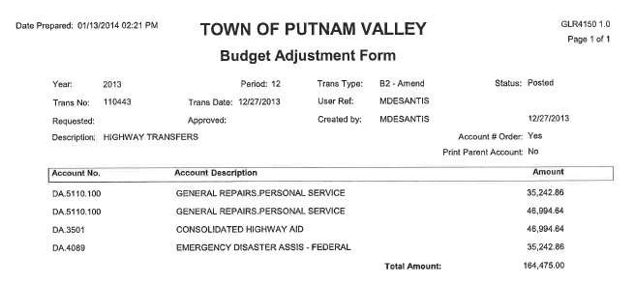
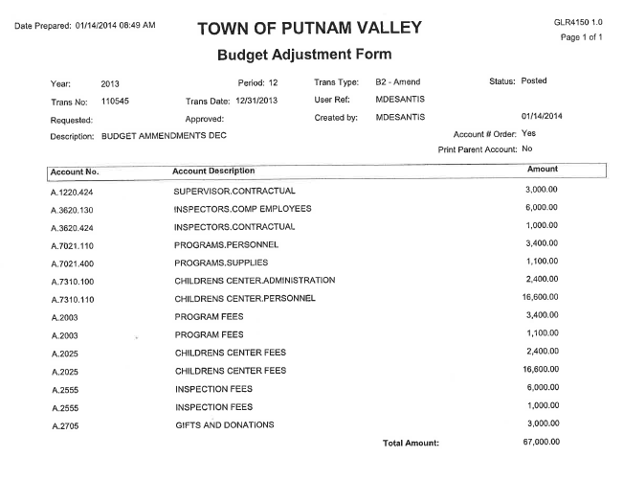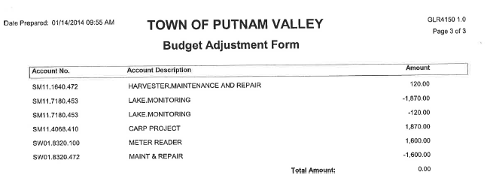
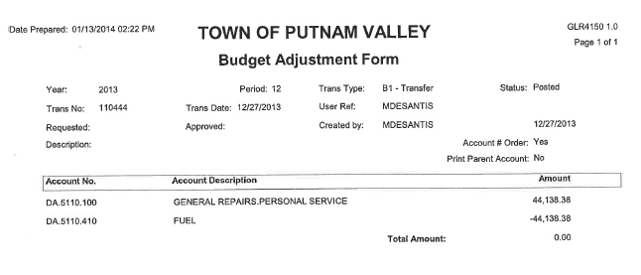
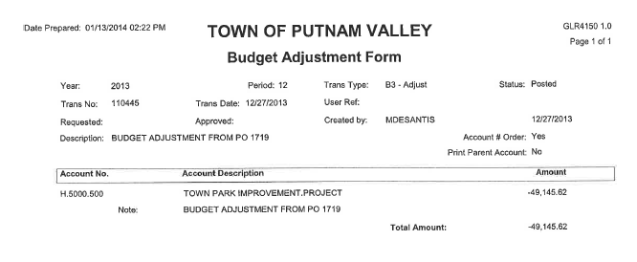
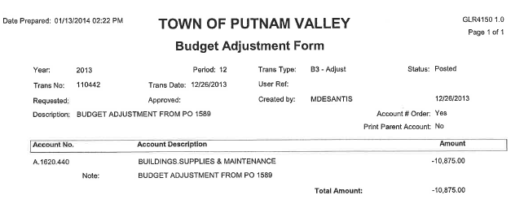

Seconded by Councilwoman Annabi, unanimously carried.

AUDIT OF MONTHLY BILLS

Presented by Supervisor Tendy

RESOLUTION # R 14-86

RESOLVED, that the Town Board approve the following bills, after audit, being paid:

VOUCHER NUMBERS AMOUNTS
6068, 6080-6083 $5,744.00
6038, 6040-6041,6044-6046,
6048, 6056, 6059, 6061,
6065, 6067, 6069-6071,
6074-6079, 6082, 6084 $44,499.89
6157-6168, 6174-6175,6220,
6227, 6247, 6248, 6251,
6252, 6270, 6273,6281-6284 $19,980.96
6039, 6042, 6043, 6047,
6049-6055, 6057, 6058,6060,
6062, 6063, 6064, 6072, 6073,
6103-6105,6113, 6118, 6172,
6176-6177, 6181, 6295 $98,097.81
6119-6125, 6127-6131, 6133,
6135-6140, 6231, 6239, 6279, 6280 $16,262.41
6182-6203, 6228, 6230, 6264,
6265, 6267-6269, 6274, 6275,
6277, 6285, 6286, 6287, 6289,
6290,6298 $61,343.33
6066, 6106-6112, 6114,
6169-6171, 6173, 6179-6180,
6254-6263, 6266, 6272, 6276,
6293, 6294, 6299 $59,708.35
6240-6246, 6253, 6271, 6288,
6291, 6292, 6300, 6301 $12,516.48

Seconded by Councilwoman Annabi, unanimously carried.

Supervisor Tendy moved to go into Executive Session at 7:30 p.m. to discuss personnel and contractual matters with no further business taking place. Seconded by Councilman Luongo, unanimously carried.

Respectfully submitted,

Eileen Royael
Town Clerk 1-16-14

